The Battle of Hastings, by ______________________________________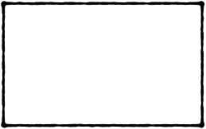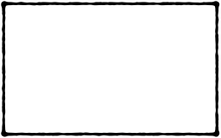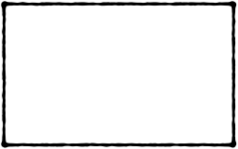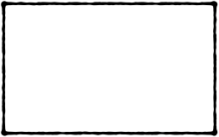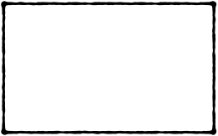

6

5

4

2

3

1