Parisian landmarks: reference sheet

The images below are all famous buildings or monuments in Paris.

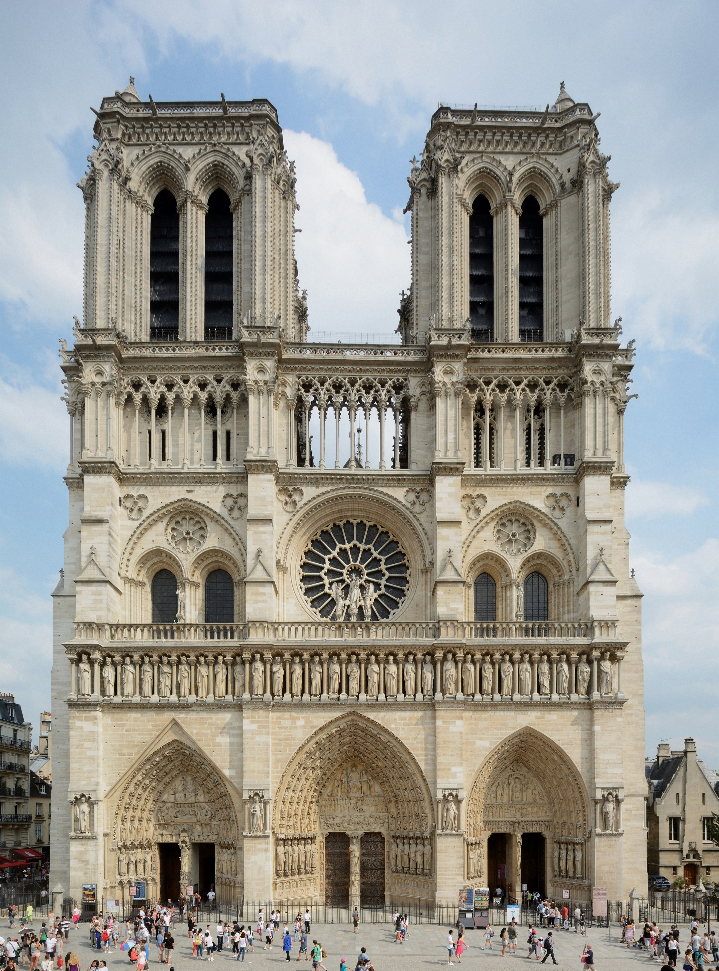
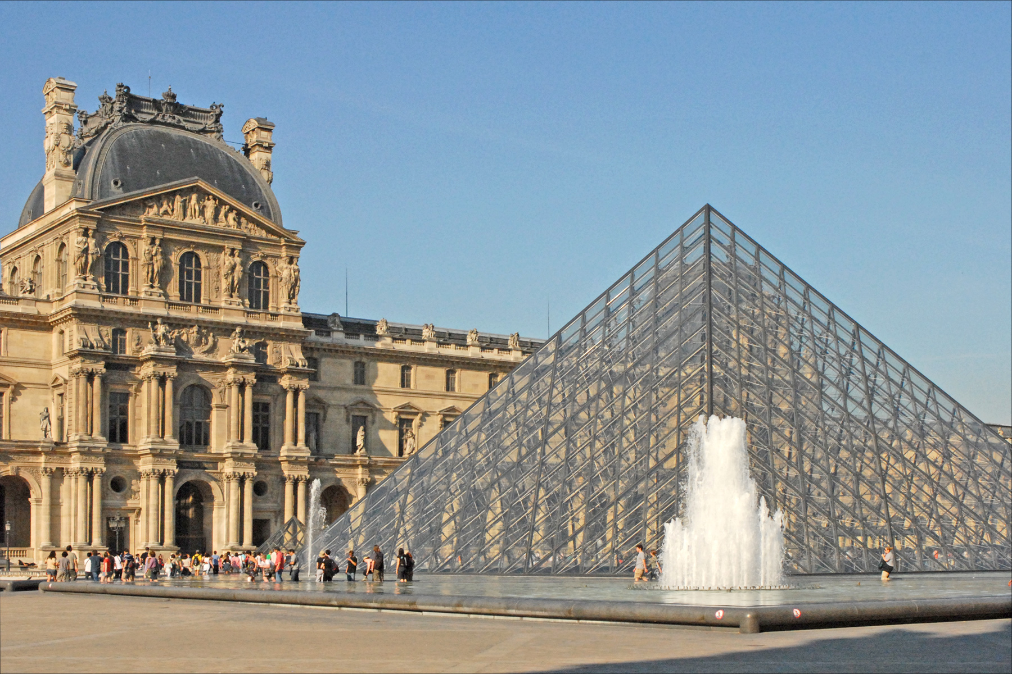
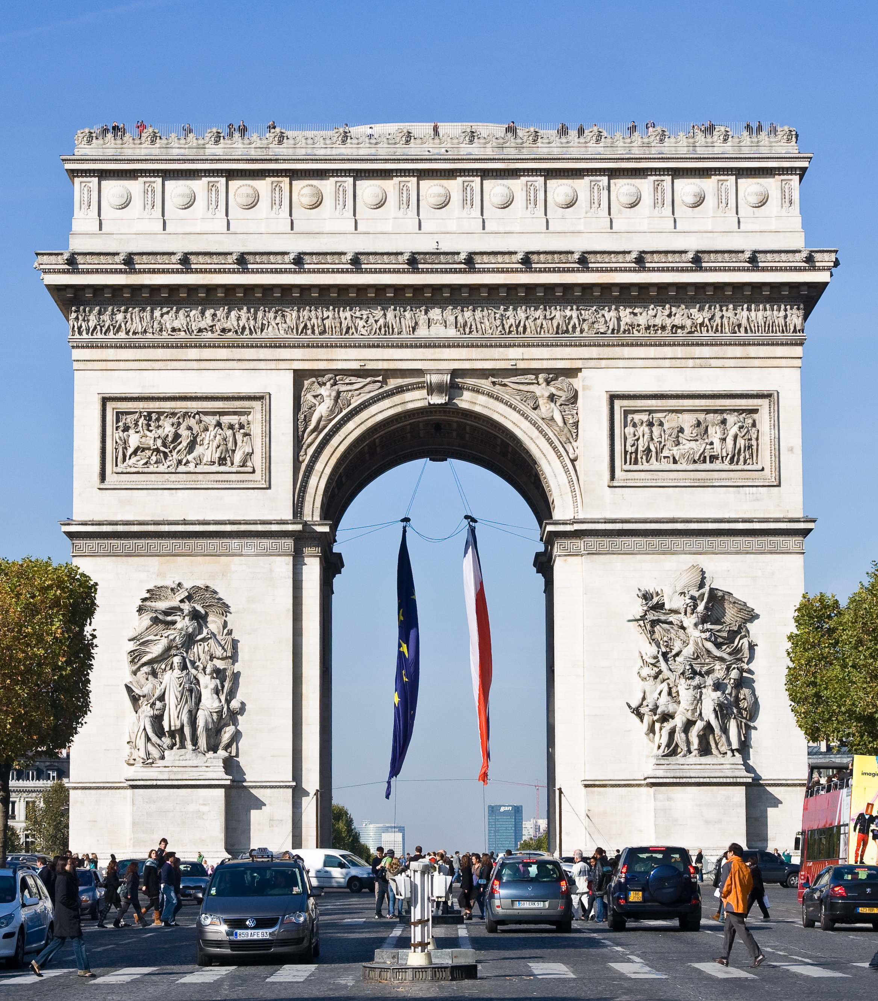
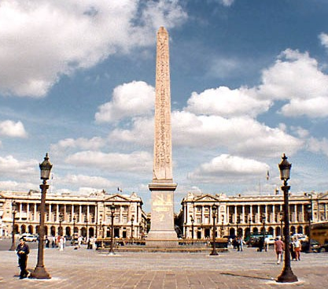
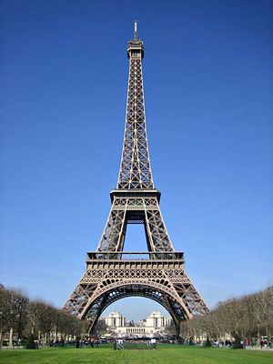
Look at the names we commonly know them by, and their French names.
The Arc de Triomphe  The Arc de Triomphe | The Eiffel Tower  La Tour Eiffel | The Place de la Concorde  La Place de la Concorde
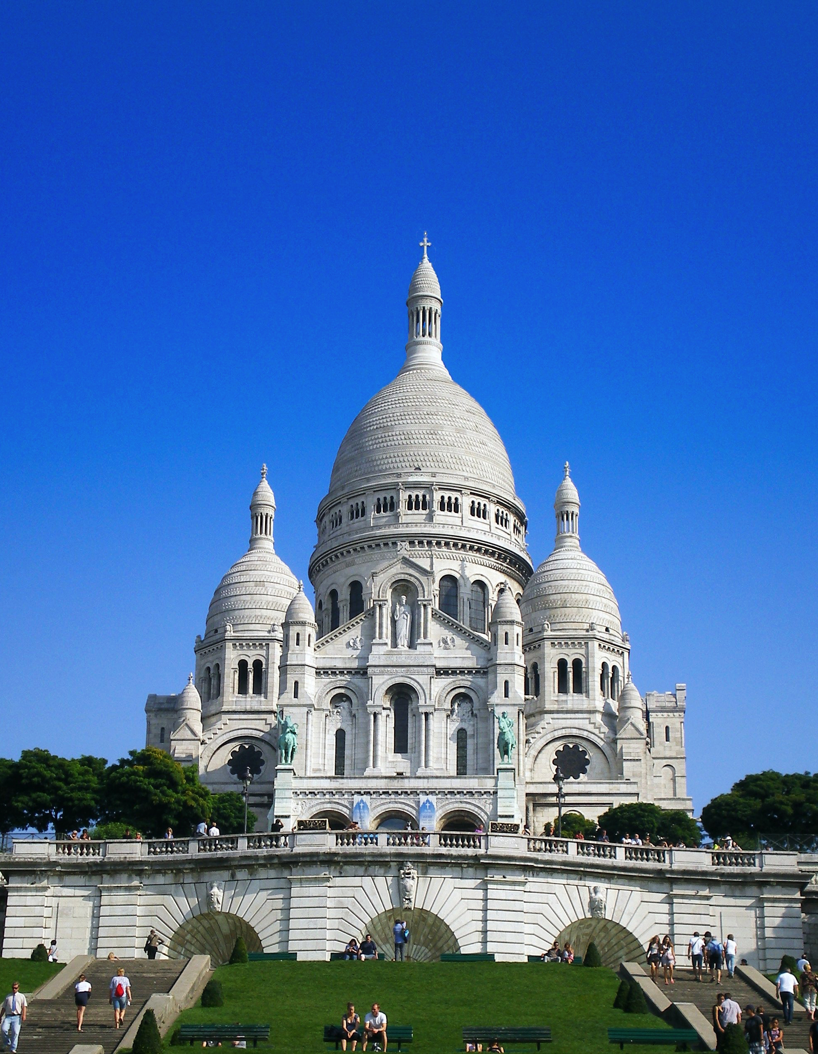
The Sacré Coeur  Le Sacré Coeur | The Louvre  Le Musée du Louvre | Notre Dame  La Cathédrale Notre Dame
The River Seine  La Seine | The Moulin Rouge  Le Moulin Rouge | The Champs Élysées  Les Champs Élysées
