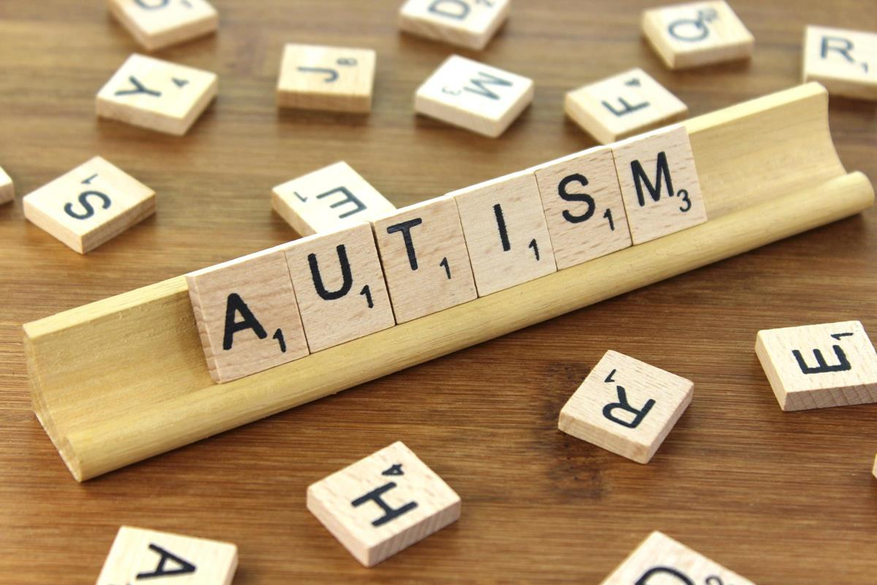

About the breadth of the spectrum
Autism is recognised as a lifelong developmental disability that affects how people perceive the world and interact with others. Each child with autism is a unique individual, with unique needs and abilities that are experienced in individual ways. You will have heard labels such as Autism, Autism Spectrum Disorder, Asperger’s Syndrome, Pervasive Development Disorder and Childhood Autism – all included in the ‘spectrum’ that is referred to. It is not a disease and cannot be ‘cured’ but through appropriate intervention and approaches, children can be supported to develop life skills and coping strategies and progress in their understanding and learning.
Individuals on the autism spectrum share difficulties in the areas of social communication, social interaction, restrictive, repetitive patterns of behaviour and, often, sensory issues. Some also have compounding challenges such as mental health and learning difficulties that require individualised levels of support.
Although the exact cause of autism has not been identified, ongoing research suggests that both genetic and environmental factors may be responsible. Autism is not the result of parenting, social context or in any way the responsibility of the individual.
Formal identification is made through a diagnosis that is (best practice) the result of a multi-disciplinary team, calling on the expertise of a speech and language therapist, paediatrician, psychiatrist and/or psychologist. A diagnosis helps the individual and the family/carers to better understand the difficulties being experienced and should lead to appropriate access to support.
The National Autistic Society, in information entitled Autism facts and history, states that, ‘Autism is much more common than many people think. There are around 700,000 people on the autism spectrum in the UK – that's more than 1 in 100¹. If you include their families, autism is a part of daily life for 2.8 million people.’ Considering this figure with respect to schools would indicate that every school will have students on the spectrum and good practice would suggest that understanding these individual needs to appropriately support these children is without question.
Research Autism states that ‘Many children and young people on the autism spectrum have co-morbidities (co-occurring conditions and syndromes) which bring their own problems and which may complicate the problems caused by autism.’ These include:
- Learning disabilities
- Gastro-intestinal issues
- Difficulties with concentration and organisation
- Neurological conditions such as epilepsy, dyspraxia and ADHD
- Mental health issues
- Sensory integration difficulties
- Sleep disturbance
- Behavioural difficulties including self-injury, anger and disruptive behaviour.
The world can seem a very unpredictable and confusing place to children on the autism spectrum. Our challenge within schools is to reduce the confusion and anxiety by providing routine and predictability while sensitively introducing flexibility and helping the child to develop coping strategies that will lead to greater independence and the opportunity to live a fulfilling life.

