The importance of an appropriate work area
The classroom environment has been addressed throughout the book and is, as you have gathered, an essential area for attention and planning. If you consider the two photographs below, you will notice that one is much busier than the other. Which one would you consider to be best suited to a child on the autism spectrum? Which will allow for focus and which might distract? The single table in front of the window on the left would not be appropriate given the distractions from outside. The table on the right could be adapted for workstation use.

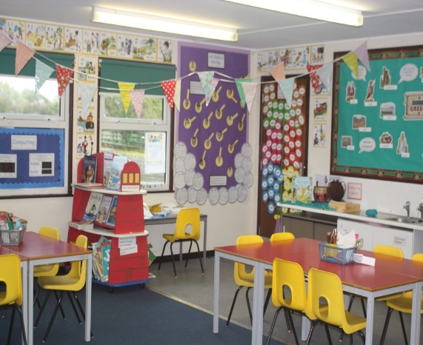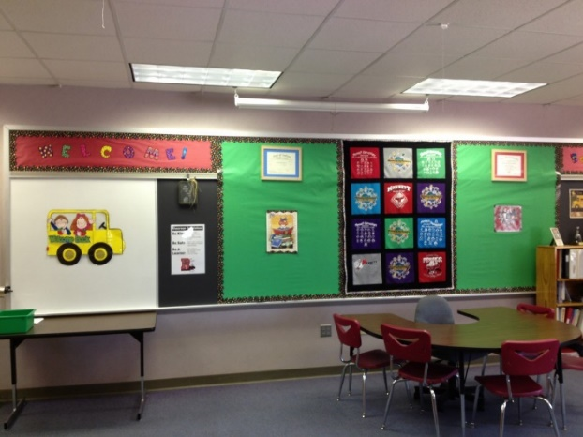

When considering where a child will be able to concentrate on tasks, it is important to look at the context of the overall space. For some children, a dedicated workstation is beneficial while another child may work better placed in a small group. A workstation facing the wall with supporting schedules and prompts neatly organised on the space in front of the child can be helpful to reduce distraction. This does not mean that the child never joins a group or does not participate in larger carpet time group activities. Deciphering when the workstation is needed is part of individual planning.

With both the individual workstation and the allocated group table, consider the position within the room. Avoid high traffic areas near the door and sink, for example. In the group context try to avoid close proximity to other tables where the child is being bumped into through movement of peers.

Take a good look at the space you have and weigh up how bookshelves and storage units can be used to create a ‘bay’ for a workstation. In the photos below, a little imagination could create very useful space by rearranging the shelves and tables. I have never seen a classroom that could not be adapted to accommodate a workstation and make it a positive and productive environment for a child requiring this consideration.

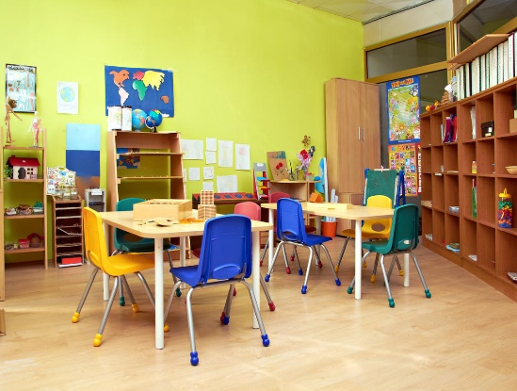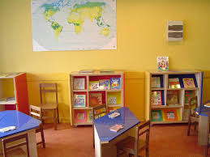

Workstations come in many different presentations, from those specifically built and purchased for use to those set up with resources the school has access to. The resources and tasks are well planned and organised, with a system suitable to the child being carefully designed. The tasks may be taught and/or facilitated in this space, leading to independent work. Expectations such as number of tasks and time to complete them are supported by visuals and timers, also leading to the development of independence.

