How to maximise play and learning in the playground
Children at play conjures up thoughts of chatting, laughing, running, jumping, impromptu games and fun. When these less-structured times are confusing and overwhelming rather than providing a sense of relief and freedom, we need to plan for them. For children on the autism spectrum this is often one of the most difficult and anxious times of the day.

I recall observing and then talking to a primary-aged girl in a mainstream school. She had been referred to our ASD specialist school as a more appropriate placement. I asked her what she did at playtime and her response was, ‘I walk around the edge of the playground, slowly, so that no one notices me.’ I understood and I felt sad for her. When you don’t feel you fit in, when you don’t find it easy to make friends, when you don’t fully understand the social rules, you are bound to opt out and hide.

So, how do we insure that children who don’t naturally enjoy the freedom and the activity of play have a positive time during breaks? Here are some suggestions:
- It is always necessary to create a balance between active participation and the child’s need for some space and ‘down’ time after the pressure of the classroom. Try to respect this by being aware of enabling both alone time and engagement.
- Assign staff to different roles at playtime. Often, each member of staff observes and remains alert to any issues, arguments, bumps and scuffles. This is, of course, essential. Facilitating children to engage and participate is also essential. If at all possible, allocate staff to the two different roles – the watchers and the engagers. Facilitating play and drawing your ASD children into activities with their peers is a social plus.
- A ‘safe haven’ where anxieties can be lowered and relaxation enabled is a bonus for any playground. Even more so for a child who may be apprehensive about where to go and what to do at play. Of course, the purpose will be explained and peers may be encouraged to join the child and have a quiet presence with them.
- Choose playground equipment carefully. Provide both large adventure type physical options as well as small equipment for individuals and pairs of children to enjoy. Part of the staff facilitator role can be offering options such as bubbles, ring toss and balloon chasing. Many enjoyable activities do not need to be expensive but through having a range of options you soon learn what will engage the child and encourage social play.

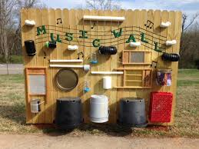
- A sensory wall to explore and engage with can be very inviting and, of course, the traditional sand and water activities are often part of outdoor play. Many sensory walls can be commercially purchased but it is possible to make one for a fraction of the cost and your imagination can run wild with what to include and modify over time.

- Sensory gardens can be expansive or created in a range of flower beds and plant pots. Choosing plants that provide a range of aroma and a spectrum of colour are wonderful to look at, smell and feel. Plants such as lavender can be used to make crafts and many provide collage material.
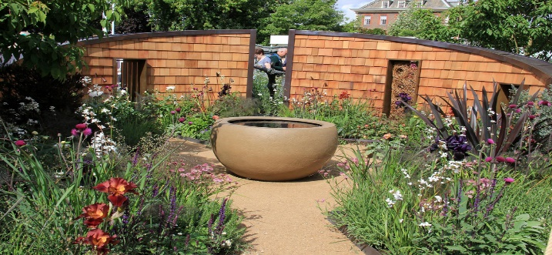

Be bold in making your outdoor spaces into an extension of learning and provide opportunities in the playground to develop play, communication and social opportunities that build foundations for ongoing learning.

