Practical suggestions to make the most of the TEACCH system
The TEACCH Autism Program is a clinical, training, and research program based at the University of North Carolina – Chapel Hill. TEACCH uses a method called ‘Structured TEACCHing’. This is based on the unique learning needs of people with ASD, including their strengths in visual information processing.

The principles of this programme, applied to your work with children on the autism spectrum, will support successful understanding on the daily routine and enable clarity that leads to success in learning. Taking the opportunity to access training to introduce this in your classrooms is worth considering and evaluating.

Consider the images below and see how clear the instructions and resources are for children’s use. After being introduced, these resources lead the child to work independently and support skills such as organisation, responsibility for resources and tidying them away, increasing the number of process steps and generalising the use of materials.



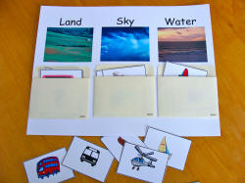

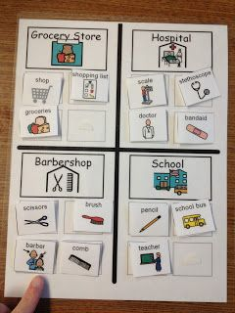

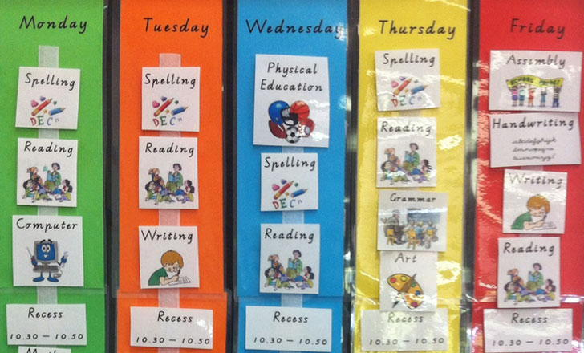

TEACCH training is provided in the UK and is well worth accessing to enable staff in your school to understand and implement the many strategies presented.

