Visual examples of individualised choice boards
Helping a child to make choices addresses independence and makes others aware of preferences. By adding new activities and resources, we widen the choices available to the child and reduce the inflexibility that comes from focusing on one special interest.

Choice time can be schedules as something for the entire class to participate in or it can be a specific reward for children who need to have time broken up to maintain concentration. Here are some examples:

Samantha’s Choice Board
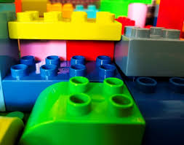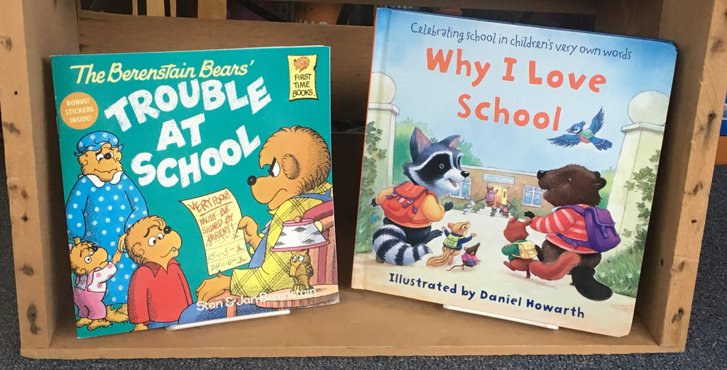
sand Lego books

Ben’s Choice Board

iPad® Globe Drawing

Bear in mind that the choices need to be linked to the child’s interests and the things that motivate them. Choice boards may be offered when work is finished or built into the work schedule. You may choose to use ‘First…. Then’ with choices to follow a given a task. If there is a range of choices, determine how many should appear at any one time, interchanging them as appropriate.

For some pupils, a list may suffice, without the images seen in the examples. For others, the choices may require concrete objects rather than pictures. Considering the unique needs of the individual must be at the heart of planning for choice.

