The positive impact of extra-curricular opportunities
Not only do extra-curricular opportunities provide a menu of new and varied experiences for your children, they also provide valuable life skills for future development.

- Physical fitness sessions on individual pieces of equipment provide opportunities for exercise, health and wellbeing and take away the pressure of team sports. Learning to set and break personal records reduces competition with others. A bonus is that this may become an activity outside of school and home where the child has confidence to pursue it independently.

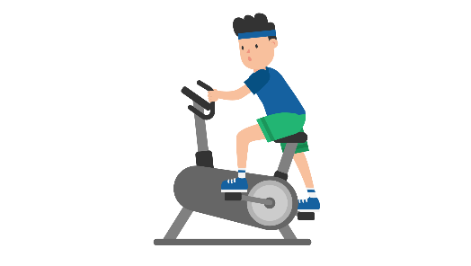

- Healthy eating clubs are a wonderful way to introduce new skills and tempt reluctant eaters into trying new things. Special diets, obviously, have to be taken into consideration. Planning the sessions together and generating ideas from the pupils helps them to have ownership. The skill of making a shopping list and going to the shops to buy ingredients brings in a wealth of life skills that also enhance the curriculum. There are so many fun ideas for fruit and vegetables and themed food activities online – amazingly exciting and at your fingertips.
- Most schools have the space to accommodate some raised beds for growing vegetables and flowers. For some children, the chance to get their hands dirty is a wonderful invitation. Seeing the process of cultivating, to planting, to tending, to growing and reaping the harvest is an experience they will never forget. Using the vegetables for the healthy eating club is a great benefit. In many urban environments, children have no idea that food comes from the soil. Aside from the development of vocabulary and gardening skills, using photos throughout the process enables sequencing tasks and recall of events.
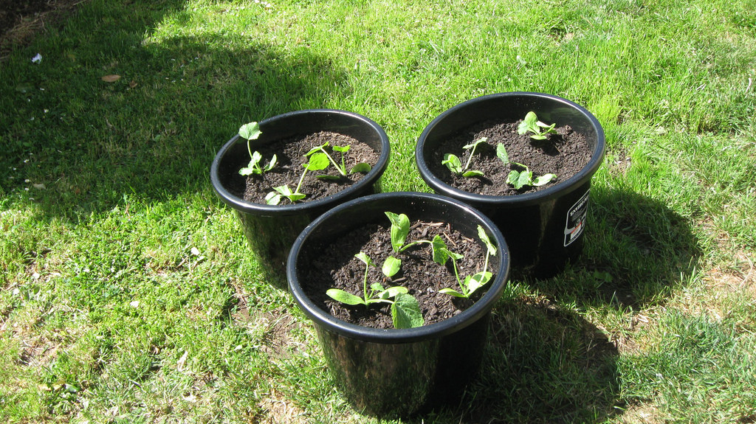
- I observed a wonderful extra-curricular session in a school where a small room had been turned into a hairdresser’s salon. Time had been taken to make this space attractive and welcoming with chairs, hairstyle posters and mirrors as well as all of the equipment you wold expect to find in such a venue. The interest was so high that there had to be a rota of children coming to take their turns throughout the session. They pretended to use the sink, the hairdryer and range of combs and brushes (that were regularly cleaned and disinfected). There was a reception desk and a child making appointments. There was a waiting area with magazines. What a great opportunity to encourage the imagination as well as social conversation and close proximity. The staff facilitated but did not take over. It was a treat to watch this busy little salon.

Remember that these opportunities are not just time fillers. They are valuable reinforcements to the curriculum and widen the scope of activities for the children as well as building self-confidence and teaching or reinforcing new skills.

