Thinking and saying template

What I say

What I think

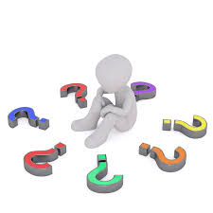

Ideally, the character in the middle should be the child you are using this resource with, clearly indicating that it is his/her thoughts and comments that are being discussed.
Very often, the message you are trying to convey is that the child may think anything but needs to think about the impact of any words if said out loud. He may think, ‘You don’t smell very nice,’ but to say this out loud to a member of staff or a child is going to cause embarrassment and it is best left unsaid or to be shared privately with a key worker who can offer advice.

