Enabling pupils to express themselves
I have often been concerned when a member of staff has, for example, given a child toast at snack time, already spread with butter and jam because, ‘That’s what he always has.’ Now, the child may choose this snack but he may also get tired of it and want something different one day. How will you know? On another point, why is he not being supported to spread his own butter and jam?

Offering a bowl of fruit or slices of cut fruit, a plate of crackers, toast or a bowl of crisps, give choice. By choosing, the child has a voice. You may use the Picture Exchange Communication system, an iPad® app or a choice board to enable communication in making choices. That’s great! I have observed some schools where older children manage the snack time choices and encourage their younger peers to select for themselves. A word of caution, choosing is not just for food and snacks. It should occur throughout the day for equipment, peers to work with, activities, materials, etc.

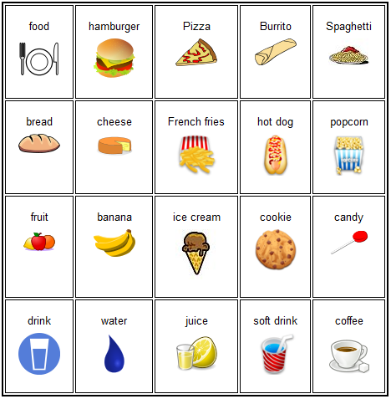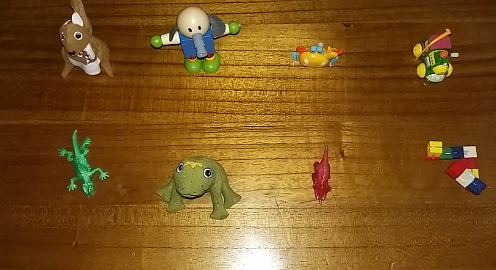
PECS sample page Sensory Toy Choice Board

Give your pupils a voice by letting them have real choices!

