Broadening horizons across the curriculum
I’m sure you agree that all lessons need to be well planned, differentiated, resources ready and in good shape if they are to meet the needs of children. This is certainly the case when working with children on the autism spectrum. If we are dithering and without the necessary equipment to hand, the situation will soon unravel.

Recognising the importance of visual learning and the need for concrete presentation is the first step in getting the curriculum focus right. For example, a group of able children with autism were learning about life in Roman times. Background work had been done regarding a time line and some visual images had been shown, depicting villages, lifestyle and attire. When the group was asked what they thought the children did in the evenings, the first reply was, ‘Watched TV.’ The visuals to that point had not shown anything about children specifically but they did, of course, show the different living conditions, cooking facilities, etc. That was not enough. Back to the drawing board! The teacher found images of children in Roman times, explored with the group what they were doing and then the contrast was possible.

Be aware of overusing worksheets and abstract presentations. Rather than a pencil exercise for addition to 10, use a game such as addition bingo or two-sided beans. Cast ten two-sided beans onto the table and record how many came up black and how many white.
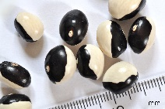

Use dominoes for counting and matching, providing an opportunity to take turns, socialise with peers and even get some support from peers if needed.
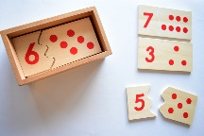

Is it necessary to write out the matching halves of a sentence or can they be on strips to join together? Can you increase observation by giving a stimulating picture and asking the child to list ten things seen in it?

Remember that when children do an activity to further their learning, the process is as important as the end product. They learn by the doing.

