# Further engaging resources

In most schools, budgets are tight and there are competing demands for the priorities each department and general school needs. There are so many commercial resources available when you have a generous budget, BUT there are so many good activities that can be replicated by you, or even made as a class project, to make your budget go further.

Here are some examples:

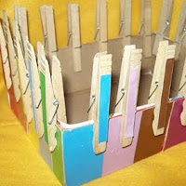 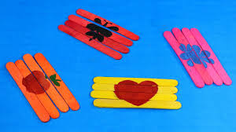 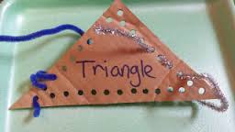

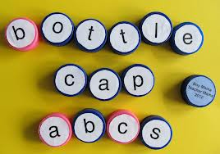 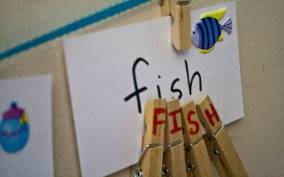 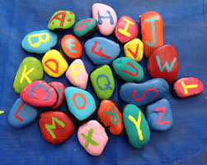

Once again, remember that the process is an important part of learning. Making involves learning and it gives children ‘ownership’ of the resources. It incorporates being creative, listening to and following instructions, collecting resources and having the skills to execute the task.

Guard against death by worksheet – consider the purpose of what you are asking the pupils to do and whether the paper and pencil exercise can be achieved in a more stimulating way that will better retain the information you are wanting the child to learn.

**Always consider active learning and reduce the passive use of worksheets by teaching and embedding skills through games. Yes, you may need the worksheets as evidence but recording the active participation in learning through digital photography will often better engage your pupils.**