Difficulties with generalisation
We take so much for granted in generalisation and most children will simply pick things up along the way and just ‘get it’. When a child finds this illusive and struggles to make the links, we need to find ways to support and heighten generalisation.

At the most complex end, this may take the form of a child not recognising objects in the same category that differ from current experience. Look at spoons for example:

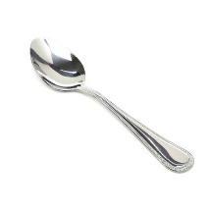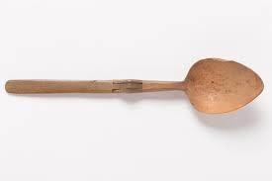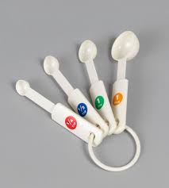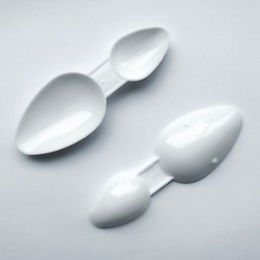

Spoons come in many shapes and sizes, colours and materials. By explaining ‘spoonness’ and the purpose of the different spoons, the similarities and differences, you are generalising a category. Having a tray of spoons of different sizes, shapes, etc. will consolidate what a spoon is.

Now widen this to consider other classifications such as dogs. If the child’s first experience with a dog is a Chihuahua, will he recognise a Dalmatian as the same category? Some children need to be shown that a spoon is a spoon is a spoon and a dog is a dog is a dog. By recognising the gap and taking the time to fill it, you are enhancing learning and making the world better understood.
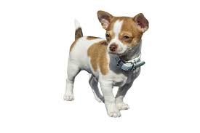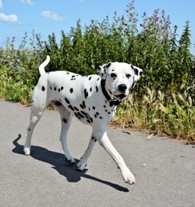

A relevant example is a boy who really enjoyed food technology and was skilled at peeling and chopping carrots. He used a plastic-handled peeler and a rectangular cutting board at school. When on a residential trip, he volunteered to do this task. He sat motionless with the peeler (metal) and the cutting board (round) and did not know what to do. It was only when it was demonstrated the same purpose and procedure explained, that he tackled the task. Most children will easily move from one utensil to another, from one pen to another, from one route to school to a diversion. But when this is not the case, using the ‘teaching moment’ is crucial.

Do remember that generalising things between home and school can be difficult too. Work closely with parents/carers to ensure understanding in each environment.

