Presenting targets visually
Here is one example of a child friendly target sheet with a feedback column for the child to self-assess.
My Targets
My Targets   | What do I need to do?  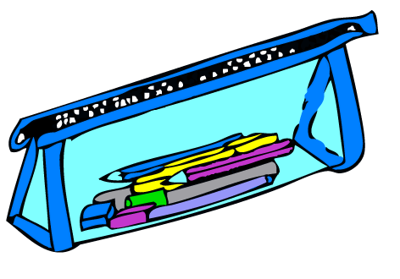 | Who will help me?  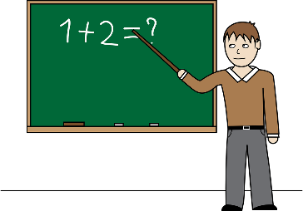 | How did I get on?  
I will try to come into school nicely in the morning. | Smile and say “Good Morning”. | All the staff at my school
I will try to get on with doing work. | Listen to my classroom staff  Do my best every day. | Mrs XX  Mrs YY  Mr ZZ  Other staff
I will try to play nicely with other children | - Share  - Take turns  - Be a good loser | Other children  All the staff

This same format can be used for curriculum targets and, of course, you must ensure that the child understands the target and that support is available for making progress. One helpful target might be: ‘To remember to ask for help when I do not understand’.

