Motivating children through reward
Not every child responds to verbal praise. For some, this is ignored or not given the attention you generally expect. Remembering that visual understanding is often better received by children on the autism spectrum, it is worth trying to develop a reward chart that fits the individual interests of the pupil. Knowing the child will help you recognise how many ‘tokens’ the child will work for and while this may begin with just one, or the use of ‘First…. Then’, extending the time on task and the number of tokens to be earned should be increased over time.

Here are some examples that show variety, all based on individual needs:

Aaron is working for

Tokens: 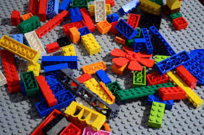

Alice’s Reward Chart

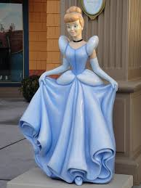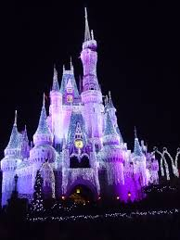
Alice’s tokens:

Nathan’s Reward Chart

Nathan’s tokens:

2
3
4
1

4
3
2
1

