Skills progression template: A progression of vehicles
Skill Level | Bike, Trike or Scooter | Example of vehicle
Element 8 | Balance walker | 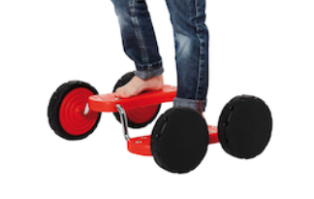
Element 7 | Two-wheeled scooter  Bike with pedals | 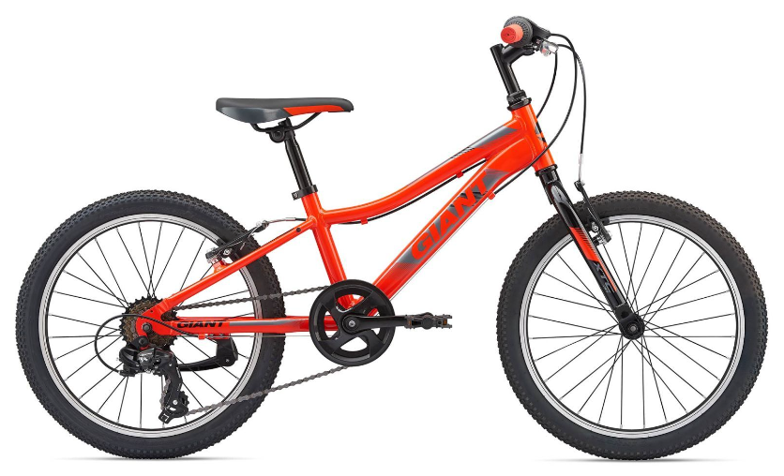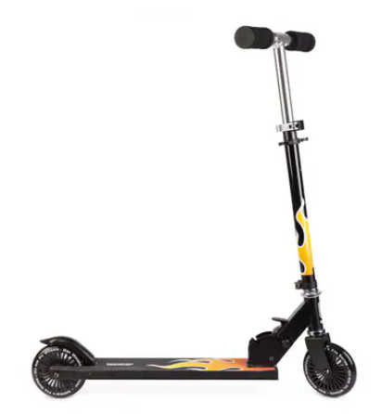
Element 6 | Three-wheeled turning bar scooter | 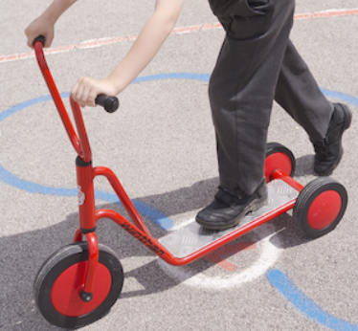
Element 5 | Three-wheeled balance scooter | 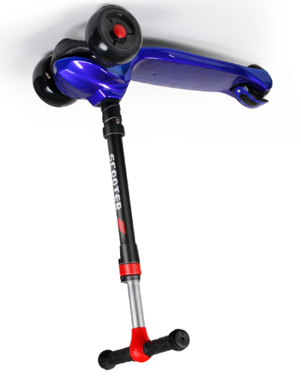
Element 4 | Trike with pedals  Balance Bike | 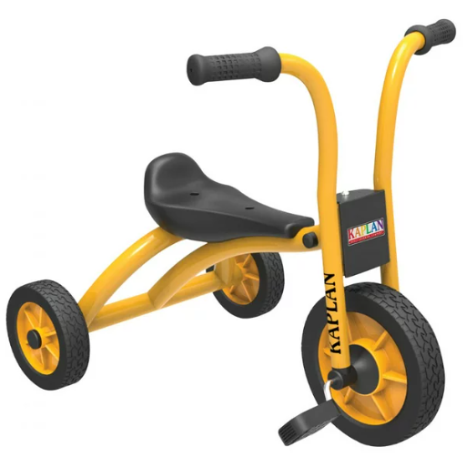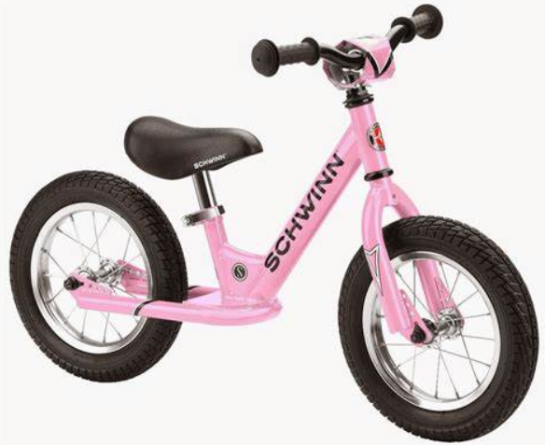
Element 3 | Trike with back support but without pedals | 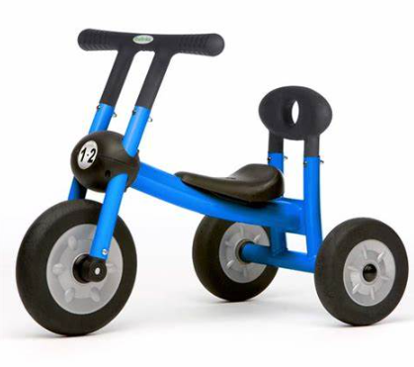
Element 2 | Trike with adult push/steering bar, back support and seat belt | 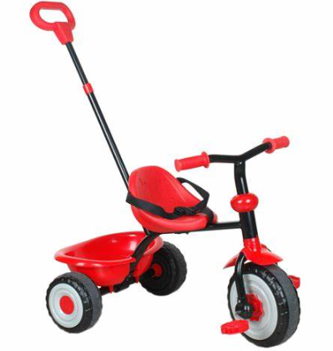
Element 1 | Pushchair | 