A globalised high street
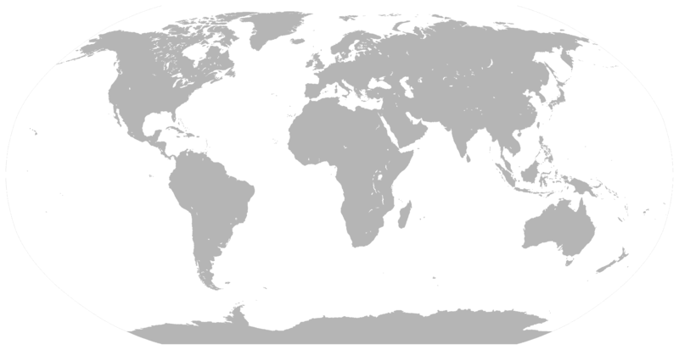
Arrow width | Number of stores
1mm | 1
2.5mm | 2
5mm | 3
7.5mm | 4
1cm | 5

