Lesson 4: Match the equipment with the descriptions, then use this to complete the table.

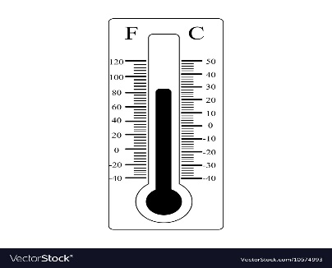 |  | Rain Gauge  Precipitation is water falling from the sky.  Measures the amount of rainfall in mm. Not only does a rain gauge measure rainfall, but also all other forms of precipitation
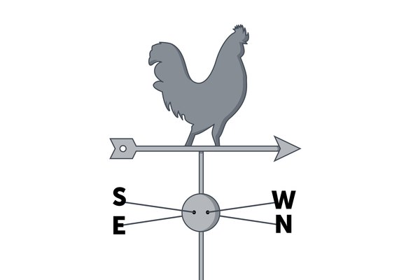 |  | Thermometer  Temperature means how hot or cold it is.  It is usually measured with a thermometer in degrees centigrade(ºC)
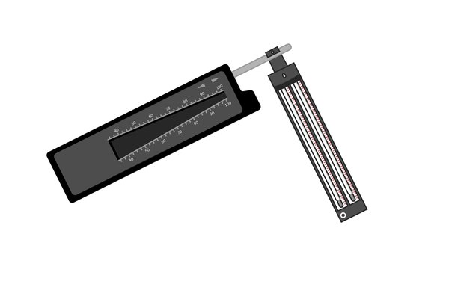 |  | Campbell stokes recorder  Sunshine is light and warmth from the sun.  A Campbell Stokes Recorder measures sunshine.  This type of recorder is made up of a glass ball which concentrates sunshine on to a thick piece of card. The sunshine then burns a mark on the card which shows the number of hours of sunshine in the day.
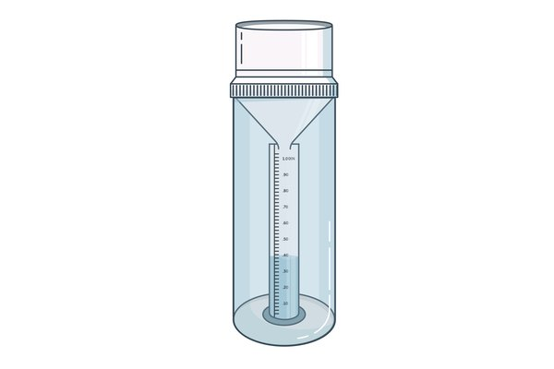 |  | Weathervane  Wind direction is where the wind is blowing from.  Measures wind direction by pointing towards North, East, South or West.
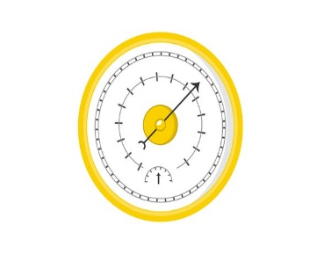 |  | Barometer  Pressure is a measure of the force exerted by air.  Pressure is measured with a barometer in millibars (mb).
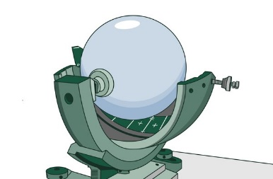 |  | Anemometer  Wind speed is how fast the wind is blowing. An anemometer measures wind speed in mph.  The most common type looks like a toy windmill. The faster the wind blows the faster the cups spin around. The wind speed is shown on a dial, just like a car's speedometer.
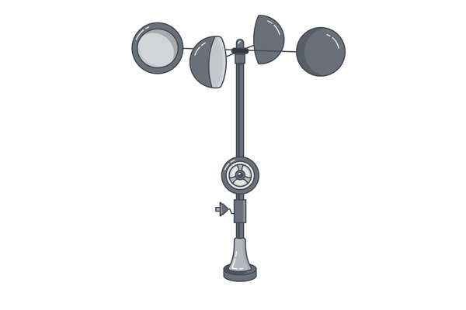 |  | Hygrometer  A hygrometer measures temperature and humidity. It measures humidity as a percentage. It measures the relative humidity of the air through evaporation. It has two thermometers, and it measures the amount of evaporation.  Humidity is the amount of water vapour in the air.

Weather term | Definition | Usually given in | Instrument used
Temperature | How hot or cold it is. | Degrees centigrade | Thermometer
Precipitation
Humidity
Wind Speed
Wind direction
Sunshine
Air Pressure

