Cloud identification guide

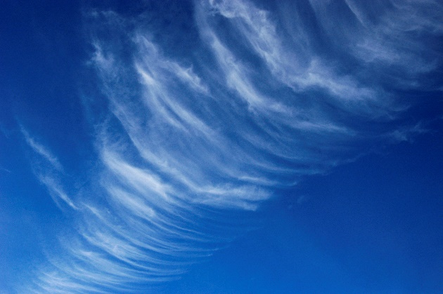 | Cirrus  Cirrus are wispy clouds which are high clouds, usually between 20,000 and 40,000 feet high.  They are made of ice crystals.  They look like wisps of hair.
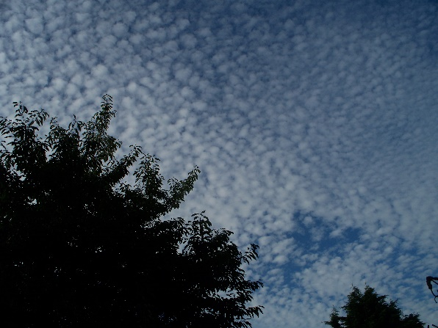 | Cirrocumulus  These are found between 20,000 and 40,000 feet.  These are made of small white clouds called cloudlets but are found at high levels.  Some people think it looks like scaly fish skin.
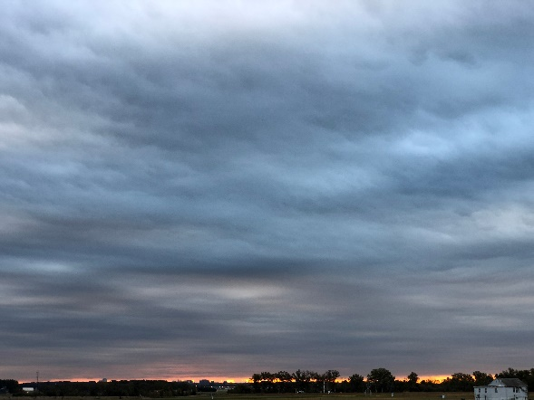 | Altostratus  These are found between 6,500 and 20,000 feet.  They are layered and featureless – flat and spread out.  They eventually become nimbostratus – these clouds produce rain or snow
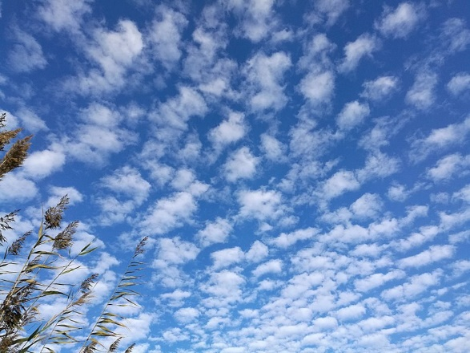 | Altocumulus  These are found between 7,000 and 18,000 feet.  These are patches of clouds called cloudlets.  There are different types of altocumulus and some of them are very spectacular!
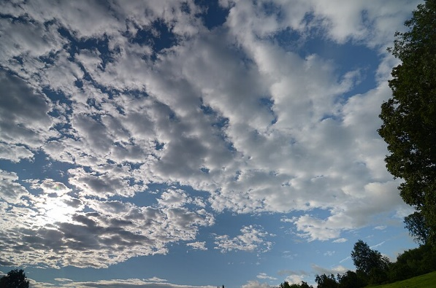 | Stratocumulus  These are found between 1,200 and 6,500 feet.  They are lumpy at the base but flat on top.  Theya re the most common clouds on earth.
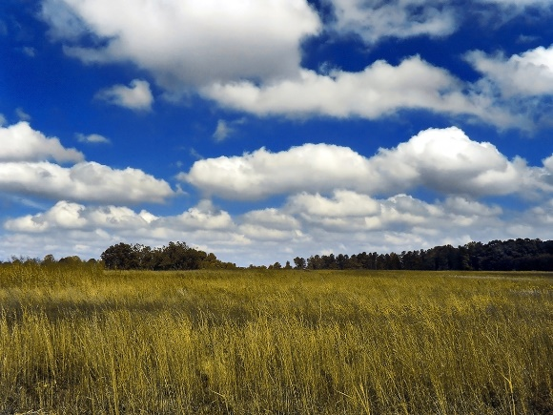 | Cumulus  These are found between 1,200 and 6,500 feet.  They are fluffy clouds, like cotton wool balls.  They are detached clouds, separate puffs of cloud across the sky.
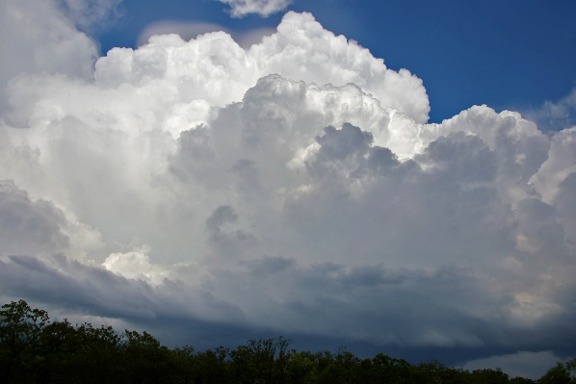 | Cumulonimbus  These are found between 1,100 and 6,500 feet.  They are usually tall towering clouds with an anvil-shaped top.  They are usually dark. They bring with them heavy rain and thunderstorms.
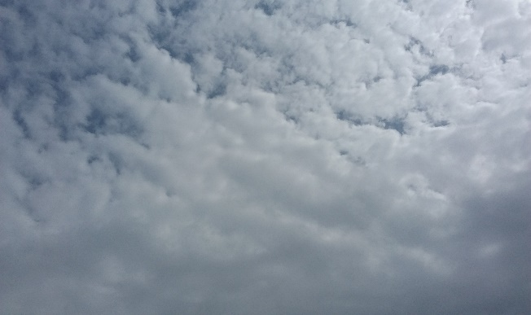 | Stratus  Stratus clouds are low-level and are found between 0 and 1,200 feet.  They look like a blanket of cloud.  They are the lowest-lying cloud shape.

