Pond species guide

Species picture | Name | Trophic level
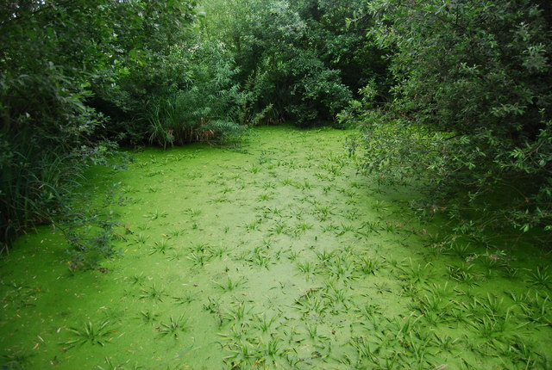 | Algae | Producer
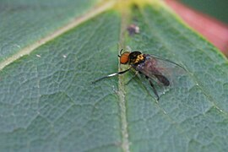 | Blackfly | Detritivore
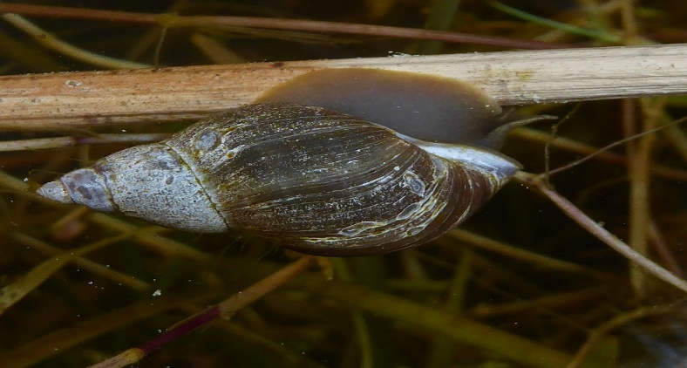 | Pond snail | Primary consumer
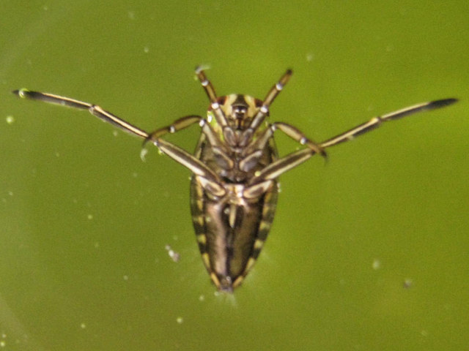 | Water boatman | Primary consumer
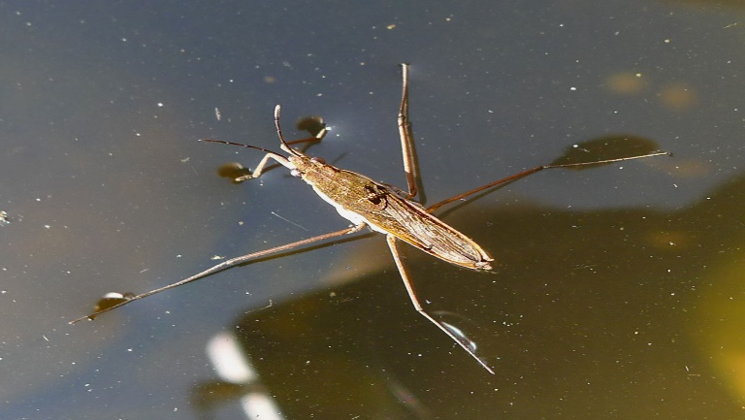 | Pond skater | Secondary consumer
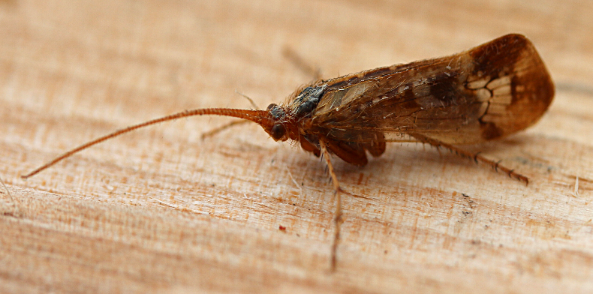 | Caddis fly | Primary consumer/ Secondary consumer  (some eat only pondweed or algae)
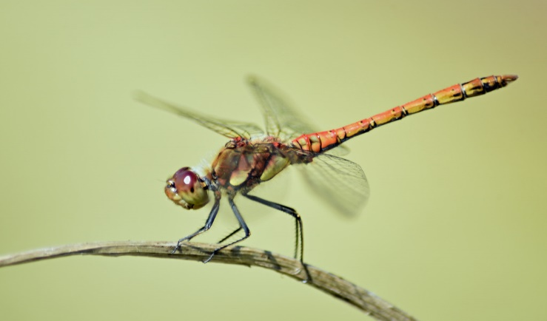 | Dragonfly | Secondary consumer
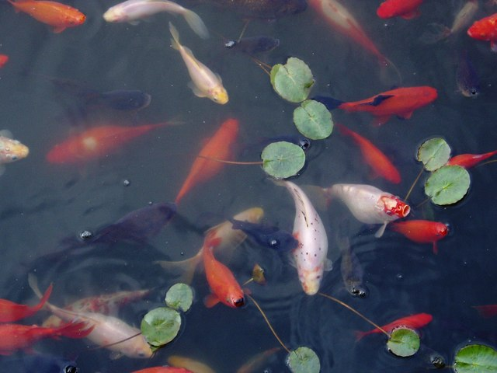 | Fish | Secondary consumer / Tertiary consumer
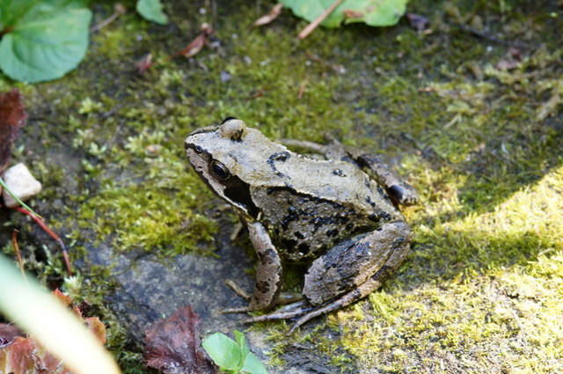 | Frog | Tertiary consumer

Pictures:
Algae: https://www.geograph.org.uk/photo/1963014
Blackfly: https://commons.wikimedia.org/wiki/File:Blackfly_(Simulium_sp.),_Baltasound_-_geograph.org.uk_-_5087708.jpg
Pond snail: https://www.flickr.com/photos/63394592@N08/29022843011
Caddis fly: https://commons.wikimedia.org/wiki/File:Caddis_fly_%2843647760295%29.png
Dragonfly: https://www.flickr.com/photos/conall/51328644883
Water boatman: https://www.geograph.org.uk/photo/1918833
Fish: https://commons.wikimedia.org/wiki/File:Fish_in_the_pond_at_the_Welcome_Break_motorway_services,_Oxford_-_M40_-_Junction_8A_-_geograph.org.uk_-_976256.jpg
Pond skater: https://commons.wikimedia.org/wiki/File:Common_Pond_Skater._Gerris_lacustris._Gerridae_-_Flickr_-_gailhampshire_%281%29.jpg
Frog: https://www.geograph.org.uk/photo/4108484

