Northampton
Town
Centre
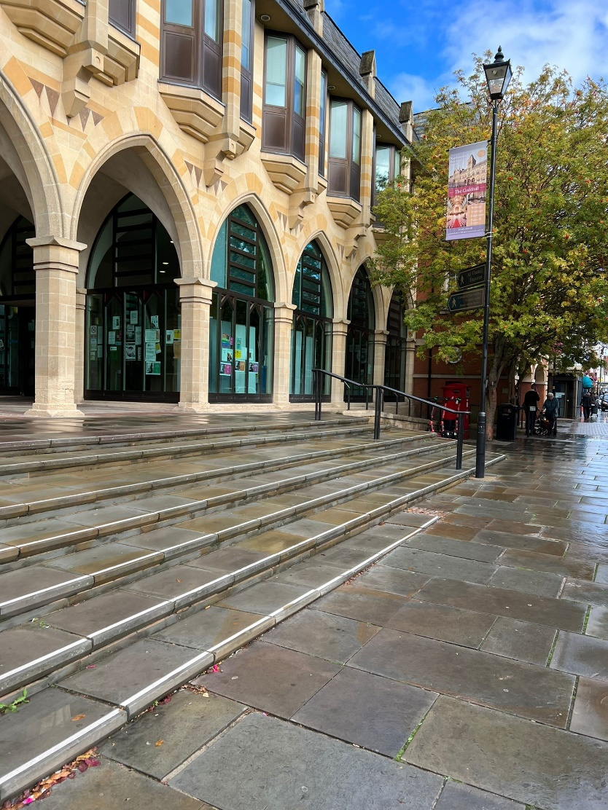

Inequalities and transects

Name………… Group……

Today you will be completing a study of Northampton Town Centre. We are doing this to investigate inequalities and transects. These concepts will both be assessed in your exam. The questions that you answer in your exam will be based around these two concepts. All of the data that we collect data will be important. It is also important that you remember what methods you carried out and WHY you carried them out.

The 6 sites will be investigating are:
Site | Page | Location
1 | 3-7 | Abington Street
2 | 8-11 | The Guildhall
3 | 12-15 | Market Square
4 | 16-20 | St Giles Street
5 | 21-24 | Cultural Quarter
6 | 25-28 | Drapery

Whilst you are walking around you will need to take notes at each site, complete the surveys, take photographs, draw field sketches and write down your observations. All of this information will help you in both your Paper 3 exam and in the urban/rural unit we have studied.

It is really important that we take this information down at each site as we won’t get another chance to collect this data. You will be assessed on your own fieldwork in your exam. There will be at least 2 questions about your own fieldwork, so you need to know what you did and why you did it.

Our enquiry question:
Is Northampton Town Centre accessible for all?

Our hypotheses:
Abington Street is more accessible than St Giles Street.

People with a visual impairment struggle to access key services in Northampton.

Site 1: Abington Street, Northampton. (From BBC Radio Northampton)
Draw a labelled field sketch in this box. What can you see at this site? What inequalities are present?

Bi-polar Survey – Environmental Quality Survey
Negative Evaluation | Bi-Polar Score |  |  |  |  |  |  | Positive Evaluation
 | -3 | -2 | -1 | 0 | +1 | +2 | +3
Pavements and roads are in poor working order |  |  |  |  |  |  |  | Pavements and roads in a good state of repair
Lots of litter and no visible bins |  |  |  |  |  |  |  | No obvious litter and lots of bins.
Lots of canine faeces and no visible dog bins |  |  |  |  |  |  |  | No obvious canine faeces and lots of dog bins
Lots of vandalism and graffiti |  |  |  |  |  |  |  | No evidence of vandalism or graffiti
Unattractive location |  |  |  |  |  |  |  | Attractive location
Not much green space |  |  |  |  |  |  |  | Lots of green space

Give a score to each statement. If the location is in poor condition your scores would be in the minus. If there is little evidence of either positive or negative the score would be zero. Total score ______________
Likert Survey

Question | Strongly Agree | Agree | Neither agree nor disagree | Disagree | Strongly Disagree
This location is accessible for all.
This location is well cared for.
This location is used by a wide variety of people.
This location is a good use of space/land.
This location feels safe
Input your opinion by ticking/highlighting one box in each row .

Notes about this location – what else can you see? Are there any other inequalities present?

Observation Study of Abington Street

What to record |  | Notes
Facts | Date and time, location, weather
Physical environment | What is the layout of the environment
 | How is the environment being used by people?
Social environment | How many people?
 | Demographics (age, gender, diversity)
 | How are people arranged in the area? (solo, groups, arranged activities)
 | What are people doing?
How does area make you feel? What impression do you get?

Land Use Survey – Abington Street (Transect)

1. Charity Shop, 2. Clothing Shop, 3. Café/Restaurant, 4. Supermarket, 5. Homeware, 6. Estate Agent, 7. Personal Services, 8. Bank, 9. Other, V. Vacant
Accessibility Survey
Negative evaluation | -3 | -2 | -1 | 0 | +1 | +2 | +3 | Positive evaluation
No clear distinction between the kerb and pavements. No dropped curbs. |  |  |  |  |  |  |  | Kerbs should be of contrasting colour and clearly indicate the boundary of the pavement.
Pavement is uneven with multiple trip hazards. |  |  |  |  |  |  |  | Pavement is even with no trip hazards. Clear pathways.
No tactile pavement, no distinction between path and road. |  |  |  |  |  |  |  | Tactile pavement is used at traffic crossings
Steps do not have handrails and steps are uneven heights. No ramps. |  |  |  |  |  |  |  | Steps have handrails and all steps are an even height. Ramps to aid accessibility.
Signs are small and difficult to read from a distance |  |  |  |  |  |  |  | Signs are clear to read with a consistent font style.
Signs are on reflective or shiny surfaces |  |  |  |  |  |  |  | Signs are not on reflective or shiny surfaces
Shops have steps to access or heavy closed doors. |  |  |  |  |  |  |  | Shops can easily be accessed
Notes on accessibility of this location

Site 2: Guildhall – building and road
Draw a labelled field sketch in this box. What can you see at this site? What inequalities are present?

Bi-polar Survey – Environmental Quality Survey
Negative Evaluation | Bi-Polar Score |  |  |  |  |  |  | Positive Evaluation
 | -3 | -2 | -1 | 0 | +1 | +2 | +3
Pavements and roads are in poor working order |  |  |  |  |  |  |  | Pavements and roads in a good state of repair
Lots of litter and no visible bins |  |  |  |  |  |  |  | No obvious litter and lots of bins.
Lots of canine faeces and no visible dog bins |  |  |  |  |  |  |  | No obvious canine faeces and lots of dog bins
Lots of vandalism and graffiti |  |  |  |  |  |  |  | No evidence of vandalism or graffiti
Unattractive location |  |  |  |  |  |  |  | Attractive location
Not much green space |  |  |  |  |  |  |  | Lots of green space

Give a score to each statement. If the location is in poor condition your scores would be in the minus. If there is little evidence of either positive or negative the score would be zero. Total score ______________
Likert Survey

Question | Strongly Agree | Agree | Neither agree nor disagree | Disagree | Strongly Disagree
This location is accessible for all.
This location is well cared for.
This location is used by a wide variety of people.
This location is a good use of space/land.
This location feels safe
Input your opinion by ticking/highlighting one box in each row .

Notes about this location – what else can you see? Are there any other inequalities present?

Observation Study of the Guildhall

What to record |  | Notes
Facts | Date and time, location, weather
Physical environment | What is the layout of the environment
 | How is the environment being used by people?
Social environment | How many people?
 | Demographics (age, gender, diversity)
 | How are people arranged in the area? (solo, groups, arranged activities)
 | What are people doing?
How does area make you feel? What impression do you get?

Accessibility Survey
Negative evaluation | -3 | -2 | -1 | 0 | +1 | +2 | +3 | Positive evaluation
No clear distinction between the kerb and pavements. No dropped curbs. |  |  |  |  |  |  |  | Kerbs should be of contrasting colour and clearly indicate the boundary of the pavement.
Pavement is uneven with multiple trip hazards. |  |  |  |  |  |  |  | Pavement is even with no trip hazards. Clear pathways.
No tactile pavement, no distinction between path and road. |  |  |  |  |  |  |  | Tactile pavement is used at traffic crossings
Steps do not have handrails and steps are uneven heights. No ramps. |  |  |  |  |  |  |  | Steps have handrails and all steps are an even height. Ramps to aid accessibility.
Signs are small and difficult to read from a distance |  |  |  |  |  |  |  | Signs are clear to read with a consistent font style.
Signs are on reflective or shiny surfaces |  |  |  |  |  |  |  | Signs are not on reflective or shiny surfaces
Shops have steps to access or heavy closed doors. |  |  |  |  |  |  |  | Shops can easily be accessed
Notes on accessibility of this location

Site 3: Market Square
Draw a labelled field sketch in this box. What can you see at this site? What inequalities are present?

Bi-polar Survey – Environmental Quality Survey
Negative Evaluation | Bi-Polar Score |  |  |  |  |  |  | Positive Evaluation
 | -3 | -2 | -1 | 0 | +1 | +2 | +3
Pavements and roads are in poor working order |  |  |  |  |  |  |  | Pavements and roads in a good state of repair
Lots of litter and no visible bins |  |  |  |  |  |  |  | No obvious litter and lots of bins.
Lots of canine faeces and no visible dog bins |  |  |  |  |  |  |  | No obvious canine faeces and lots of dog bins
Lots of vandalism and graffiti |  |  |  |  |  |  |  | No evidence of vandalism or graffiti
Unattractive location |  |  |  |  |  |  |  | Attractive location
Not much green space |  |  |  |  |  |  |  | Lots of green space

Give a score to each statement. If the location is in poor condition your scores would be in the minus. If there is little evidence of either positive or negative the score would be zero. Total score ______________
Likert Survey

Question | Strongly Agree | Agree | Neither agree nor disagree | Disagree | Strongly Disagree
This location is accessible for all.
This location is well cared for.
This location is used by a wide variety of people.
This location is a good use of space/land.
This location feels safe
Input your opinion by ticking/highlighting one box in each row .

Notes about this location – what else can you see? Are there any other inequalities present?

Observation Study of Market Square

What to record |  | Notes
Facts | Date and time, location, weather
Physical environment | What is the layout of the environment
 | How is the environment being used by people?
Social environment | How many people?
 | Demographics (age, gender, diversity)
 | How are people arranged in the area? (solo, groups, arranged activities)
 | What are people doing?
How does area make you feel? What impression do you get?

Accessibility Survey
Negative evaluation | -3 | -2 | -1 | 0 | +1 | +2 | +3 | Positive evaluation
No clear distinction between the kerb and pavements. No dropped curbs. |  |  |  |  |  |  |  | Kerbs should be of contrasting colour and clearly indicate the boundary of the pavement.
Pavement is uneven with multiple trip hazards. |  |  |  |  |  |  |  | Pavement is even with no trip hazards. Clear pathways.
No tactile pavement, no distinction between path and road. |  |  |  |  |  |  |  | Tactile pavement is used at traffic crossings
Steps do not have handrails and steps are uneven heights. No ramps. |  |  |  |  |  |  |  | Steps have handrails and all steps are an even height. Ramps to aid accessibility.
Signs are small and difficult to read from a distance |  |  |  |  |  |  |  | Signs are clear to read with a consistent font style.
Signs are on reflective or shiny surfaces |  |  |  |  |  |  |  | Signs are not on reflective or shiny surfaces
Shops have steps to access or heavy closed doors. |  |  |  |  |  |  |  | Shops can easily be accessed
Notes on accessibility of this location

Site 4. St Giles Street
Draw a labelled field sketch in this box. What can you see at this site? What inequalities are present?

Bi-polar Survey – Environmental Quality Survey
Negative Evaluation | Bi-Polar Score |  |  |  |  |  |  | Positive Evaluation
 | -3 | -2 | -1 | 0 | +1 | +2 | +3
Pavements and roads are in poor working order |  |  |  |  |  |  |  | Pavements and roads in a good state of repair
Lots of litter and no visible bins |  |  |  |  |  |  |  | No obvious litter and lots of bins.
Lots of canine faeces and no visible dog bins |  |  |  |  |  |  |  | No obvious canine faeces and lots of dog bins
Lots of vandalism and graffiti |  |  |  |  |  |  |  | No evidence of vandalism or graffiti
Unattractive location |  |  |  |  |  |  |  | Attractive location
Not much green space |  |  |  |  |  |  |  | Lots of green space

Give a score to each statement. If the location is in poor condition your scores would be in the minus. If there is little evidence of either positive or negative the score would be zero. Total score ______________
Likert Survey

Question | Strongly Agree | Agree | Neither agree nor disagree | Disagree | Strongly Disagree
This location is accessible for all.
This location is well cared for.
This location is used by a wide variety of people.
This location is a good use of space/land.
This location feels safe
Input your opinion by ticking/highlighting one box in each row .

Notes about this location – what else can you see? Are there any other inequalities present?

Observation Study of St Giles Street

What to record |  | Notes
Facts | Date and time, location, weather
Physical environment | What is the layout of the environment
 | How is the environment being used by people?
Social environment | How many people?
 | Demographics (age, gender, diversity)
 | How are people arranged in the area? (solo, groups, arranged activities)
 | What are people doing?
How does area make you feel? What impression do you get?

Accessibility Survey
Negative evaluation | -3 | -2 | -1 | 0 | +1 | +2 | +3 | Positive evaluation
No clear distinction between the kerb and pavements. No dropped curbs. |  |  |  |  |  |  |  | Kerbs should be of contrasting colour and clearly indicate the boundary of the pavement.
Pavement is uneven with multiple trip hazards. |  |  |  |  |  |  |  | Pavement is even with no trip hazards. Clear pathways.
No tactile pavement, no distinction between path and road. |  |  |  |  |  |  |  | Tactile pavement is used at traffic crossings
Steps do not have handrails and steps are uneven heights. No ramps. |  |  |  |  |  |  |  | Steps have handrails and all steps are an even height. Ramps to aid accessibility.
Signs are small and difficult to read from a distance |  |  |  |  |  |  |  | Signs are clear to read with a consistent font style.
Signs are on reflective or shiny surfaces |  |  |  |  |  |  |  | Signs are not on reflective or shiny surfaces
Shops have steps to access or heavy closed doors. |  |  |  |  |  |  |  | Shops can easily be accessed
Notes on accessibility of this location

Land Use Survey – St Giles Street

1. Charity Shop, 2. Clothing Shop, 3. Café/Restaurant, 4. Supermarket, 5. Homeware, 6. Estate Agent, 7. Personal Services, 8. Bank, 9. Other, V. Vacant
Site 5: Cultural Quarter
Draw a labelled field sketch in this box. What can you see at this site? What inequalities are present?

Bi-polar Survey – Environmental Quality Survey
Negative Evaluation | Bi-Polar Score |  |  |  |  |  |  | Positive Evaluation
 | -3 | -2 | -1 | 0 | +1 | +2 | +3
Pavements and roads are in poor working order |  |  |  |  |  |  |  | Pavements and roads in a good state of repair
Lots of litter and no visible bins |  |  |  |  |  |  |  | No obvious litter and lots of bins.
Lots of canine faeces and no visible dog bins |  |  |  |  |  |  |  | No obvious canine faeces and lots of dog bins
Lots of vandalism and graffiti |  |  |  |  |  |  |  | No evidence of vandalism or graffiti
Unattractive location |  |  |  |  |  |  |  | Attractive location
Not much green space |  |  |  |  |  |  |  | Lots of green space

Give a score to each statement. If the location is in poor condition your scores would be in the minus. If there is little evidence of either positive or negative the score would be zero. Total score ______________
Likert Survey

Question | Strongly Agree | Agree | Neither agree nor disagree | Disagree | Strongly Disagree
This location is accessible for all.
This location is well cared for.
This location is used by a wide variety of people.
This location is a good use of space/land.
This location feels safe
Input your opinion by ticking/highlighting one box in each row .

Notes about this location – what else can you see? Are there any other inequalities present?

Observation Study of the Cultural Quarter

What to record |  | Notes
Facts | Date and time, location, weather
Physical environment | What is the layout of the environment
 | How is the environment being used by people?
Social environment | How many people?
 | Demographics (age, gender, diversity)
 | How are people arranged in the area? (solo, groups, arranged activities)
 | What are people doing?
How does area make you feel? What impression do you get?

Accessibility Survey
Negative evaluation | -3 | -2 | -1 | 0 | +1 | +2 | +3 | Positive evaluation
No clear distinction between the kerb and pavements. No dropped curbs. |  |  |  |  |  |  |  | Kerbs should be of contrasting colour and clearly indicate the boundary of the pavement.
Pavement is uneven with multiple trip hazards. |  |  |  |  |  |  |  | Pavement is even with no trip hazards. Clear pathways.
No tactile pavement, no distinction between path and road. |  |  |  |  |  |  |  | Tactile pavement is used at traffic crossings
Steps do not have handrails and steps are uneven heights. No ramps. |  |  |  |  |  |  |  | Steps have handrails and all steps are an even height. Ramps to aid accessibility.
Signs are small and difficult to read from a distance |  |  |  |  |  |  |  | Signs are clear to read with a consistent font style.
Signs are on reflective or shiny surfaces |  |  |  |  |  |  |  | Signs are not on reflective or shiny surfaces
Shops have steps to access or heavy closed doors. |  |  |  |  |  |  |  | Shops can easily be accessed
Notes on accessibility of this location

Site 6: The Drapery
Draw a labelled field sketch in this box. What can you see at this site? What inequalities are present?

Bi-polar Survey – Environmental Quality Survey
Negative Evaluation | Bi-Polar Score |  |  |  |  |  |  | Positive Evaluation
 | -3 | -2 | -1 | 0 | +1 | +2 | +3
Pavements and roads are in poor working order |  |  |  |  |  |  |  | Pavements and roads in a good state of repair
Lots of litter and no visible bins |  |  |  |  |  |  |  | No obvious litter and lots of bins.
Lots of canine faeces and no visible dog bins |  |  |  |  |  |  |  | No obvious canine faeces and lots of dog bins
Lots of vandalism and graffiti |  |  |  |  |  |  |  | No evidence of vandalism or graffiti
Unattractive location |  |  |  |  |  |  |  | Attractive location
Not much green space |  |  |  |  |  |  |  | Lots of green space

Give a score to each statement. If the location is in poor condition your scores would be in the minus. If there is little evidence of either positive or negative the score would be zero. Total score ______________
Likert Survey

Question | Strongly Agree | Agree | Neither agree nor disagree | Disagree | Strongly Disagree
This location is accessible for all.
This location is well cared for.
This location is used by a wide variety of people.
This location is a good use of space/land.
This location feels safe
Input your opinion by ticking/highlighting one box in each row .

Notes about this location – what else can you see? Are there any other inequalities present?

Observation Study of The Drapery

What to record |  | Notes
Facts | Date and time, location, weather
Physical environment | What is the layout of the environment
 | How is the environment being used by people?
Social environment | How many people?
 | Demographics (age, gender, diversity)
 | How are people arranged in the area? (solo, groups, arranged activities)
 | What are people doing?
How does area make you feel? What impression do you get?

Accessibility Survey
Negative evaluation | -3 | -2 | -1 | 0 | +1 | +2 | +3 | Positive evaluation
No clear distinction between the kerb and pavements. No dropped curbs. |  |  |  |  |  |  |  | Kerbs should be of contrasting colour and clearly indicate the boundary of the pavement.
Pavement is uneven with multiple trip hazards. |  |  |  |  |  |  |  | Pavement is even with no trip hazards. Clear pathways.
No tactile pavement, no distinction between path and road. |  |  |  |  |  |  |  | Tactile pavement is used at traffic crossings
Steps do not have handrails and steps are uneven heights. No ramps. |  |  |  |  |  |  |  | Steps have handrails and all steps are an even height. Ramps to aid accessibility.
Signs are small and difficult to read from a distance |  |  |  |  |  |  |  | Signs are clear to read with a consistent font style.
Signs are on reflective or shiny surfaces |  |  |  |  |  |  |  | Signs are not on reflective or shiny surfaces
Shops have steps to access or heavy closed doors. |  |  |  |  |  |  |  | Shops can easily be accessed
Notes on accessibility of this location

