Measurement | Problems with the method (reliability) | How would you improve it (accuracy) | Did your method impact your conclusion? Why?
Gradient
Bedload size
Bedload shape
River width
River depth across
River centre depth
River velocity
Wetted Perimeter


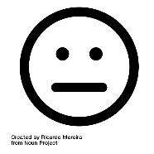
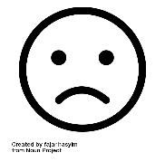
Place each method onto the scale. Explain why you have placed it there.

