How to make Biofuel Briquettes -- A Guide for Dummies

What you will need:
- Steel oil drum (55 gallon or similar)
- Biomass (agricultural waste such as rice husks, coconut husks, etc)
- Three bricks to raise drum off the ground
- Wood to start inital fire
- Large bags to crush charcoal in
- Corn starch
- Boiling water
- A briquette press (see design)
- Sheet metal/tile (to seal the drum)

The process:

Create the kiln:
- Cut a square hole in the top of the drum, 8cm from the edge
- Cut 9 small air holes in the bottom of the drum for air flow
- Create a lid out of sheet metal, large enough to cover the square hole

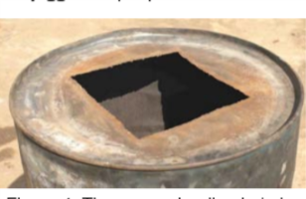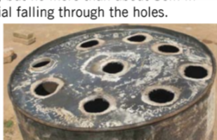

Burning the biomass:
- Place a large stick through the centre of the drum
- Fill the drum with no more than 16kg of biomass, ensuring air flow through the drum
- Remove the stick, leaving a hole through the biomass to the bottom
- Poke flammable material through the bottom of the drum so it is sticking out the holes (about 20cm sticking out, this is the wick)
- Start a small fire in between the bricks using wood
- Carefully sit the drum on the three bricks raised off the ground (note: these bricks will be removed once burning)
- Light the wicks at the bottom first, followed by the top of the material (drop through the central hole)
- Burn material in oil drum kiln for 10 min until white smoke starts to get darker, thicker and yellower. Light a match and throw it on top of the drum, if it is too soon the smoke will not ignite. If the timing is right, the smoke will catch fire
- Allow material to burn for another 10 minutes

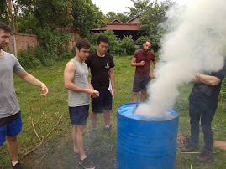
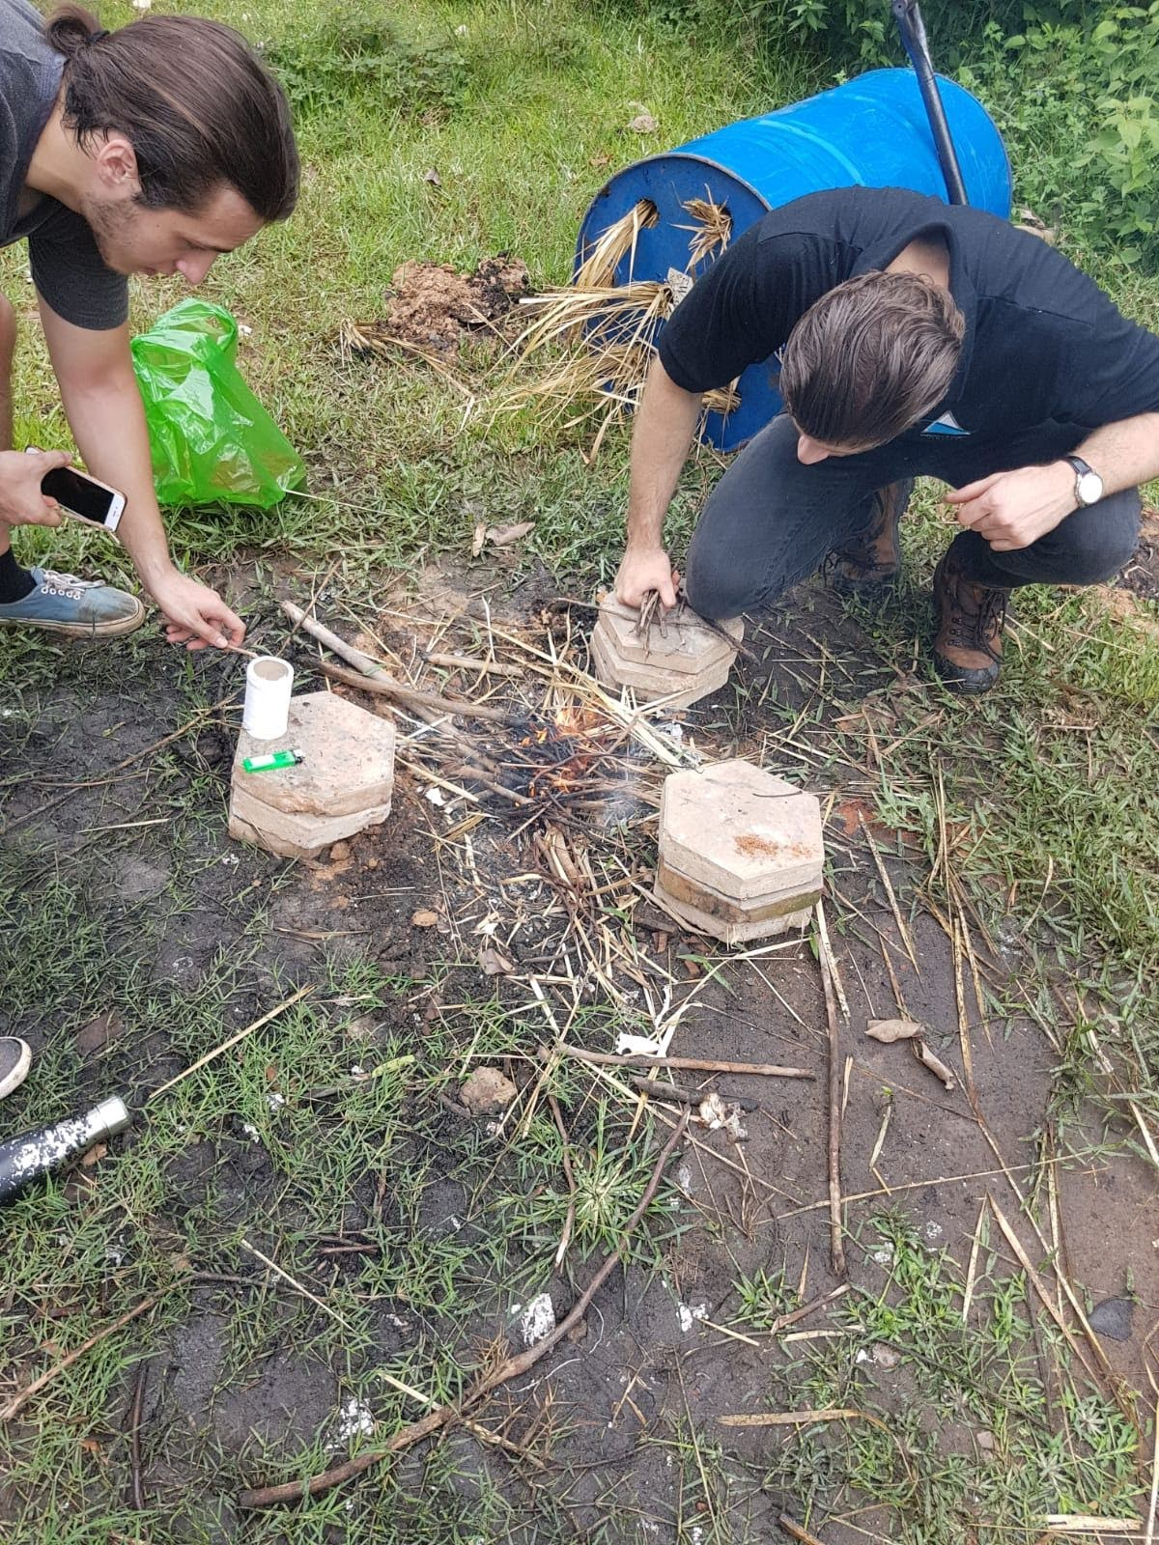

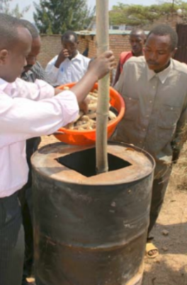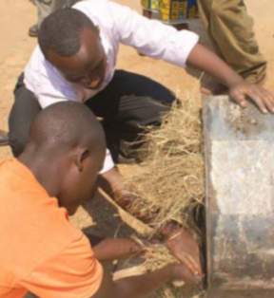

Sealing the drum:
- Place the lid on the top of the drum (if flames shoot out from the edges, it is not yet ready to be covered and should be allowed to burn for longer)
- Carefully remove the three bricks underneath the drum one by one, taking care to not topple the drum. This should be done with a stick and multiple people.
- Once the drum is resting on the ground, seal the edges by throwing sand or dirt around the base of the drum.
- Allow the material to carbonise for 2-3 hours, ensuring no one touches the drum

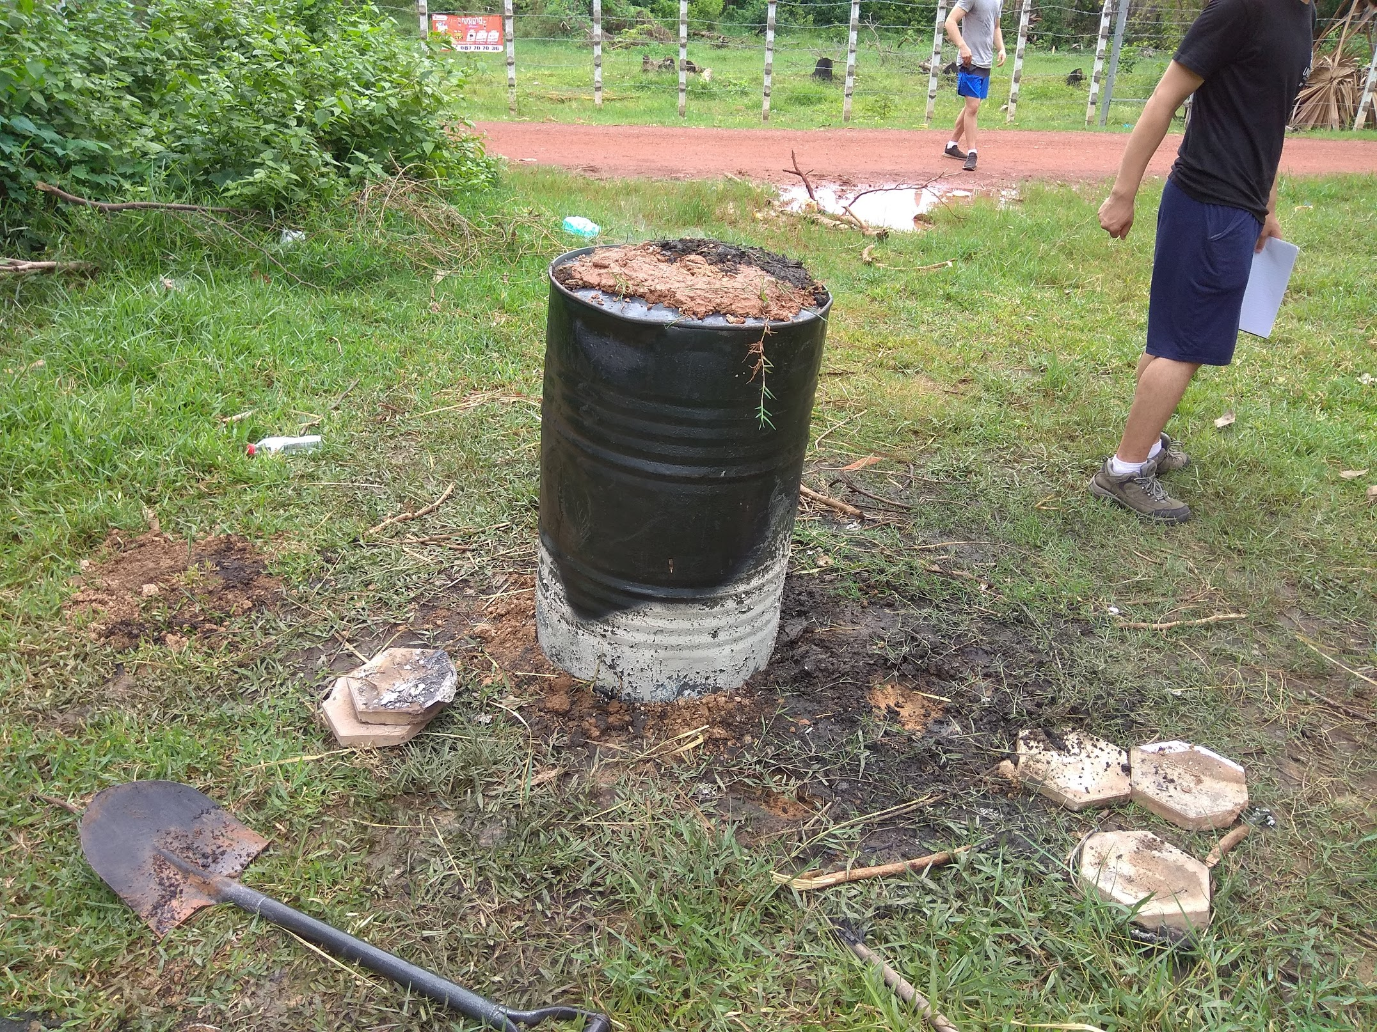
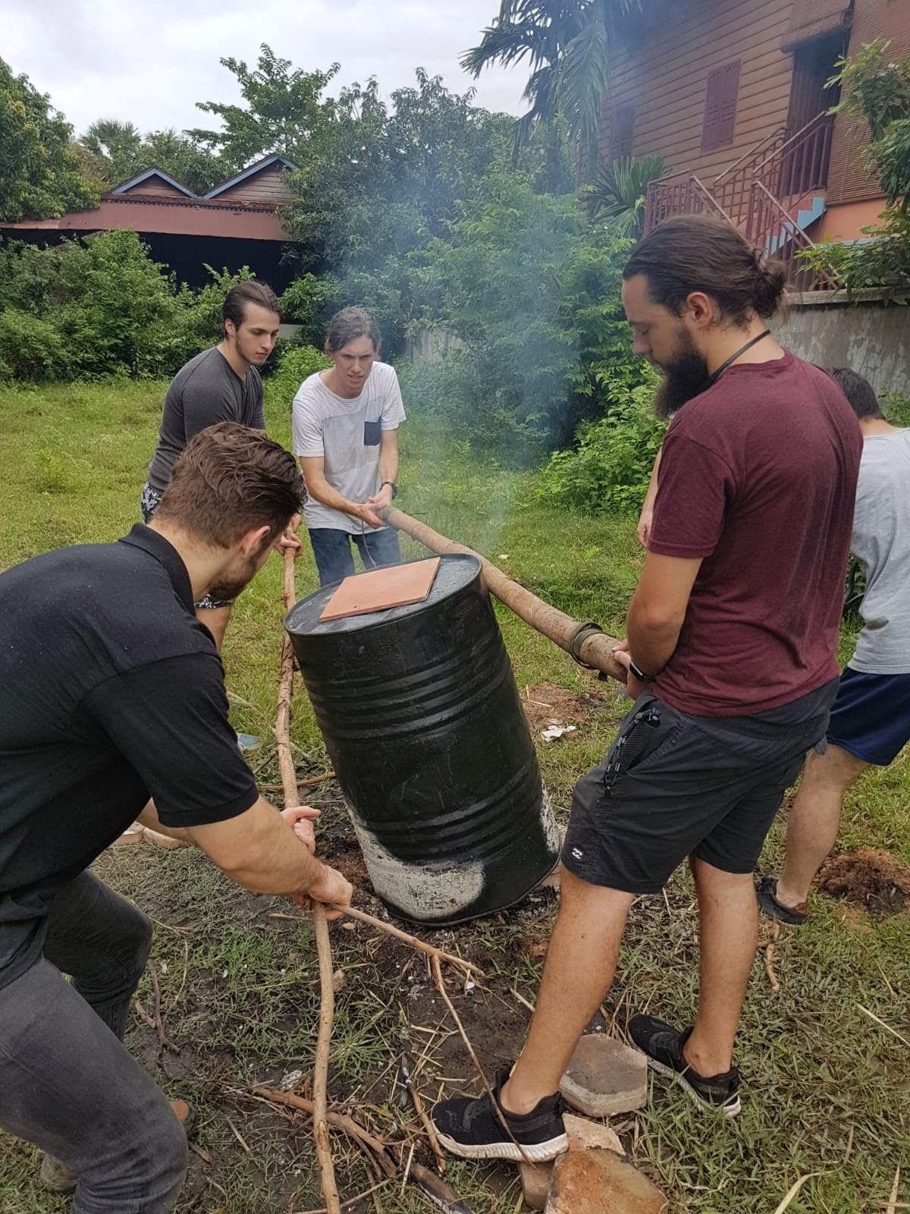

Making the powder:
- After 2-3 hours, pour the contents of the drum onto a sheet and remove any non-carbonised biomass
- Pour the carbonised biomass into a large sealed bag and sprinkle some water inside to minimise dust
- Seal the bags and crush the biomass into charcoal powder (should be easy to crush by hand)
- Continue to remove any non carbonised material, until the charcoal is a fine powder

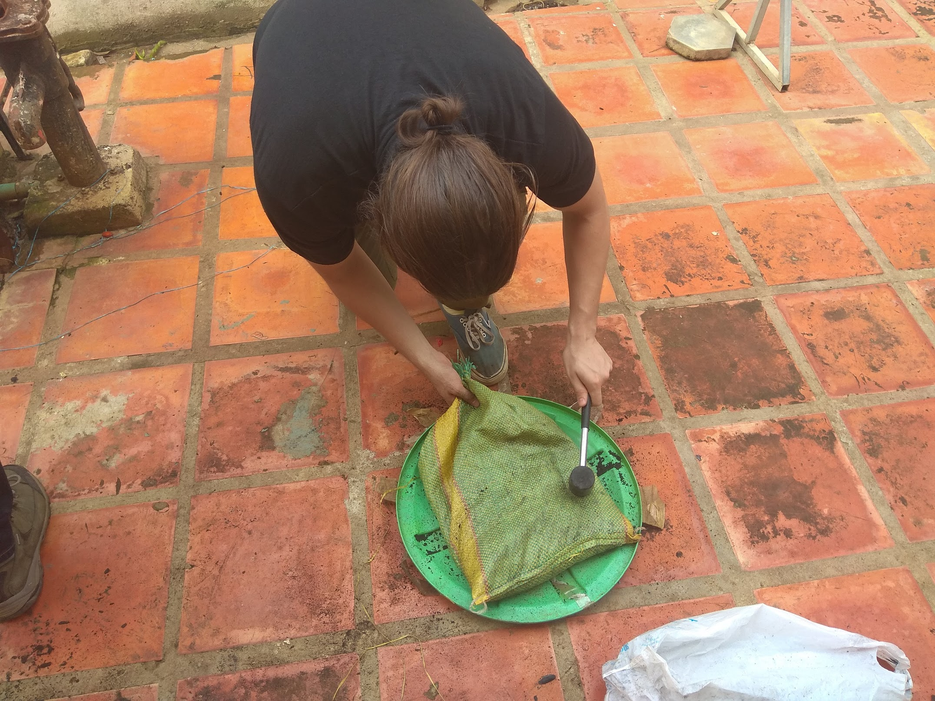

Preparing the binder:
- Add corn starch to hot water to form a thick porridge in a bucket, the starch will clump but can be broken up with stirring
- Continue to add water or starch until the consistency is that of porridge
- Add the mixture to the charcoal powder and mix through
- Test if the mixture is ready by compressing with hands, if the ball falls apart the charcoal needs more binder. Continue to add until clumps can be formed by hand and hold their shape.

Pressing the briquettes:
- Place the mixture into the briquette press
- Press the briquettes, removing as much water as possible
- Allow them to dry in the sun for at least 2 days (alternatively accelerate the process over heat)
