STUDENT WORKSHOP PLAN

- Personal Introduction
- Project Everest Pitch/Explanation (incl. Information as to why we are interested in having interns from the university and what their role would be)
- Activity 1: Ice-Breaker
- Activity 2: My Ideal Farm
- Activity 3: 5 windows & a door
- EOI collection form

1. PERSONAL INTRODUCTION
- Hi my name is …. and I work for Project Everest etc.

2. PROJECT EVEREST PITCH/EXPLANATION (incl. Information as to why we are interested in having interns from the university and what their role would be)
- Powerpoint we used is in the drive under ‘Workshop Presentation’
- Explain the company: why it started, how it works
- Explain the company in your COUNTRY: e.g. in Timor Leste we are doing 3 projects (agriculture, energy & recycling)
- Explain the AGRICULTURE project (e.g. regions you are looking into, the type of research you are doing…)
- Explain why we are looking for interns (e.g. data collection, brainstorming workshops…)
- Explain what the process will be (e.g. selection today, contact Monday, training re. forms/soil tests/interviewing skills, interviewing, potential long-term work with Project Everest)
- Explain what we are looking for in Interns (e.g communication & english skills)
- Explain that they will get a certificate for their work with us
- Any questions?

3. ACTIVITY 1: ICE-BREAKER
- To warm them up - get them to raise their hands if the statement is true for them
  - Raise your hand if...you grew up on a farm
  - If your parents are farmers
  - If you are in first year of university
  - If you are in second year etc.
  - If you are an agronomy major
  - If you are a socio-economic agriculture major
- General scenarios with two options… (get them to move to different sides of the room depending on their answer…)
  - Do you have more than 4 siblings? (e.g. if yes then go to the Left, if no then go to the right side of the room)
  - Do you like Messi or Ronaldo better? (Timor-Leste has a big soccer culture)
  - Do you like Australia or Spain better?
  - Do you want to go to Australia?
- Farming scenarios with two options… (same as one above)
  - Do you live more than 1 hour from Dili (capital of Timor Leste)
  - Do your parents sell their crop in local markets or the supermarket?
  - Do you want to be a farmer when you leave university?
  - Are your parents independent farmers of are they part of a farm group?

4. ACTIVITY 2: MY IDEAL FARM
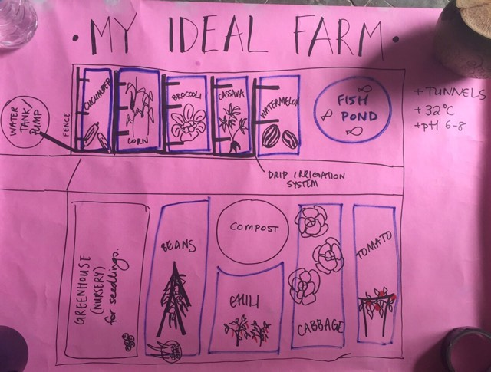

- Above is the example we showed students of our ideal (but realistic farm)
- Explain that we have been visiting farms and have seen these technologies on farms in Timor Leste
- Split them into 5 groups (of around 3-4 students) and got them to draw their ideal farm using the methods/technologies they had…
  - Seen
  - Learnt from their parents
  - Learnt at University
- They then presented and asked each other questions about their models

5. ACTIVITY 3: 5 WINDOWS & A DOOR
- Explain that you have been interviewing farmers etc. about the major challenges that farmers face in Timor Leste
- Get them to suggest the main challenges that they have observed/studied
  - Write these on a whiteboard/poster
- Get them to pick e.g. the most important 3-5 (interesting to see their priorities)
- Split people into groups again and assign 1 challenge to each team
- Get them to fill out the following diagram of solutions in different circumstances…
- Discuss

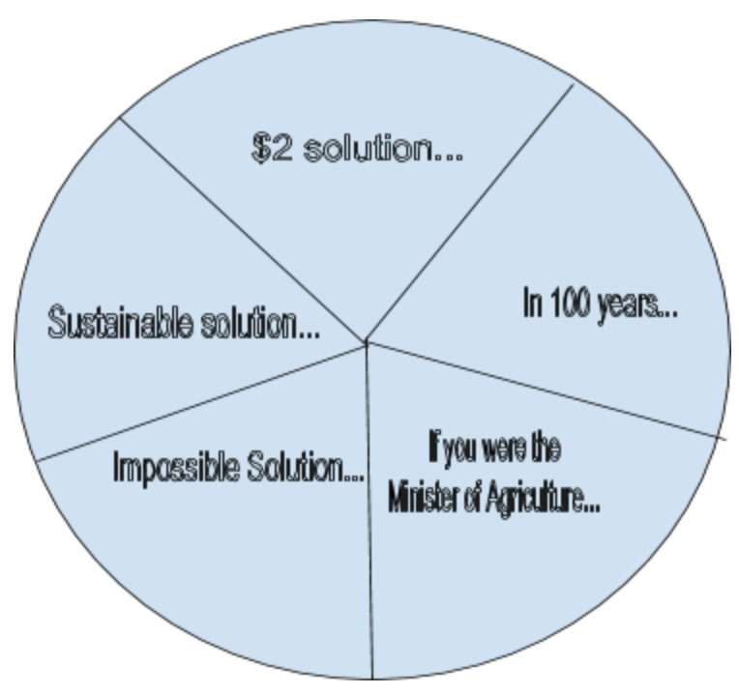

6. EOI COLLECTION FORM

Full name | Phone Number | Uni Major | Workshop Feedback (& rate/10) | English skills (observation) | General comments | Availability

Suggestions/potential changes
- Start with an ice-breaker rather than the Project Everest pitch
- Add diagrams to Powerpoint Presentation/as much as possible (good for dealing with language barriers)
- Go prepared! (Take e.g.s of everthing and practice running through it before you go)
- Work on pitching/public speaking skills - confidence, relax, body language etc.
- Have fun with it!
- If you are taking down intern names and trying to choose a small list later → either take pics of them or get them to wear name tags so they’re easier to remember

