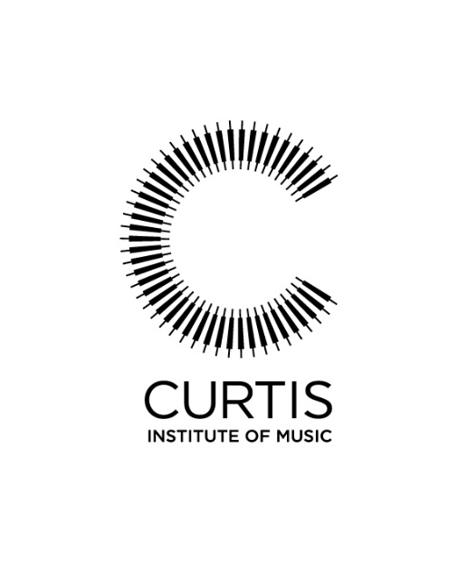
Avery Gagliano Biography
Current as of June 2024. Please do not edit without permission.

Celebrated as “a distinctive young talent” (International Piano), pianist Avery Gagliano is recognized for interpretations with great emotional depth and a “distinctly narrative approach” (Miami International Piano Festival). Having first risen to international acclaim as the winner of the First Prize and Best Concerto Prize at the 2020 National Chopin Piano Competition, she has performed in prominent international venues including Carnegie Hall, Warsaw Philharmonic Hall, the Louis Vuitton Foundation, Salle Cortot, Luxembourg Philharmonie, Ehrbar Saal in Vienna, and La Grange au Lac in Évian.
Avery’s 2024-25 season includes performances with the Buffalo Philharmonic and Orchestra i Pomeriggi Musicali in Milan, as well as recitals in Miami, Key West, Washington, Vancouver, Berlin, and Warsaw. A Finalist of the prestigious 2025 American Pianists Awards, she will also be featured as a soloist with the Indianapolis Symphony and the Indianapolis Chamber Orchestra.
In recent seasons, Avery has appeared with orchestras such as the Louisville Orchestra, Maryland Symphony, and Rochester Symphony, as well as in recitals throughout Europe at the invitation of Sir András Schiff for his Building Bridges series. She has performed at leading festivals including the Verbier, Gilmore, Aspen, Bravo! Vail, Sanibel, and Miami International Piano festivals, and is an alumna of the Gstaad Piano Academy, Lieven Piano Foundation, and the Lang Lang International Music Foundation’s Young Scholars Program. A sought-after collaborator and dedicated chamber musician, she regularly shares the stage with ensembles such as the Balourdet Quartet and New York’s Jupiter Symphony Chamber Players.
Avery’s debut album, Reflections (Steinway & Sons, 2021) features repertoire at the heart of her music making, including works by Chopin, Haydn, Schumann, and Adès. Her interpretations of works by Chopin have been hailed as “revelatory” (New York Classical Review), while recent programs have featured her passion for Schubert’s late piano sonatas and highlighted lesser-known works. Her performances have been broadcast across the United States on leading radio programs such as Chicago’s WFMT, Philadelphia’s WRTI, NPR’s From The Top, and the celebrated American Public Media show Performance Today, where she is a 2024 Young Artist in Residence.
Avery is a recent graduate of the Curtis Institute of Music, where she studied with Robert McDonald, Gary Graffman, and Jonathan Biss. In Fall 2024, she joins Sir András Schiff’s Performance Programme for Young Pianists at the Kronberg Academy in Germany. For more information visit averygagliano.com

