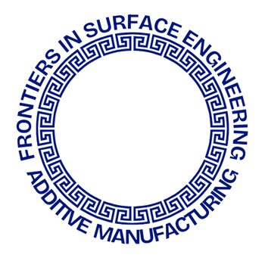


International Conference
on Frontiers in Surface Engineering and Additive Manufacturing

IIT Kharagpur, India

Title of the Paper (Times New Roman Bold 12 pts)
Author 1ª*, Author 2^{b}, Author 3^{b}, Author 3^{c}..............(Times New Roman 12 pts)
ª Affiliation 1, ^{b} Affiliation 2, ^{c} Affiliation 3
Email :

Abstract (Times New Roman Bold 12 pts)
Abstract must be written with max 250 words in Times New Roman font size 12. Single-space within paragraph, double-space between paragraphs, Image inserts acceptable, 1 inch margin on four sides. In any case, the total abstract including references should not exceed ONE page. Contents of more than a page shall not be included in the final accepted version for printing.

key words :

