**AUTISM AWARENESS**

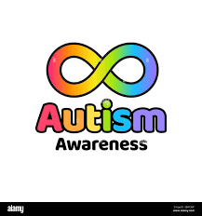



This year in St. Bernard’s, we are working towards gaining an **Autism Impact Award** for our school. Autism awareness is crucial for fostering understanding, acceptance and support for children with ASD in Primary Schools.

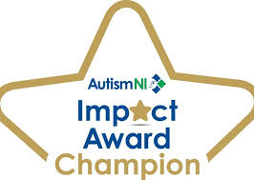

**Understanding Autism Spectrum Disorder (ASD)**

***WHAT IS AUTISM?***

Autism is a developmental condition that affects how individuals communicate, interact socially, and process information. It’s called a ‘spectrum’ because the challenges and strengths of individuals with autism vary widely.

Common signs of Autism in Primary School-Aged Children

1. Difficulty with social interactions (e.g; making friends, interpreting social cues, making eye contact)
2. Delayed or atypical speech and language development
3. Sensory sensitivities (e.g; to sounds, lights, textures)
4. Restrictive or repetitive behaviours or intense focus on specific interests
5. Preference for routine and difficulty adapting to change
6. Walking on tip-toes or hand-flapping
7. Monotone voice or use of odd tone/accent when speaking

If you have concerns about your child and think that they match some/all of the profile above, get in contact with your GP. Get in touch with school also and have a chat with your child’s teacher to see if they notice any of the traits too. Understanding the signs of autism can help you to seek early intervention, which is critical for skill development and academic success.

Please see below some useful links where you can find further information on Autism including advice, support networks, resources and up and coming opportunities.

1. **Autism NI** – <https://autismni.org/>
2. **Autism NI Family support team** - <https://www.familysupportni.gov.uk/Service/6388/carers/autism-ni--support-groups-all-of-ni>
3. **Middletown Centre for Autism** - <https://www.middletownautism.com/>
4. **National Autistic Society** - <https://www.autism.org.uk/what-we-do/families/families-ideas-for-days-out/northern-ireland>
5. **The Autism Society -** <https://autismsociety.org/>

Please keep an eye on our **Facebook Page** and **Website** for further up-to-date information on Autism Awareness!

