Abstract Title (Bold, 16)
A. Author^{1*}, B. Author² and C. Author³
¹Affiliation and full address of A. Author
² Affiliation and full address of B. Author
³ Affiliation and full address of C. Author
* e-mail address of the corresponding author
This is a template for the preparation of the abstracts submitted to the International Conference on Scientific Advances in Natural and Technological Sciences (SAINTS) 2027. Formatting of text sizes and fonts (Arial 10) for the main body of the abstract), margins, spacing (simple), paragraphs, page, etc. have been chosen to normalize the final contents of the book of abstracts. Therefore, the organization thanks the authors for preparing the abstract following this structure, without changing the format parameters.
Keywords: The author should add 3-5 keywords.

Abstract
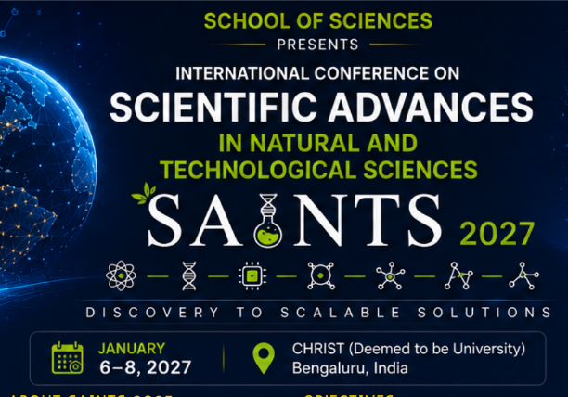
This document should be prepared in MS Word format. If you are pasting a prewriting text, chose the option “keep text only” when paste, writing later the special characters (Greek, symbols, super/subscript, etc.). The best option is to write directly in this template document, substituting the text of the sections. Please note that the abstract should be a single paragraph and should not exceed 1 page. All submissions must be written in clear English. If required a figure or a table can be included in the abstract. The caption of figures and tables should be formatted in Arial 8. “Table x” and “Figure x” in the caption should be formatted in bold.
Figure 1. Example of image and caption.

REFERENCES
[1] Staffell, I., Scamman, D., Velazquez Abad, A., et al., The role of hydrogen and fuel cells in the global energy system. Energy & Environmental Science, 2019, 12, 463–491.
[2] Züttel, A., Hydrogen Storage: Methods and Materials. Springer, Berlin, 2008.

