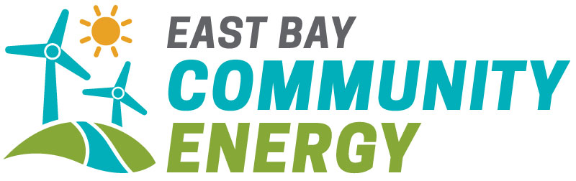

East Bay Community Energy
2018 California Renewable Energy
Request for Proposals

Exhibit A: Notice of Intent to Bid Form

This Notice of Intent to Bid (“NOI”) shall serve as notice to East Bay Community Energy (EBCE) that the company listed below intends to participate as a seller (“Bidder”) in EBCE’s 2018 California Renewable Energy Request for Proposals. Only Bidders that have submitted a valid NOI will be provided the answers to bidder questions regarding this RFP.
EBCE requires that the Bidder return the NOI by 5 PM PT on Monday, June 15, 2018 by email to eegrenewablerfp@edisonenergy.com with the subject line of: “EBCE Renewable Energy RFP NOI – [Developer Name].”
Contact Information:
Company Name

Bidder Primary Contact Name

Bidder Primary Contact Title

Bidder Primary Contact Email

Bidder Primary Contact Phone

Bidder Secondary Contact Name

Bidder Secondary Contact Title

Bidder Secondary Contact Email

Bidder Secondary Contact Phone

(on the next page, please indicate company’s initial plan for proposals)
Initial plan for proposals:

 | Project 1 | Project 2 | Project 3 | Project 4 | Project 5 | Project 6
Technology

County

Expected COD
Proposed Settlement Locations (please check all that apply):

Pnode

PG&E DLAP

SCE DLAP

SDG&E DLAP

NP-15

SP-15

ZP-26

The chart above is intended to provide an indicative sense of projects East Bay Community Energy will see. Company is not required to submit bids that match the above chart.

