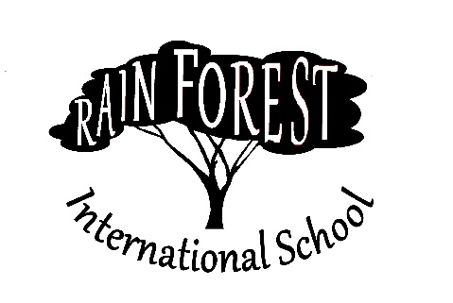

JOB POSTING – SCHOOL YEAR 2023

**Title:** Library Media Specialist

**Line of Authority:** Reports to RFIS Director of Academics

**Staff Reporting to the Library Media Specialist:** Library Clerk, Assistant Librarian

**Goal:** To enable students to use the library efficiently and effectively for academics and pleasure in order to prepare them for the next stage of life and life-long learning; to enable staff to find the resources necessary to supplement curricular needs.

**Key Result Area #1 – Daily Running of Library**

**Key Result Area #2 – Collection Development and Management: Curricular and Student Interest**

**Key Result Area #3 – Teaching Information Literacy**

**Key Result Area #4 – Collaboration with Teachers**

**Key Result Area #5 – Technology/Media**

**Key Result Area #6 - Professional Development**

**Key Result Area #7 – Personal Development**

Rain Forest International School is a school located in Yaounde, Cameroon serving grades 6-12. RFIS was founded in 1991 to provide missionaries in this part of Africa with an excellent academic program for their children. Today, RFIS serves mission families from all over the world, as well as students from Cameroon.

RFIS offers a Christian academic, social, athletic, artistic and spiritual environment that prepares students for their next stage of life. We are looking for people with a passion to transform lives who possess specific skills and abilities, as well as a desire to partner with a mission organization to provide partnership development to supply your financial needs while your serve.

For more information, please visit our website at [www.RFIS.org](http://www.RFIS.org) , or email the Director at [RFIS-Director@rfis.org](mailto:RFIS-Director@rfis.org).