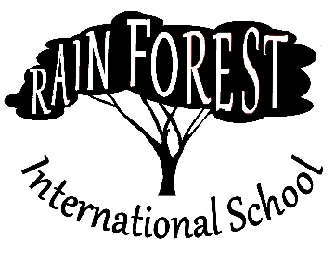
JOB POSTING – SCHOOL YEAR 2023
Title: 6th Grade Transition Teacher
Line of Authority: Reports to Director of Academics
Goal: To provide for the education needs of 6th grade Cameroonian students in a semi-sheltered classroom, preparing them for the rigors and culture of the American school system. This position will require knowledge of the English Language Learner best practices or TESOL experience.

Key Result Area #1 – Course Planning & Preparation
Key Result Area #2 – Instruction
Key Result Area #3 – Assessment
Key Result Area #4 – Professional Responsibilities
Key Result Area #5 – Professional Development
Key Result Area #6 – Personal Comportment and Development

Rain Forest International School is located in Yaounde, Cameroon serving grades 6-12. RFIS was founded in 1991 to provide missionaries serving in this part of Africa with an excellent academic program for their children. Today, RFIS serves mission families from all over the world, as well as students from Cameroon.
RFIS offers a Christian academic, social, athletic, artistic and spiritual environment that prepares students for their next stage of life. We are looking for people with a passion to transform lives who possess specific skills and abilities, as well as a desire to partner with a mission organization to provide partnership development to supply your financial needs while your serve.
For more information, please visit our website at www.RFIS.org , or email the Director at RFIS-Director@rfis.org.

