[Insert Community Hero Name]

[Insert Community Hero photo]

[Insert Community Hero Description]
[Hi, I’m Tanisha and I have been Quit for 5 years, I quit smoking for the health of myself and for my children. I started smoking when I was 15 years old due to peer pressure and I smoked for 10 years.]
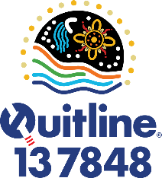
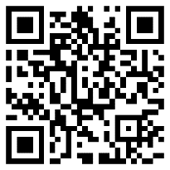 | Call your Aboriginal Health Service on _______________  or AQL 13 7848 for support in quitting smoking. |  | [Insert Health Service logo]

