The Heinz Leadership Training Program

Zerinee, Ally, Moe

Table Of contents

List of Illustrations………………………………………………………………………………...1
Executive Summary……………………………………………………………………………….2
Introduction………………………………………………………………………………………..3
Leadership style 1
Leadership style 2
Leadership style 3
Leadership style 4
Conclusion…………………………………………………………………………………………
References………………………………………………………………………………………....

List of Illustrations

Figure 1 Kraft Heinz has lost about 64% of its market value since 2017 5

Executive Summary
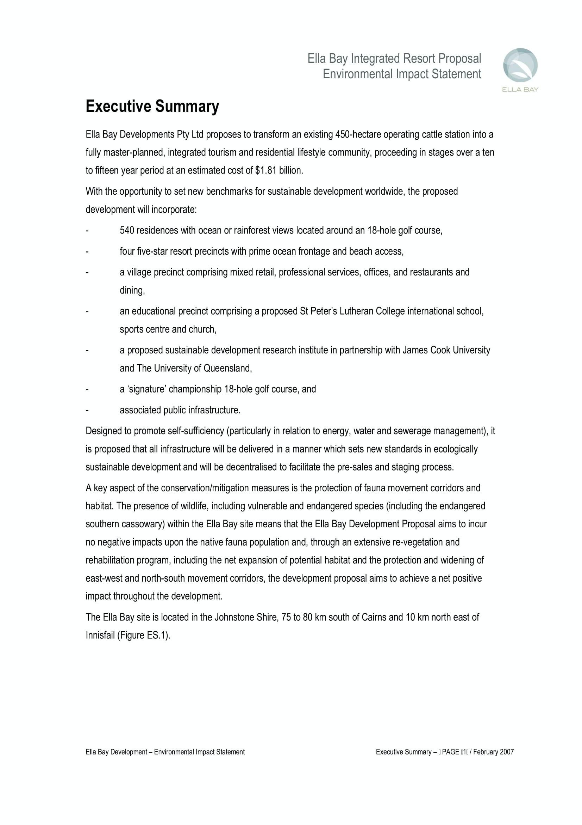

Introduction

Heinz Ketchup, established in 1869, has been a leading ketchup brand in the market for over 100 years. Heinz Ketchup is a product manufactured by the H.J. Heinz Company which has a headquarters in Pittsburgh, Pennsylvania. In 2013 Heinz was bought out by Warren Buffett and Berkshire Hathaway for a whopping 23 billion dollars. When this purchase became implemented the new owners partnered with a Brazilian PE Firm, 3G Capital. As a result of this partnership, the Brazilian firm was able to cut expenses. What Buffet and Hathway didn’t consider was how cutting expenses would affect the company. Little did they know Heinz would begin to fall apart.

These expense cuts greatly affected employees at Heinz and ultimately resulted in low turnover and low satisfaction amongst employees. Manufacturing plants shut down which left hundreds of employees jobless and left room for layoffs. Employees could no longer feel comfortable at work considering they were no longer allowed free products and couldn’t even have a mini-fridge at their workstations. Employees began to feel unvalued and started to see the workplace as a school where they had to ask permission to do anything. In order to make a copy, an Employee had to ask permission, and with that permission granted no color printing was allowed and everything was required to be double-sided. As Buffet began to install executives, employees began to get scolded and were told there is not a work and family balance. Heinz was implying that all employees should be devoting all of their time to the company. Heinz's poor decision to cut expenses resulted in the company neglecting their employees.

Although these issues occurred for two years, in an effort to try to resolve their expense issue, Heinz purchased Kraft. In doing so, Heinz disregarded the neglect his employees were already facing and now expected them to combine and work with a new company with its own employees. Heinz was eager to dig their way out of debt but how far was Heinz willing to push their employees in order to do so?

Heinz needs to develop a way to implement a top-down training program that will be centralized on one primary leadership style. In this report, various leadership styles will be examined to help determine which style the organization should utilize in the training process.

Body Paragraphs
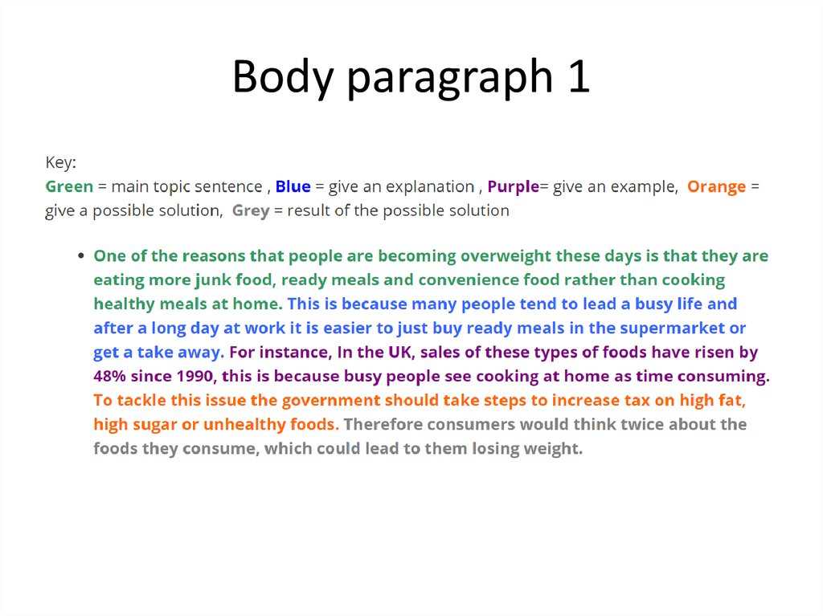
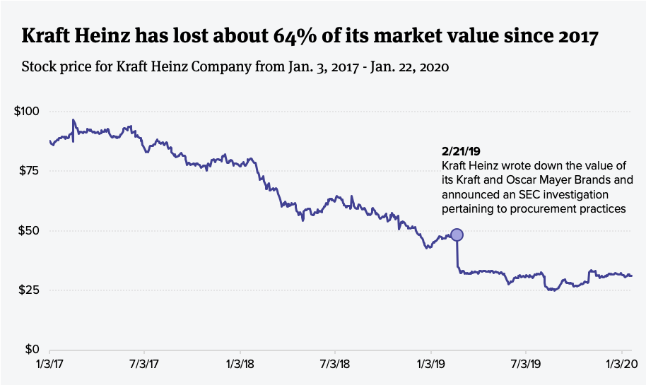

Conclusion
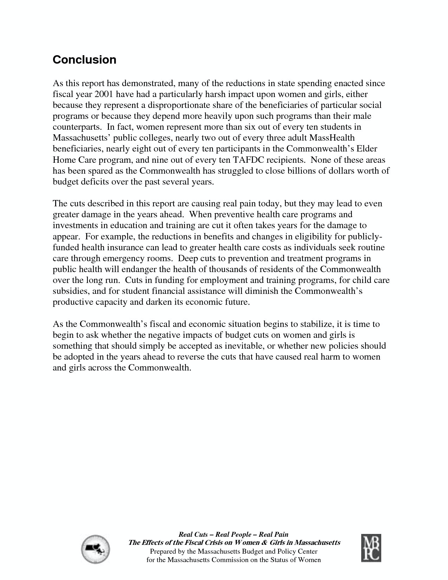

Appendix ?? supporting information- employee training manual- more detail about what essay says

References
(APA formatting)...We need 7+ sources

https://reallyright.com/2019/03/29/kraft-heinz-co-is-melting-down/

https://www.themuse.com/advice/common-leadership-styles-with-pros-and-cons

https://www.cnbc.com/2019/05/07/misconduct-at-kraft-heinz-puts-spotlight-on-pressure-to-meet-targets.html

Images

https://www.ciodive.com/news/kraft-heinz-cio-data-analytics/570165/ figure 1

Goal-You need to articulate your analysis and present your argument to persuade your audience to be on board with you.

Assignment Scope
You work for an executive coaching firm that has been hired by the CEO of [Heinz Company]. The company has been struggling with high employee turnover and low satisfaction as it relates to company leadership. Your firm has been brought on to develop a top-down training program that will be centralized on one primary leadership style. To determine the most appropriate style for this company, you will analyze four distinct leadership styles of your choosing (e.g. servant, authoritative). Research the common characteristics of each style (including communication strategies), analyze the types of organizations in which those styles are best and least suited to succeed as well as how each style would fare within the organization you’ve chosen for this project. Make a recommendation for which style (or two styles) the organization should utilize in the training.
In your formal business report, you should focus on business-influencing factors that are relevant to the client company’s business. In broad sense, those factors could fall into such environmental categories as: economic, political, cultural/social, and technological, along with market demand, competition, infrastructure, etc.

Formatting Standards
- Write an analytical formal business report as a team
- Employ the direct strategy to disclose recommendations first and then elaborate on analysis (stating facts don’t provide my opinion as much, cut to the chase)
- Include appropriate graphics as needed (7-10) original or referenced graphics are usually expected)

ally | Title page$✔$ | intro✔ | - Executive summary  - 1 leadership body paragraph | 3 graphics
zz | Table of contents✔ | references✔ | 2 leadership body paragraphs | 3 graphics$✔$
moe | list of illustrations (more than 3) | Appendix? | - 1 leadership body paragraph  - Conclusion | 3 graphics

