SWM517: Organ Donation Policy

Executive Summary
To the Minister of Health, Mr Greg Hunt MP, and relevant Department personnel – the purpose of this document is to highlight the need to implement policy in regards to organ donation and support for organ donation recipients.
I will be putting forward three recommendations in regards to the wellbeing of patients within the health system; as well as providing the possible productivity outcomes associated with these proposed changes.
It is important that these changes to the system are implemented as soon as possible, to not only ease the impact on the health system, but to provide the best outcomes for patients.

Why is this issue important?
Organ donation is perceived to be a controversial topic within the Australian populace, but in fact 90% of Australians would seriously consider signing the relevant documentation if prompted by a family member to discuss the issue (Saul 2017). In reality, the average donations per million people (dpmp) is closer to 20.8 dpmp – meaning around 50% of the population would consider signing onto the program. Australia has had informed consent laws since 1982, and a donor registry since 2000 (Abadie and Gay 2006). So why is this the case?
Australia currently has an Opt-In system for organ donation, for deceased persons (cadaver-sourced) under the program titled “Donate Life” (Department of Health 2013). The program is first offered to citizens when applying for their Learner’s Permit and Probationary Licence, and requires parental consent to fill out the form. The purpose is to promote discussion, rather than forcing citizens to act immediately on committing to organ donation after death or accident. After obtaining a full licence in adulthood, the individual is prompted at licence renewal to sign the forms (Department of Human Services 2017). There is also some scope to living transplants, mainly in regards to kidney and partial liver transplants (Alexander, Clayton and Chadban 2017). Cadaveric donation is, however, sometimes the only option for patients.
However, the current program is not enforced, as it is considered an informed consent or ‘Opt-In’ system. In some cases licences are renewed by spouses or parents on behalf of an individual, therefore, the prompt to sign up to the program does not occur. The consequences of this do have a severe impact on the system; and as aforementioned, with 90% of the populace prepared to sign on, it seems conflicting that Australia currently suffers from a substantial waiting list for patients.
As of 2016, the Opt-In system meant that 1400 patients were awaiting organ donation (Department of Human Services 2017). Of these, it is only likely that about 200 will receive an organ transplant during the 2016-2017 year, and some patients have to wait up to 3 years, relying on a pager to notify them when to get to the required hospital (Saul 2017).
A costing study (Jarl and Gertham 2011) evaluated data from 1987 to 2008; with the purpose of seeing what the overall profit would be based upon known studies. They determined the following: Kidney transplantation saved roughly $20000 per year and added six years of life; Liver transplantation saved $45000+ per year, adding 5 years of quality life (Sagmeister, et al. 2002); Lung transplantation in excess of $100000; and heart transplants between $50000-$100000 per year, adding on average seven years of life.
This was after the costs had been taken for surgery, pre and post operational procedure, and other common health costs (Jarl and Gertham 2011) (Sagmeister, et al. 2002).

What does research tell us?
The following aggregate data highlights the extent of organ donation in Australia. Figure 1 shows the national average donations per million people for 2016. The average was 20.8 donations per million people, which is roughly 500 donations per the entire populace of 24 million people; and a percentage of 0.002%.
With some of the more populous states such as New South Wales and Queensland below the national average; and with Victoria only slightly above, this is a concern.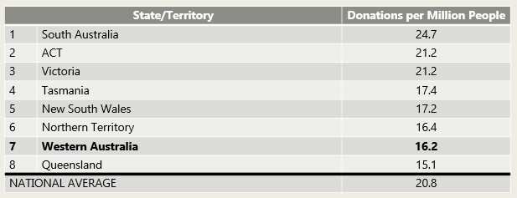
Figure 1- SOURCE: (Department of Human Services 2017)
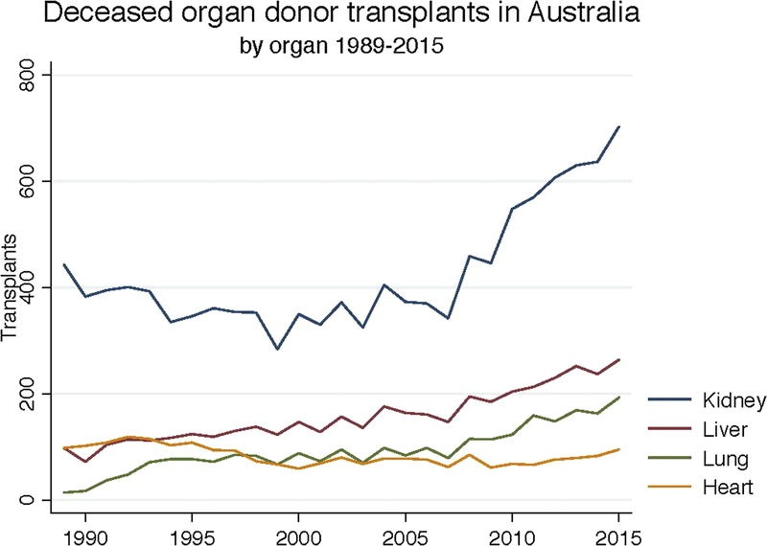
The trend for cadaveric organ donation, specifically type of organ transplanted, is also available for the quarter century between 1990 and 2015 (Figure 2, below). Kidney and Liver transplants are the most common in Australia, which may be related to alcohol and drug consumption (Gunn 2013).
The overall trend is increasing, however the waiting list is growing too – over the 2015-2016 period, 500 people were added to the waiting list even though 400 received transplants (Australian New Zealand Organ Donation Registry (ANZOD) 2017).
Figure 2- SOURCE: (Alexander, Clayton and Chadban 2017)

Table 1- Actual Deceased Donors: Organ retrieval with the purpose of transplantation. The organs may have been deemed unfit for use after surgery. SOURCE: (Australian New Zealand Organ Donation Registry (ANZOD) 2017)
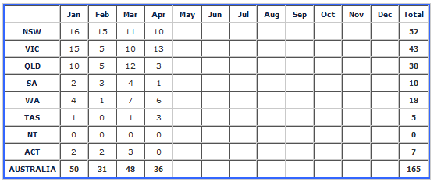
In Table 1, above, are the numbers for cadaveric organ retrieval so far in 2017. This is the most up to date data. Not all of the organs will be fit for transplantation- issues include cancer, contamination, partial or total organ cell death, incompatible immune antigens.
There may also be rare instances whereby organs are transplanted, but the host body rejects the organ/s biologically. As such, this is not an accurate representation of the true number of successful transplants. Arguably, the point is that even if 165 transplants took place in this portion of the year, and all were successful, then there is still a waiting list of at least 1235 patients.

What are the implications of the research?
Presumed consent countries have on average 17.29 cadaveric donors per million population per year, 3.10 more than informed consent countries. This difference, however, is not significant at conventional test levels (Abadie and Gay 2006). Through examination of consent laws, where a presumed consent, Opt-Out program was legislated, there would be a hypothetical increase of 25-30% organ donation within the first several years (Abadie and Gay 2006). This implementation would not have an immediate impact, however over time will decrease waiting lists. It is particularly the case if organs from living rather than cadaveric sources were promoted; and more so if xenomorphic material was used.
Within Australia, there is still a disparity between rural and regional health, indigenous health, and urban health. This is also evident with trends for organ donation. Investigating the specific example of kidney transplants within rural and regional Australia, Indigenous women were more likely to be stuck on dialysis than any other group; and indigenous men and women were less likely to commence treatment within their home or locality (McKercher, et al. 2017). The burden of renal disease specifically is understated as it is often not attributed as a cause of death within the Indigenous population (Hoy, Mott and McDonald 2016).
Indeed, research in regards to kidney transplants in children from rural, remote and regional areas determined that regardless of heritage, these children were 35% less likely to be offered a transplant due to their location (Francis, et al. 2016).
The saving of costs, as previously stated, can only be hypothesised, but would be close to $1 million per year of quality life per person (Jarl and Gertham 2011). In Australia, this would be close to $1 billion in savings per year. There is still a lack of data in regards to costs; and a strong recommendation is to further investigate this aspect of the issue.

What other countries experiences tell us?
For a full list of countries and organ donation laws, see Appendix 1 (Abadie and Gay 2006) (Almaslamani, et al. 2016). From the data gathered, the majority of the European continent has adopted laws similar to Spain with an Opt-Out legislation. The laws were used as a model for many nations. Australia, the United States of America, and the United Kingdom have Opt-In legislation.
As aforementioned, Spain currently has the most robust and successful laws in relation to organ donation. Brazil and Vietnam are quite successful in their implementation of organ donation laws. New Zealand is considered to have some of the least effective organ donation laws (Abadie and Gay 2006) due to the inclusion and significance of Maori and Polynesian cultures within the New Zealand constitution.
SPAIN
Spain currently has an organ donation plan which is Opt-Out. The country has a population of roughly 46 million people, and an organ donation rate of 36 per million (Abadie and Gay 2006). This is adequate enough to keep the waiting list at 0. Since 1980, the estimated savings from kidney transplants alone in Spain has been $50 million (Miranda, et al. 1999) (Matesanz, A decade of continuous improvement in cadaveric organ donation: The Spanish Model 2001).
In 1989, the ‘Organizacion Nacional de Transplantes’ was formed. The purpose of this was to re-examine the current laws and regulations, and to see where improvement could be made. What was determined was that many citizens believed the solution to organ donation was strict presumed consent, however families should still be consulted (Matesanz, A decade of continuous improvement in cadaveric organ donation: The Spanish Model 2001).
To improve the system, a select team of doctors and nurses were given the title “Transplantation Specialist”, a new part time position with the sole purpose of discussing organ donation with families and patients. By placing at least one person per hospital for this position. This program saw a 10% reduction in the number of families refusing cadaveric organ donation (Matesanz, A decade of continuous improvement in cadaveric organ donation: The Spanish Model 2001). There is, however, a high emotional toll on the individual registered as Transplant Specialist, and as such they tend to burn out after 3-4 years (Matesanz, A decade of continuous improvement in cadaveric organ donation: The Spanish Model 2001). Plans have been implemented to increase the donation rate; and have indeed been successful in certain regions (Matesanz, Marazuela, et al. 2009).
BRAZIL
The country of Brazil has the second highest rate of organ donation in the world after Spain (Dal Pupo, et al. 2016). The legal framework relies on brain death, and the agreed international clinical definition of brain death. There is no legislative agreeance on cadaveric harvesting after circulatory death. Consent is then required from family before transplantation (Garcia, et al. 2015). There is also a requirement for donor cards to be on the person/s at time of death (Abadie and Gay 2006).
The Brazilian healthcare system provides universal coverage to every citizen (Garcia, et al. 2015), and the country has the largest public funded transplant program in the world. It covers 90% of transplantation, pre and post procedures, and immunosuppressive medication costs (Garcia, et al. 2015) (Dal Pupo, et al. 2016). From 1999 to 2014, the number of potential donors increased by 168% (Garcia, et al. 2015). In recent years, however, due to population growth and a lack of discussion, the issue of organ donation has become a pressing concern.
Some of the hurdles is that this system is an opt-in model; and requires members of the program to have their organ donation card on them at time of hospital admittance. There is also a lack of understanding of the model – indeed, in 2008 the waiting list was briefly at zero only due to a sports team campaign (Abadie and Gay 2006). Family consent is a key component of the culture in Brazil, and this is expressed in the laws pertaining to organ donation (Garcia, et al. 2015).
To encourage change, there is a national society – the Brazilian Society for Organ Transplantation – which is working on legal measures in regards to laxing laws on organ trade, which seems required to build influence and public trust in cadaveric transplantation (Garcia, et al. 2015).

Considerations for policy and programs
Recommendation (1): Organ Donation to become an Opt-Out, Presumed Consent program.
Objectives (1): Change the legislation through amending constitutional laws and policies.
There are multiple options for such a process:
a) Amending licensing laws to include a clause for opting out legislation (presumed consent);
b) Amending relevant ‘Medicare’ clauses and policies to include Opt-Out legislation (presumed consent) or to amend the wording and phrasing of ‘opt in’, ‘informed consent’ and/or ‘familial consent’.
c) Applying laws and negotiating with the states and territories of the Commonwealth of Australia to introduce clausations and laws to implement an Opt-Out, presumed consent program.
The goal will then be to decrease waiting lists as close to 0 as possible, and to maintain that status within the Australian health system.
Expected outcomes (1): Near-immediate decrease in waiting list times, in turn lowering the National wait list from 1400 to roughly 1000 within two years and a furthermore reduction after that date.
Reasoning (1): Despite Brazil maintaining an Opt-In approach, the country has a higher population – and subsequently support for organ donation is higher within the population – compared to Australia. Therefore an Opt-Out approach is required.
Recommendation (2): Better support for Australians, particularly those in Rural, Remote and Regional areas, who require organ transplantation. A major component of this is the adoption of ‘Transplant Coordinators’ from the Spanish Model.
Part of this program for better support is proposed to include local organ storage banks; better facilities for regional hospitals to accommodate organ transplantation; more training opportunities for physicians, surgeons and nurses in said areas; implementation of the Spanish Model of ‘Transplant Coordinators’; improved awareness within Indigenous populations about organ transplantation.
Objectives (2): To decrease the disparity between time until organ donation and life expectancy post operation of rural, remote and regional Australians, including but not limited to Indigenous peoples. A better understanding of the process and requirements of transplantation.
Expected outcomes (2): Decrease in the gap between life expectancies post transplantation; less wait times for patients in Rural, Remote and Regional areas. A better understanding of the process and requirements of transplantation from a patients’ perspective.
Reasoning: The Spanish Model asks for specially trained ‘Transplant Coordinators’ for each subregional hospital. This will not only create jobs for health professionals, easing the load for doctors and nurses, but will enable a better public understanding of organ donation. This is especially important in rural and regional Australia.

Recommendation (3): To set up further investigations into the costs of organ donation, the impacts on families of all socio-economic and cultural backgrounds, and to track this data more publicly than currently so.
Objectives (3): Determine the worth of organ transplantation to use as evidence for promotion of the issue; and to have a better understanding of the process and requirements of transplantation.
Expected outcomes (3): A better understanding of the costs involved; potential redistribution of funds for Medicare to facilitate those costs to taxpayers.
Reasoning: The overall cost to Australians should be noted for future comparison, and to provide limitations/goals for future legislative programmes.

References
Abadie, A, and S Gay. 2006. “The impact of presumed consent legislation on cadaveric organ donation: A cross-country study.” Journal of Health Economics 25 (4): 599-620. doi:10.1016/j.jhealeco.2006.01.003.
Alexander, S, P Clayton, and S Chadban. 2017. “Organ Transplantation in Australia.” Transplantation 101 (5): 891-892. doi:10.1097/TP/0000000000001621.
Almaslamani, Y, Almalki H, Fadhil R, Khalaf H, and M Asim. 2016. “Transplantation in Qatar.” Transplantation 100 (12): 2437-2488. doi:10.1097/TP.0000000000001475.
Australian New Zealand Organ Donation Registry (ANZOD). 2017. Summary of Organ Donation. 8 May. Accessed May 15, 2017. http://www.anzdata.org.au/anzod/v1/summary-org-donation.html#Donors.
Dal Pupo, B, M Zanon, A.W Tach, L.V Cruz, M Cornelli, C do Valle Pereira, J Bertoglio, et al. 2016. “Two-year Epxerience of the 'Organ Donation Week' of the Federal University of Health Sciences in Porto Alegre, Brazil.” Transplantation Proceedings 48 (7): 2250-2252.
Department of Health. 2013. The Australian Organ Donor Register. 03 July. Accessed May 7, 2017. http://health.gov.au/internet/main/publishing.nsf/Content/health-organ-aodr.htm.
Department of Human Services. 2017. Australian Organ Donor Register. 20 April. Accessed May 12, 2017. https://www.humanservices.gov.au/customer/services/medicare/australian-organ-donor-register.
Francis, A, Didsbury M, Lim WH, Kim S, White S, Craig JC, and Wong G. 2016. “The impact of socioeconomic status and georgaphic remoteness on access to pre-emptive kidney transplantation and transplan outcomes among children.” Pediatric Nephrology 31 (6): 1011-1019. doi:10.1007/s00467-015-3279-z.
Garcia, V.D, M Abbud-Filho, C Felipe, and J.M Pestana. 2015. “An Overview of the Current Status of Organ Donation and Transplantation in Brazil.” Transplantation 99 (8): 1535-1537. doi:10.1097/TP.0000000000000828.
Gunn, A. 2013. Essential Forensic Biology. 2nd. Chichester: Wiley-Blackwell.
Hoy, WE, SA Mott, and SP McDonald. 2016. “An expanded nationwide view of chronic kidney disease in Aboriginal Australians.” Nephrology 21 (11): 916-922. doi:10.1111/nep.12798.
Jarl, J, and U-G Gertham. 2011. “Economic Evaluations of Organ Transplantations: A Systematic Literature Review.” Nordic Journal of Health Economics 61-82.
Matesanz, R. 2001. “A decade of continuous improvement in cadaveric organ donation: The Spanish Model.” Nefrologia 21 (5): 59-67.
Matesanz, R, R Marazuela, B Dominquez-Gil, E Coll, B Mahillo, and G de le Rosa. 2009. “The 40dpmp Plan: An Action Plan for the Improvement of Organ Donation and Transplantation in Spain.” Transplantation Proceedings 41 (8): 3453-3456. doi:http://dx.doi.org/10.1016/j.transproceed.2009.09.011.
McKercher, C, MD Jose, B Grace, PA Clayton, and M Walter. 2017. “Gender differences in the dialysis treatment of Indigenous and non-Indigenous Australians.” Australia New Zealand journal of Public Health 41 (1): 15-20. doi:10.1111/1753-6405.12621.
Miranda, B, Fernandez-Lucas M, de Felipe C, Naya M, Gonzalez-Posada J.M, and Matesanz R. 1999. “Organ Donation in Spain.” Nephrology Dialysis Transplantation 14 (3): 15-21.
Sagmeister, M, B Mullhaupt, Z Kadry, G.A Kullak-Ublick, P.A Clavien, and E.L Renner. 2002. “Cost-effectiveness of cadaveric and living-donor liver transplantation.” Transplantation 73 (4): 616-622.
Saul, Dr Peter, interview by Ellen Fanning. 2017. The Link - Organ Donation Australian Broadcasting Corporation. ABC Perth. 12 May. http://iview.abc.net.au/programs/link/NC1710H010S00#playing.

APPENDIX 1
COUNTRY | CONSENT TYPE | IMPLEMENTATION | DONOR REGISTRY
Australia | Informed, Family Confirmation | 1982 | 2000
Austria | Presumed | 1982 | 1995
Belgium | Presumed, Family Confirmation | 1986 | 1987
Brazil |  | 1963 | 1998
Bulgaria | Presumed, Family Confirmation | 1996
Canada | Informed consent | 1980
Croatia | Presumed Consent | 2000 (1989)
Cyprus | Presumed Consent | 1987
Czechia | Presumed Consent | 1984, 2002
Denmark | Informed Consent,  Presumed 1967-1990 | 1990 | 1990
Estonia | Presumed | - | -
Finland | Presumed | 1985
France | Presumed, Family Confirmation | 1976/1994 | 1990
Germany | Informed | 1997
Greece | Presumed | 1978,1983, 1999
Hungary | Presumed | 1972 | 1999
Ireland | Informed | UK Guidelines
Israel | Presumed | 1953
Italy | Presumed, Family Confirmation | 1967, 1999 | 2000
Japan | Informed, Family Confirmation | 1997
Latvia | Presumed | - | -
Lithuania | Informed | - | -
Luxembourg | Presumed | 1982
The Netherlands | Informed, Family Confirmation | 1996 | 1998
New Zealand | Informed, Family Confirmation | 1964
Norway | Presumed, Family Confirmation | 1973
Poland | Presumed | 1990, 1995 | 1996
Portugal | Presumed | 1993 | 1994
Qatar | Informed, Family Confirmation | 1997, 2015 | 2009
Romania | Informed | 1998 | 1996
Slovakia | Presumed | 1994
Slovenia | Presumed | 1996, 2000
Spain | Presumed | 1979
Sweden | Presumed, Family Confirmation  Informed 1987-1996 | 1996 | 1996
Switzerland | Informed (Some Cantons have presumed) | 1996
Turkey | Presumed, Family Confirmation | 1979
United Kingdom | Informed | 1961, 1981 | 1994
United States | Informed | 1968, 1987 | Only in some states
Source/s: (Abadie and Gay 2006) (Almaslamani, et al. 2016)

