Executive Summary (200 as its not included in the assignment) finish 4, 5 and 6
- What are you talking about?
- Why you are talking about it?
- What are you going to do?
- What are the benefits of it?
- Scope of the study?

Example, we spend 1b dhs in IT..etc

Scope of the study
- Mention what you will be doing in this assignment

Introduction. (500 Words)
- What is category Management in general? (2 Reference, CIPS what is category management)
Note, Total of 3 reference. Use below slides as reference in addition to another 2 references and use some photos if available.

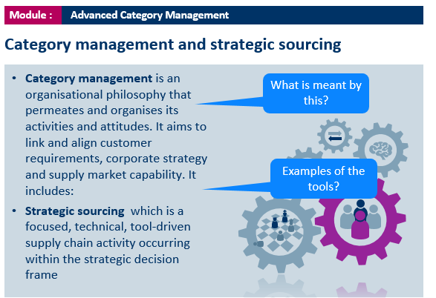
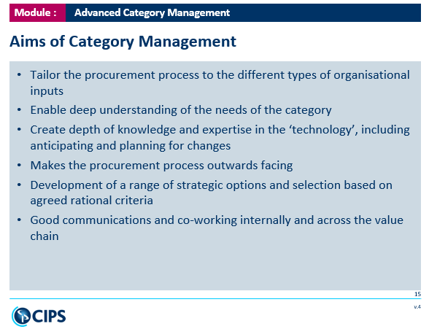

Introduction to the Department of Culture and Tourism & DCT Procurement (300 words)
- Who we are (DCT)?
- What we do (DCT)?
Note, (1) Mention the author of the page
(2) Use some pictures

Category Management (3 to 4 references) Krijak, swot, People, Management) 500 to 800 words How? Slide 35, Slide 20
Note, (1) Slide 35 and 20 showing below can be used as a reference
(2) Total of 3 reference to be mentioned
(3) The CIPS Category Management Model should be drawn for the project as below figure.

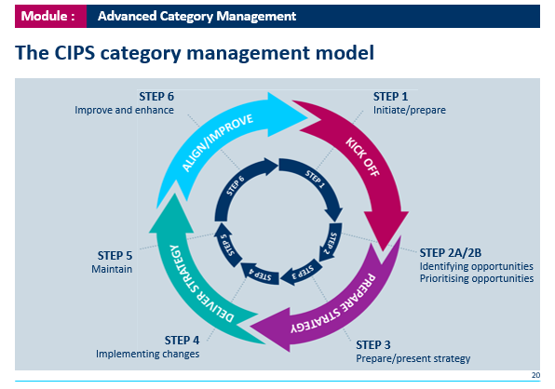
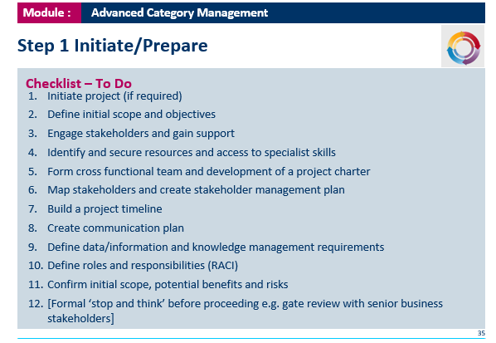

- Step 1(What is the benefit I’ll bring to the organization)
- Have a diagram and table and a checklist which includes what is the scope of the category slide 36) (below figure)
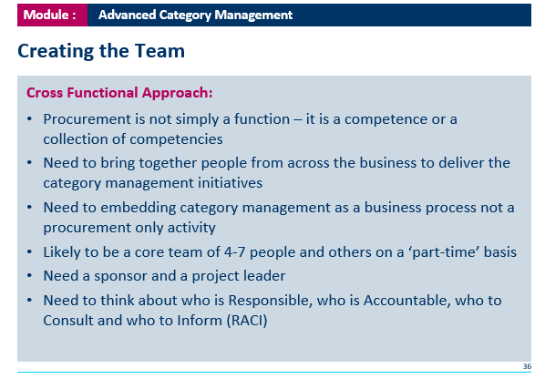
- Identify the stake holders
- Use RACI model in how identify the stakeholders.
- For the categories refer to slide no. 26 (use the Below Figure and templates).
  - Master data.
  - Meeting stake holders.
  - Demand.
  - Risks. (Have a risk matrix Red and the Green)
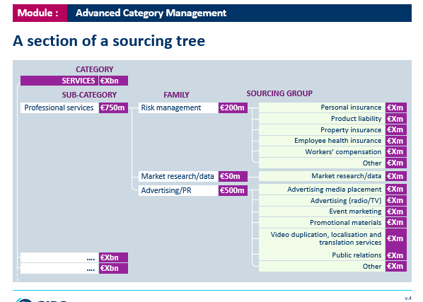
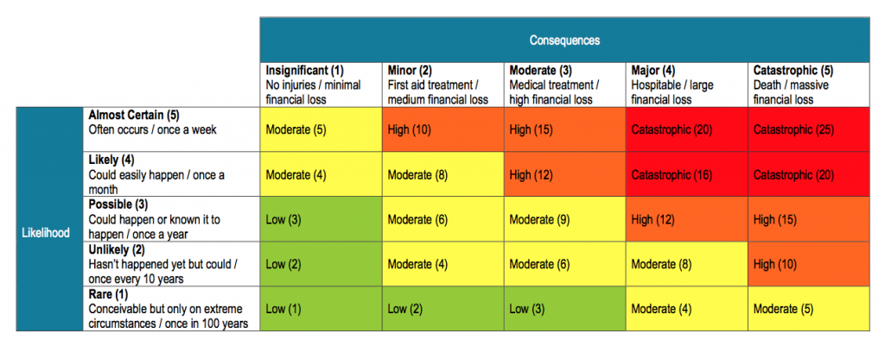

Cross Functional

Slide 37 - Print 2 / PMP (reference) - Basic Project Management.
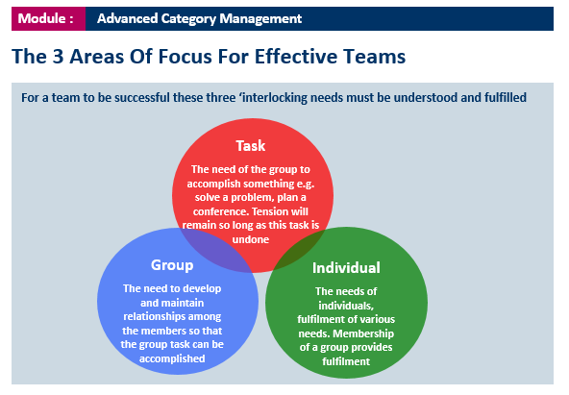

Step 2 Have we identified the opportunities? Reference to Page 30.
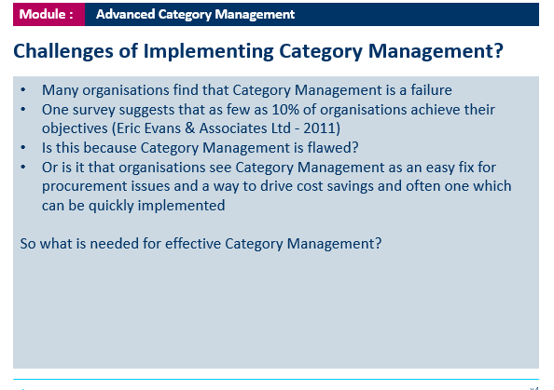

One of the key benefits of doing a category management if vendor rationalization. (STP)
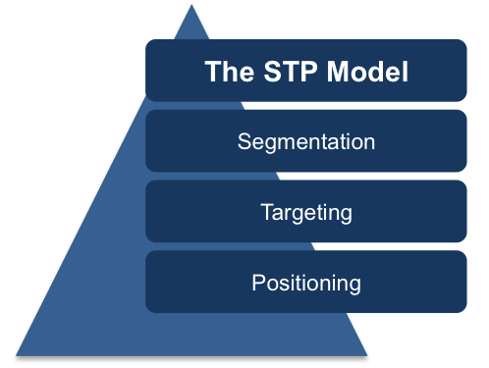

PESTLE,


5. Quarters
- Types of tenders: Open, Close and Restricted.
- Contract negotiation plan.
- Performance Management (KPIs)
  - Why?
  - What?

Page 44. Add the diagram. 4th reference Mendillo / French and Raven (Google Scholar)
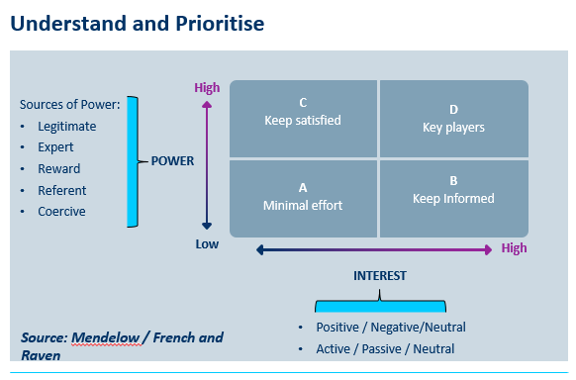
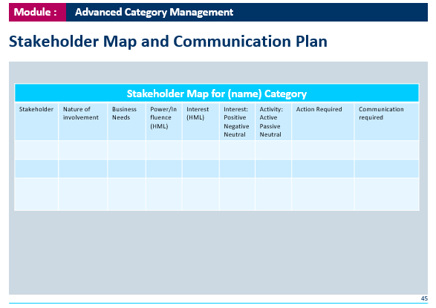

Conclusion (2 or 3 references) 500 to 700 words
- Findings
- How?
- What?
- Risks? One if the risks is the people.
- Risk Mitigation.
- Plan to build

Recommendation (300 words)

The challenges

The implementation plan

The improvement

Reference (Harvard Style)

Bibliography (Harvard Style)
- Lists
  - List of Tables
  - List of Figures
  - List of Illustrations

Additional Notes:
- Kindly use a lot of graphs and tables in the assignment (add reference/ source them too)
- You may use the below figures as reference too.


