957Z LOADER SPECIFICATIONS
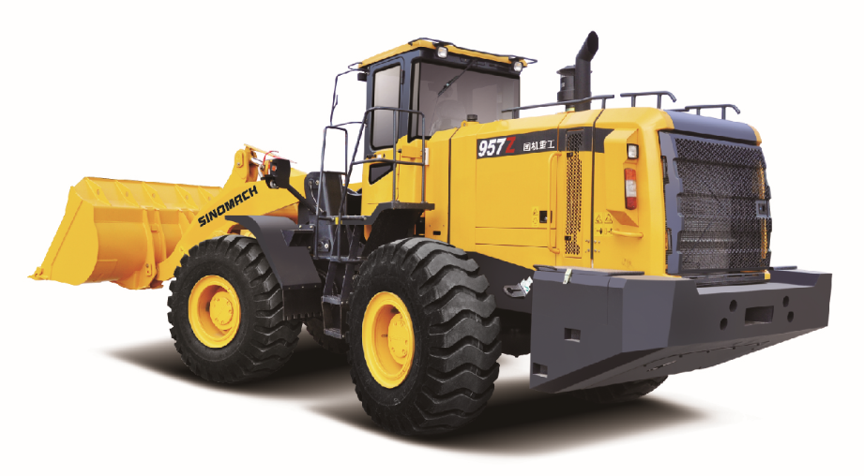
Techiniacl Specification 性能参数

Overall Dimension总尺寸
1 | Length(with bucket on ground)总长（铲斗放置地面） | 8120(mm)
2 | Width(to outside of wheels)总宽（到轮胎外沿） | 2800(mm)
3 | Bucket width铲斗宽度 | 2928(mm)
4 | Height(To the top of the cab)高度（到驾驶室顶） | 3450(mm)
5 | Wheel base轴距 | 3300(mm)
6 | Min. ground clearance最小离地间隙 | 450(mm)
Technical Specification性能参数
1 | Rated load额定载重量 | 5000(Kg)
2 | Operating weight操作重量 | 17300KG
3 | Rated bucket capacity额定斗容 | 3.1(m³)，optional 2.2-4.5 (m³)
4 | Max. dump clearance最大卸载高度 | 3136(mm)
5 | Dump reach卸载距离 | 1121(mm)
6 | Min. turning radius(wheel)轮胎外最小转弯半径 | 6192(mm)
Diesel engine发动机
1 | Model型号 | Cummins  6LTAA9.3-C220 | ShangChai  SC11CB220G2B1
2 | Type形式 | Direct injection. 直喷
3 | Rated output额定功率 | 162kW
5 | Total exhaust of cylinder排气量 | 9.3L | 10.45L
9 | Rated speed额定转速 | 2200rpm
10 | Max. Torque最大扭矩 | 940N.m/1400rpm | 920N.M/1400 rpm
Transmission System传动系统
1 | Model型号 | ZF采孚4BP210
2 | Type形式 | 3-elements single stage  三相单级
3 | Gear shift position档位 | 4F、3 R前四后三档位
4 | Speed速度（F/R） | 6.8/7.1，13.3/14.0，25.2/26.5，39.6
5 | Max. drawing force最大牵引力 | 170kN
6 | Size of tire轮胎型号 | 23.5-25-16PR
- Working Hydraulic System工作液压系统
1 | Model of oil pump工作油泵型号 | SGP2100/2080R01
2 | System pressure系统压力 | 18MPa
3 | Model of Muti-way directional valve 多路阀型号 | YGDF32Ⅱ-YL18
5 | Pilot valve先导阀型号 | 单手柄先导阀DXS-00
- Steering System转向系统
1 | Model of steering pump转向泵型号 | SGP2100/2080R01
2 | Model of redirector 转向器型号 | TLF2J-800-22-A
3 | Model of priority valve 优先阀 | YXL-F250F-N7
4 | System pressure转向系统压力 | 16MPa
- Brake System制动系统
1 | Type of traveling brake 行车制动形式 | Caliper disc brake钳盘式制动器  Multi-disc wet type brake optional选装多盘片湿式制动
2 | Air pressure制动气压 | 6-7.5(kgf/cm²)
3 | Type of parking brake停车制动形式 | Manual control cutting-off air brake手动控制切断气压制动
- Oil Capacity加油量
1 | Fuel(diesel)燃油 | 280(L)
2 | Engine lubricating oil机油 | 24(L)
3 | Oil for converter and gear box变速箱油 | 45(L)
4 | Oil for hydraulic system液压系统油 | 180（L)
5 | Oil for driving axles（F/R）前后驱动桥油 | 18/18(L)

