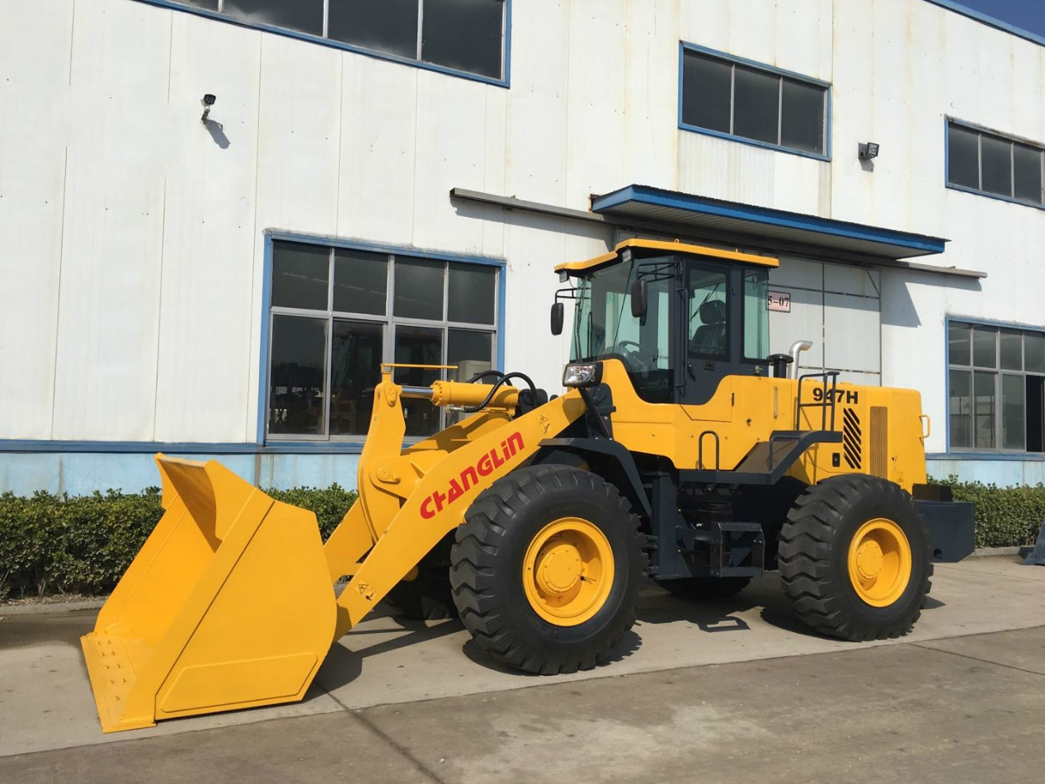

947H WHEEL LOADER SPECIFICATIONS
- Equipped with Dongfeng Cummins engine
- Luxury cabin decoration and A/C provide operator comfort
- 4 forward & 3 reverse power shift transmission
- Combined seal cylinder obtains high seal performance and more reliability

- Overall Dimension整机尺寸
1 | Length(with bucket on ground)整机长度 |  |  |  |  |  |  |  |  |  |  |  |  | 7670(mm)
2 | Width(to outside of wheels)整机宽度（到轮胎外侧） |  |  |  |  |  |  |  |  |  |  |  |  | 2570(mm)
3 | Bucket width铲斗宽度 |  |  |  |  |  |  |  |  |  |  |  |  | 2680(mm)
4 | Height(To the top of the cab)高度（到驾驶室顶部） |  |  |  |  |  |  |  |  |  |  |  |  | 3375(mm)
5 | Wheel base轴距 |  |  |  |  |  |  |  |  |  |  |  |  | 3067(mm)
6 | Tread轮距 |  |  |  |  |  |  |  |  |  |  |  |  | 1860(mm)
7 | Min. ground clearance最小离地间隙 |  |  |  |  |  |  |  |  |  |  |  |  | 460(mm)
Main Technical Specification主要技术参数
1 | Rated load额定载荷 |  |  |  |  |  |  |  |  |  |  | 4000(Kg)
2 | Operating weight整机操作重量 |  |  |  |  |  |  |  |  |  |  | 12300KG
3 | Rated bucket capacity额定斗容 |  |  |  |  |  |  |  |  |  |  | 2.35(m³)
4 | Max. breakout force最大崛起力 |  |  |  |  |  |  |  |  |  |  | 130kN
5 | Max. dump clearance最大卸载高度 |  |  |  |  |  |  |  |  |  |  | 3176(mm)
6 | Dump reach卸载距离 |  |  |  |  |  |  |  |  |  |  | 1095(mm)
7 | Dump angle at any position 在任意位置卸载角 |  |  |  |  |  |  |  |  |  |  | ≥45⁰
8 | Digging depth(with bucket bottom horizontal)挖掘深度 |  |  |  |  |  |  |  |  |  |  |  | 190(mm)
9 | Max. turning radius最大转弯半径
 | (1) Outside of bucket 铲斗外侧 |  |  |  |  |  |  |  |  |  |  | 6300(mm)
 | (2) Outside of rear wheel后轮外侧 |  |  |  |  |  |  |  |  |  |  | 6052(mm)
10 | Pivot angle frame 转向角 |  |  |  |  |  |  |  |  |  |  | 38+1⁰
11 | Oscillating angle of rear axle后桥摆动角 |  |  |  |  |  |  |  |  |  |  | +11º
12 | Lifting time of bucket铲斗提升时间 |  |  |  |  |  |  |  |  |  |  | ≤5.5(sec.)
13 | Lowering time of bucket铲斗下降时间 |  |  |  |  |  |  |  |  |  |  | ≤3.2(sec.)
14 | Dumping time翻斗时间 |  |  |  |  |  |  |  |  |  |  | ≤1.1(sec.)
15 | Traveling speed(Km/h)，4 forward and 3 reverse 行驶速度，4前进档，3后退档
 | (1) 1st gear forward前进一档 |  |  |  |  |  |  |  |  |  |  | 6.5
 | (2) 2nd gear forward前进二档 |  |  |  |  |  |  |  |  |  |  | 12
 | (3) 3rd gear forward前进三档 |  |  |  |  |  |  |  |  |  |  | 25
 | (4) 4th gear forward前进四档 |  |  |  |  |  |  |  |  |  |  | 35
 | (3) 1st gear reverse后退一档 |  |  |  |  |  |  |  |  |  |  | 6.5
 | (3) 2nd gear reverse后退二档 |  |  |  |  |  |  |  |  |  |  | 12
 | (3) 3rd gear reverse后退三档 |  |  |  |  |  |  |  |  |  |  | 25
Diesel engine发动机
1 | Model型号 |  |  |  |  |  |  | Dongfeng Cummins engine 东风康明斯  6BTA5.9-C180
 | Type形式 |  |  |  |  |  |  | Direct injection. Turbocharged. Water cooling  直喷式，涡轮增压，水冷
3 | Rated output额定功率 |  |  |  |  |  |  | 132 (kW)
4 | Inter-bore of cylinder/stroke缸径/行程 |  |  |  |  |  |  | 102X120 (mm)
5 | Total exhaust of cylinder排气量 |  |  |  |  |  |  | 5.9 (L)
6 | Current of Alternator发电机电流 |  |  |  |  |  |  | 70(A)
7 | Power of start motor启动马达的功率 |  |  |  |  |  |  | 6(KW)
8 | Voltage of starting motor启动马达的电压 |  |  |  |  |  |  | 24(V)
9 | Rated speed额定转速 |  |  |  |  |  |  | 2200(r/min)
10 | Max. Torque最大扭矩 |  |  |  |  |  |  | 750(N.M)/1500rpm
11 | Starting type启动方式 |  |  |  |  |  |  | Electric
12 | Min. specific fuel consumption最小燃油消耗率 |  |  |  |  |  |  | 212(g/Kw.h)
13 | Engine specific oil consumption机油消耗率 |  |  |  |  |  |  | 0.9-1.6(g/Kw.h)
14 | Net weight净重 |  |  |  |  |  |  | 710(kg)
Transmission System变速系统
（一）Torque Converter变矩器
1 | Model型号 |  |  |  |  | 4WG180
2 | Type形式 |  |  |  |  | 4-elements. double stage 4元件、双级
3 | Torque ratio变矩系数 |  |  |  |  | 4
4 | Cooling type冷却方式 |  |  |  |  | Pressure oil circulating循环压力油
(二)、Transmission case变速箱
1 | Model型号 |  |  | 4WG180
2 | Type型式 |  |  | Electronic control gear shift  电控换挡
3 | Gear shift position  换档位置 |  |  | 4Forward and 3 reverse gears
(三)、Axle and Tire桥和轮胎
1 |  | Type of main reducer主传动形式 |  |  |  |  | spiral bevel gear, single stage螺旋伞齿轮、单级
2 |  | Gear ratio of main reducer  主传动速比 |  |  |  |  | 5.286
3 |  | Type of final reducer轮边减速的形式 |  |  |  |  | Single stage planetary单级行星轮式
4 |  | Gear of ratio of final reducer轮边减速速比 |  |  |  |  | 4.26
5 |  | Total ratios总速比 |  |  |  |  | 22.52
6 |  | Max. drawing force最大牵引力 |  |  |  |  | 120kN
7 |  | Size of tire轮胎尺寸 |  |  |  |  | 20.5-25-16PR
Working Device Hydraulic System工作液压系统
1 |  | Model of oil pump油泵型号 |  |  |  |  |  |  |  | HGP2063-1010RC
2 |  | System pressure系统压力 |  |  |  |  |  |  |  | 180(kgf/cm²)
3 |  | Model of Multi-way directional valve多路换向阀型号 |  |  |  |  |  |  |  | D32II
4 |  | Pilot valve 先导阀型号 |  |  |  |  |  |  |  | DXS-00
5 |  | (D*L)Dimension of lifting cylinder 提升油缸尺寸 |  |  |  |  |  |  |  | Ф125*70*771(mm)
6 |  | (D*L)Dimension of tilting cylinder翻斗油缸尺寸 |  |  |  |  |  |  |  | Ф188*90*502(mm)
Steering System转向系统
1 | Type型式 |  | Middle articulated frame. Full-hydraulic flow amp. Steering  中间铰接，流量放大全液压转向
2 | Model of steering pump转向泵型号 |  |  |  |  |  |  |  | HGP 2063-1010RC-XF
3 | Model of redirector转向器型号 |  |  |  |  |  |  |  | BZZ5-500
4 | Model of distribution valve 分流阀型号 |  |  |  |  |  |  |  | FLD-F30W
5 | System pressure系统压力 |  |  |  |  |  |  |  | 14MPa
6 | Dimension of steering cylinder转向油缸尺寸 |  |  |  |  |  |  |  | Ф80*45*327(mm)
Brake System制动系统
1 | Type of traveling brake 行车制动形式 |  |  |  | Air over oil activate 4 wheel brake with capliar disc brake  气顶油作用4轮钳盘式制动器
2 | Air pressure气压 |  |  |  | 6-8(kgf/cm²)
3 | Type of emergency brake  紧急制动 |  |  |  | Automatic cutting air brake自动断气制动
4 | Type of parking brake  停车制动形式 |  |  |  | Drum brake鼓式制动  Manual control cutting-off air brake手动控制断气制动
Oil Capacity油量
1 | Fuel(diesel)柴油 |  |  |  |  |  |  |  |  |  | 150(L)
2 | Engine lubricating oil机油 |  |  |  |  |  |  |  |  |  | 13 (L)
3 | Oil for converter and gear box双变用油 |  |  |  |  |  |  |  |  |  | 45(L)
4 | Oil for hydraulic system液压系统用油 |  |  |  |  |  |  |  |  |  | 150(L)
5 | Oil for driving axles（F/R）前后桥用油 |  |  |  |  |  |  |  |  |  | 24/24(L)
6 | Oil for brake 刹车油 |  |  |  |  |  |  |  |  |  | 2X1.0(L)

