GE330D产品技术资料
GE330D SPECIFICATIONS
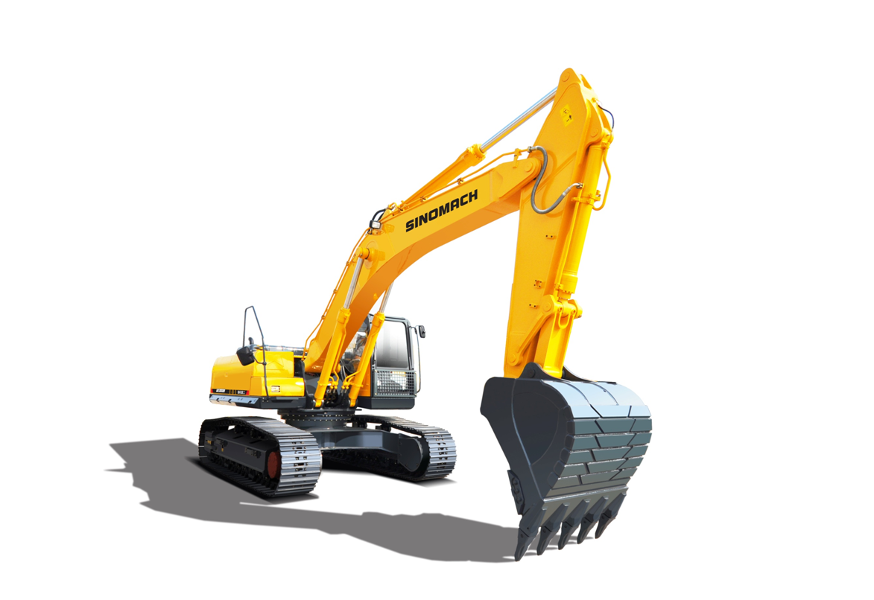

1、产品简介Introduction：
康明斯大功率发动机(符合二阶段排放法规)，动力强劲、高效节能、可靠耐用；先进的负流量液压系统，操作舒适，作业效率高，性价比极佳；全功率控制，四种功率模式适应不同工况；可靠、精准的燃油喷射系统，实时控制喷油量，使燃烧更加充分，燃油效率更高；全三维建模和有限元分析技术，保证了结构件的可靠性和稳定性。
CUMMINS engine (conforming to Ⅱ-stage emission regulations), powerful, energy efficient, reliable and durable; advanced negative flow hydraulic system, comfortable operation, high operating efficiency, excellent cost performance; full power control, four power modes to adapt to different work; reliable and accurate fuel injection system, real-time control of fuel injection, making combustion more complete, fuel efficiency; full 3D modeling and finite element analysis technology to ensure the reliability and stability of structural parts.
2.性能特点Characteristics：
(1)康明斯大功率发动机，动力强劲，燃油消耗低，可靠性高；
CUMMINS high-power engine with strong power, low fuel consumption and high reliability
(2)新型的液压系统，大排量主泵，大流量主阀，通流面积大，压力损失小，流量分配更合理，协调性更好，操作更加轻松；
New hydraulic system, large displacement main pump, large flow main valve, large flow area, small pressure loss, more reasonable flow distribution, better coordination and easier operation
(3)配备大缸径油缸，优化各关键铰点的布置，提升整机挖掘力，设置自动增压功能，随着负载的增加自动增加挖掘力；
Equipped with a large-bore oil cylinder, optimizing the arrangement of key hinge points, improving the digging force of the whole machine, setting an automatic supercharging function, and automatically increasing the digging force as the load increases.
(4)大排量回转马达、大速比的回转齿轮设计，回转启动力矩更大，回转制动效果更佳；
Large displacement slewing motor and slewing gear design with large speed ratio Higher starting torque, better slewing braking effect.
(5)针对极端恶劣的矿山作业工况，标配重载强化型动臂、矿山专用短斗杆和大容量岩石铲斗，标配加长加宽型重载底盘，优化箱形结构，工作稳定性好；
Aiming at the extremely harsh mining operation conditions, the heavy-duty reinforced boom, the mine-specific short stick and the large-capacity rock bucket are standard, and the extended and widened heavy-duty chassis is standard.
(6)新一代控制系统，根据工况需要智能调节液压吸收功率，最优化的系统匹配，保证整机的综合性能充分发挥；
New generation of control system, according to the working conditions need to intelligently adjust the hydraulic absorption power, optimized system matching, to ensure that the comprehensive performance of the machine to give full play to.
(7)配备高分辨率、高亮度的 8寸彩色防炫目监控仪表，智能电子监控系统，具备整车保养信息提示、故障的自诊断和报警等多种功能；
Equipped with high-resolution, high-brightness 8-inch color anti-glare monitoring instrument, intelligent electronic monitoring system, with vehicle maintenance information prompts, fault self-diagnosis and alarm and other functions;
(8)采用安全可靠的新型驾驶室，全新注塑内饰件，美观大方，宽敞舒适，配置全自动冷暖空调；
Adopting safe and reliable new cab, brand-new injection molding interior parts, beautiful and generous, spacious and comfortable, equipped with full-automatic cold and warm air-conditioning.
(9)整机具备防滑安全设计、过热保护设计、运动件保护设计、驾驶室防护设计，安全性高；
The whole machine is equipped with anti-skid safety design, overheating protection design, moving parts protection design, cab protection design, high safety.
(10)人性化的集中、远程式地面维护设计，保养更轻便。
Humanized centralized and remote ground maintenance design, lighter maintenance.

3．技术规格Technical specification
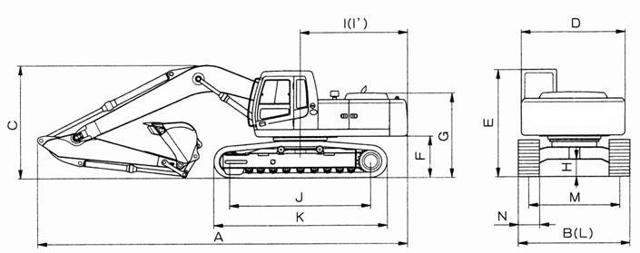
名 称ITEM |  | 单 位UNIT | 技术规格  Technical specifications
 |  | 单 位UNIT | GE330D
操作重量Operating weight |  | kg | 31880
标准斗容  Rated bucket capacity |  |  | 1.6
总长 Overall length | A | mm | 10700
总宽（600mm履带）  Overall width（600mm track） | B | mm | 3280
总高 Overall height | C | mm | 3546
转台宽度 Platform width | D | mm | 3060
驾驶室离地高  Height of cabin | E | mm | 3145
配重离地间隙 Ground clearance of counterweight | F | mm | 1193
发动机罩高  Engine cover height | G | mm | 2563
最小离地间隙  Min. ground clearance | H | mm | 471
转台尾端长度  Tail length | I | mm | 3205
尾端回转半径  Turning radius of turntable | I’ | mm | 3250
履带轴距  Wheel base of track shoe | J | mm | 4030
底盘长度  Length of chassis | K | mm | 4950
底盘宽度  Width of chassis | L | mm | 3280
履带轨距  Track shoe gauge | M | mm | 2680
标准履带宽度  Standard track width | N | mm | 600
最大牵引力  Max. traction |  | kN | 255
行走速度（高/低）  Traveling speed （H/L） |  | km/hr | 5.3/3.1
回转速度  Swing speed |  | rpm | 10.0
爬坡能力 Gradeability |  | Degree(%) | 35（70%）
接地比压 Ground pressure |  | kgf/cm² | 0.594

4.工作范围 Working range
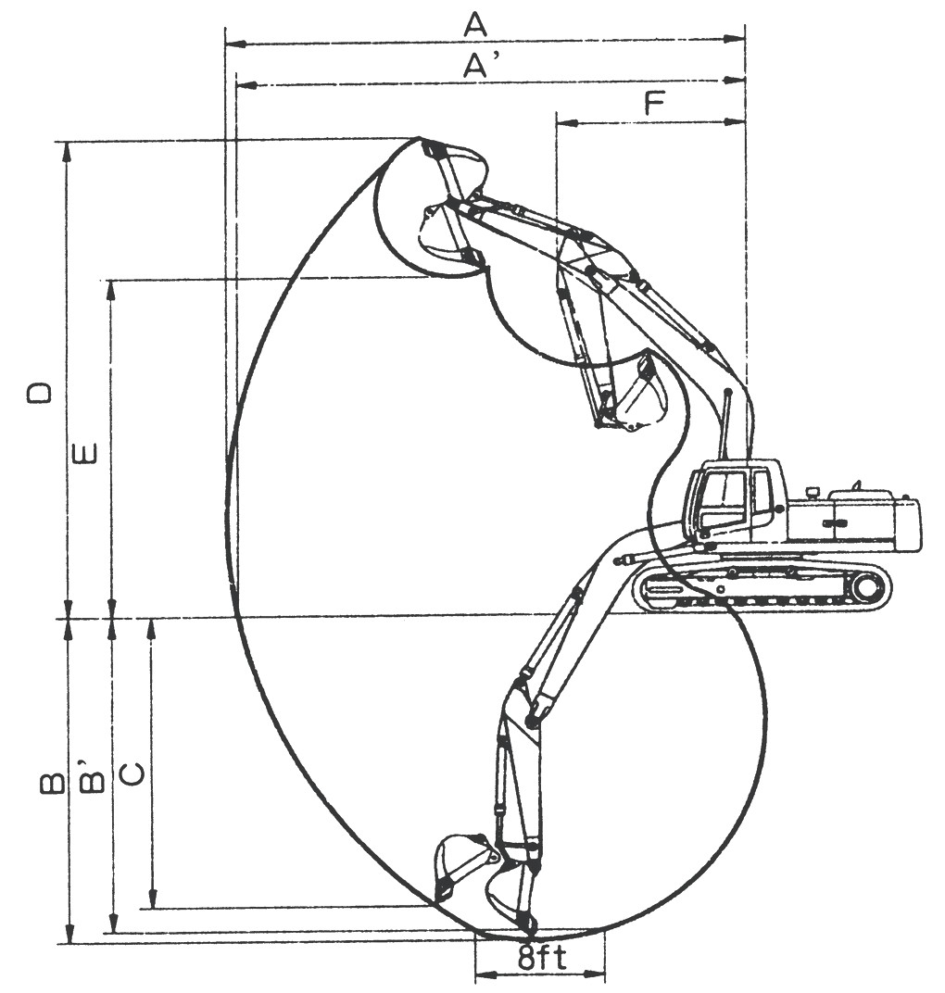

类 别 ITEM |  | 6.2m动臂，2.65m斗杆，1.6m³铲斗  6.2m arm，2.65m Stick，1.6m³ bucket
 |  | GE330D
最大挖掘半径  Maximum digging radius | A | 10233 mm
地面最大挖掘半径  Ground maximum digging radius | A’ | 10028 mm
最大挖掘深度  Maximum digging depth | B | 6536 mm
地面最大挖掘深度（2438mm水平）  Ground maximum digging depth | B’ | 6331 mm
最大垂直挖掘深度  Maximum vertical digging depth | C | 4758 mm
最大挖掘高度  Maximum digging height | D | 9617 mm
最大卸载高度  Maximum dumping height | E | 6666 mm
最小前部回转半径  Min. front turning radius | F | 4256 mm
铲斗挖掘力  Bucket digging force | ISO | 225 kN
斗杆挖掘力  Stick digging force | ISO | 182 kN
5. 发动机性能参数 Engine specifications
发动机型号 Model |  |  | 康明斯 CUMMINS  6LTAA8.9-C325
规格参数  Specifications | 型 式 Type |  | 4冲程，6缸，直列式，直喷，涡轮增压  4 Stroke，6 Cylinder in line ，direct injection， turbocharged
规格参数  Specifications | 冷却方法 Cooling type |  | 水冷 Water cooled
规格参数  Specifications | 缸径×行程 Bore diameter × stroke | mm | 114×145
规格参数  Specifications | 活塞排量Displacement | L | 8.9
规格参数  Specifications | 功率rated power | kW/rpm | 241/2000
规格参数  Specifications | 最大扭矩 Max. touque | Nm/rpm | 1400/1400
规格参数  Specifications | 额定油耗率  Rated diesel consumption | g/kW.h（rpm） | 194（1200）
规格参数  Specifications | 启动马达Starter |  | 24V 8.5kW
规格参数  Specifications | 发电机Generator |  | 28V 70A
规格参数  Specifications | 蓄电池 Battery |  | 2×12V×120Ah
6. 主要部件配置 Main configuration
部件 机型 | GE330D
排放等级 Emission | 国二 Stage Ⅱ
发动机 Engine | 东风康明斯CUMMINS  6LTAA8.9-C325
主泵Main pump | 韩川 FLUTEK  FP5V140DT
主控阀 Main valve | 恒立 INLINE  HVME270B
回转马达 Slewing motor | 韩川 FLUTEK  F5X180CHB
行走马达 Travelling motor | 纳博NABTESCO  GM60VA

