vehicle parameter table
CHL5240JSQJ5 Type Truck Crane Transport Vehicle
Vehicle name: | truck with loading crane |  | 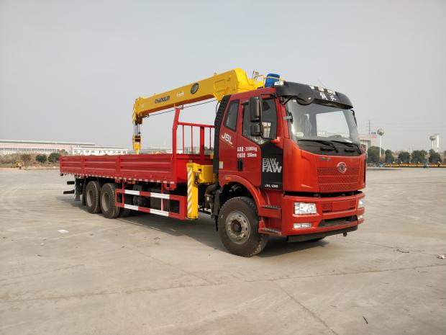
class of vehicle ： | truck with loading crane
Vehicle model: | CHL5240JSQJ5
exemption ： | deny
fuel oil ： | yes
exemption from conscription ： | deny
environmental protection ： | deny
Chinese brand: | Sinomach Heavy Industry brand | manufacturer ： | Sinomach Heavy Industry Group Changlin Co., Ltd.
engine type ： | CA6DK1-220 | engine power ： | 209/284
engine displacement ： | 7146 | Engine manufacturer: | China First Automobile Group Corporation
Chassis model: | CA1250P62K1L3T1A1E | Fuel type: | diesel oil
Dimensions (length/width/height): | 12000×2521×3870 | Trunk (length/wide/height): | 8510×2405×550
gross mass （Kg）： | 25000 | load utilization factor: | 1.21
Preparation weight (Kg): | 16295 | Rated mass (Kg): | 8575
ABS ： | have | Front passenger(s): | 2
Approach angle/Departure angle: | 22/7 | Front/rear suspension (mm): | 1400/3450
wheel base （mm）： | 5800+1350 | axle weight ： | 7000/18000 (two-axis set)
number of axles ： | 3 | Maximum speed (km/h): | 89
oil wear ： | 30.74 | Number of spring tabs: | 12/10
Number of wheels: | 10 | tyre size ： | 11.00R20
front gauge ： | 1928,1950,1988 | rear track ： | 1878/1878
Chassis standard: National V

Note: The vehicle specifications are subject to the actual published parameters.

crane technical parameters
order number | project |  |  |  | unit |  | numeric value
1 | maximum lifting moment |  |  |  | kN·m |  | 300
2 | maximum lifting load |  |  |  | kg |  | 10000
3 | maximum working range |  |  |  | mm |  | 13500
4 | fully retracted boom length |  |  |  | mm |  | 5600
5 | Maximum lifting height (above ground) |  |  |  | mm |  | About 16,000
6 | lift ratio |  |  |  |  |  | 6/4
7 | maximum boom angle |  |  |  | (°) |  | 75
8 | minimum boom angle |  |  |  | (°) |  | 0
9 | transverse span of front leg |  |  |  | mm |  | 2284~5730mm
10 | transverse span of rear outrigger |  |  |  | mm |  | 2200
11 | maximum rate of ascent | main hook  Single rope | Lift | m/min |  | 55
11 | maximum rate of ascent | main hook  Single rope | descend |  |  | 55
12 | swiveling speed |  |  |  | r/min |  | ≤2
13 | rotation angle |  |  |  | ° |  | 360° full rotation
14 | crane self-weight |  |  |  | kg |  | 5020
15 | oil pump form |  |  |  | ------------- |  | gear pump + plunger pump
16 | fuel tank capacity |  |  |  | L |  | 240
17 | working pressure of hydraulic system |  |  |  | MPa |  | 26
18 | flow rate of hydraulic system |  |  |  | L/min |  | 100

外形图 of crane

Main features of crane

(1) Rotary device
The planetary reducer is used to reduce the speed, the rotation is more stable, the rotation angle is 360 degrees, and there is no dead point.
(2) Support leg system
horizontal support leg hydraulic cylinder
The front leg of the crane adopts an extended span to enhance stability, with a full extension span of 5.7 meters.
oil cylinder of front vertical support leg
The standard hydraulic support leg can adapt to various chassis heights.
posterior leg
The standard configuration features fixed rear outriggers for normal operation. An optional hydraulic rear outrigger can be installed to enhance overall stability, making it suitable for more complex and challenging conditions.

(3) Lifting Arm System
The hexagonal cross-section is adopted, and the lateral stability and arm cylinder stiffness are greatly improved compared with the traditional quadrilateral. One basic arm, three telescopic arms, double-stage hydraulic telescopic cylinder, three and four arms extend synchronously.

(4) Control System
crane control system
The crane is controlled by the main valve, which is located at the seat.
support leg control system
The support leg is independently controlled by the leg valve to prevent misoperation and enables bilateral manipulation.

(5) Safety devices
The standard configuration includes a height limit switch and over-rolling alarm device to provide maximum protection for the working equipment.
Optional high-power LED working lights are available for low-light conditions or nighttime operations.
Optional torque limiter for enhanced safety and reliability in the working environment.

