
Sinomach Heavy Industry Group Changlin Co., Ltd.

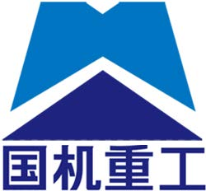

Sinomach Heavy Industry Group Changlin Co., Ltd.

Company name: Changlin Co., Ltd. of Sinomach Heavy Industry Group
Address: No.898, Huanghe West Road, Xinbei District, Changzhou City, Jiangsu Province

catalogue

Vehicle Quotation 2 2
Vehicle Parameter Table 2 3
Cranes Technical Parameters 3 3
外形图 4 of crane on vehicle 4
CRISPR CRISPR CRISPR CRISPR CRISPR CRISPR CRISPR CRISPR CRISPR CRISPR CRISPR CRISPR CRIS 5
Main Features of Crane 6 5

vehicle parameter table
CHL5310JSQD6 Type Truck Crane Transport Vehicle for Steel Plant
Vehicle name: | truck with loading crane |  | 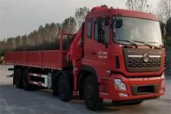
class of vehicle ： | truck with loading crane
Vehicle model: | CHL5310JSQD6
exemption ： | deny
fuel oil ： | yes
exemption from conscription ： | deny
environmental protection ： | deny
Chinese brand: | Sinomach Heavy Industry brand | manufacturer ： | Sinomach Heavy Industry Group Changlin Co., Ltd.
engine type ： | L9NS6B360 | engine power ： | 265/360
engine displacement ： | 8900 | Engine manufacturer: | Dongfeng Cummins Engine Co., Ltd.
Chassis model: | Dongfeng Tianlong 1130 | Fuel type: | diesel oil
Dimensions (length/width/height): | 12000×2550×3525(mm) | Trunk (length/wide/height): | 8400×2430×600(mm)
gross mass （Kg）： | 31000 | load utilization factor: | 1.61
Preparation mass (Kg): | 14260(Kg) | Rated load capacity (Kg): | 16610(Kg)
ABS ： | have | Front passenger(s): | 2
Approach angle/Departure angle: | 22/7 | Front/rear suspension (mm): | 1500/2700(mm)
wheel base （mm）： | 2050+4400+1350(mm) | axle weight ：
number of axles ： | 3 | Maximum speed (km/h): | 89
oil wear ： | 30.74 | Number of spring tabs: | 12/10
Number of wheels: | 12 | tyre size ： | 11.00R20
Chassis standard: National VI
Note: The vehicle parameters are based on actual measurements.

This model features a 6.3-ton folding arm specifically designed for steel mill material handling, with a maximum load capacity of 16.5 tons, making it the highest-capacity model available in the current lineup.

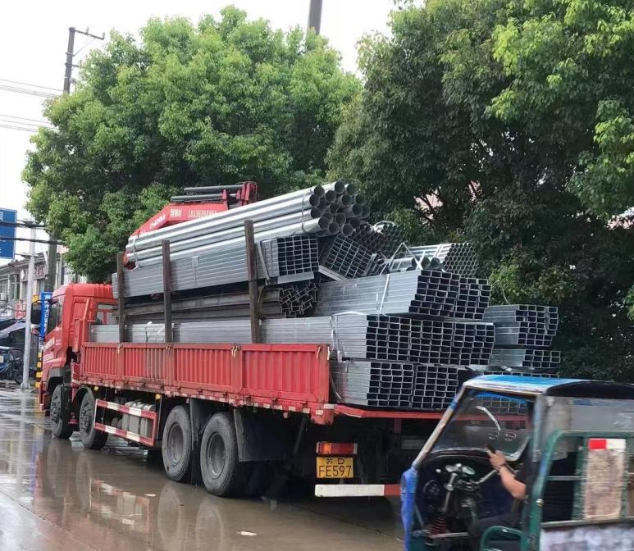

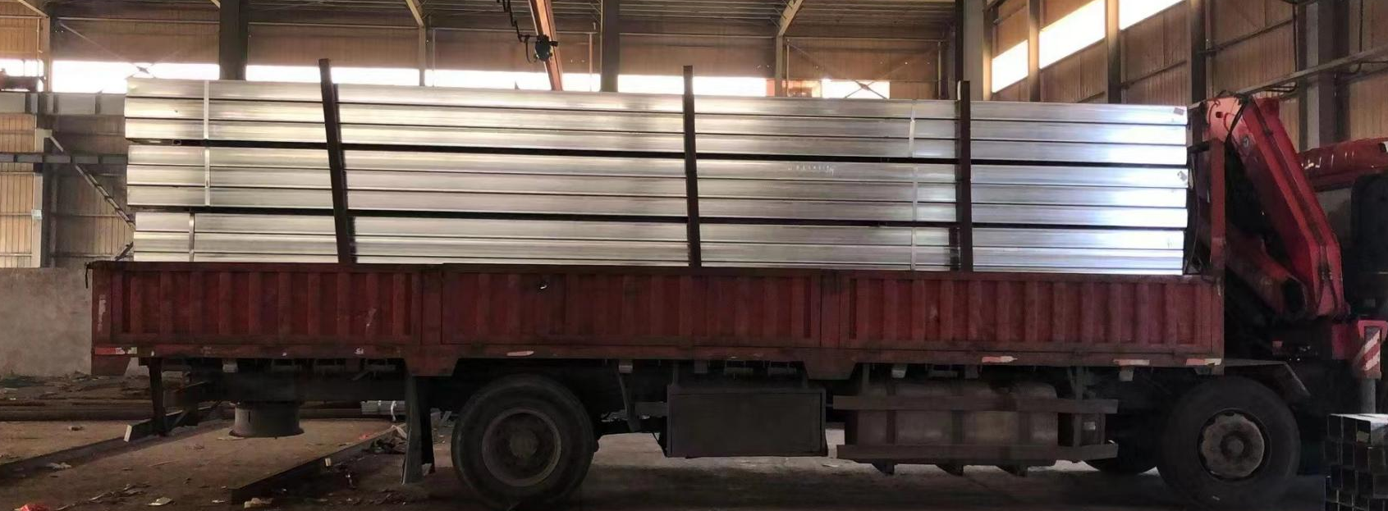

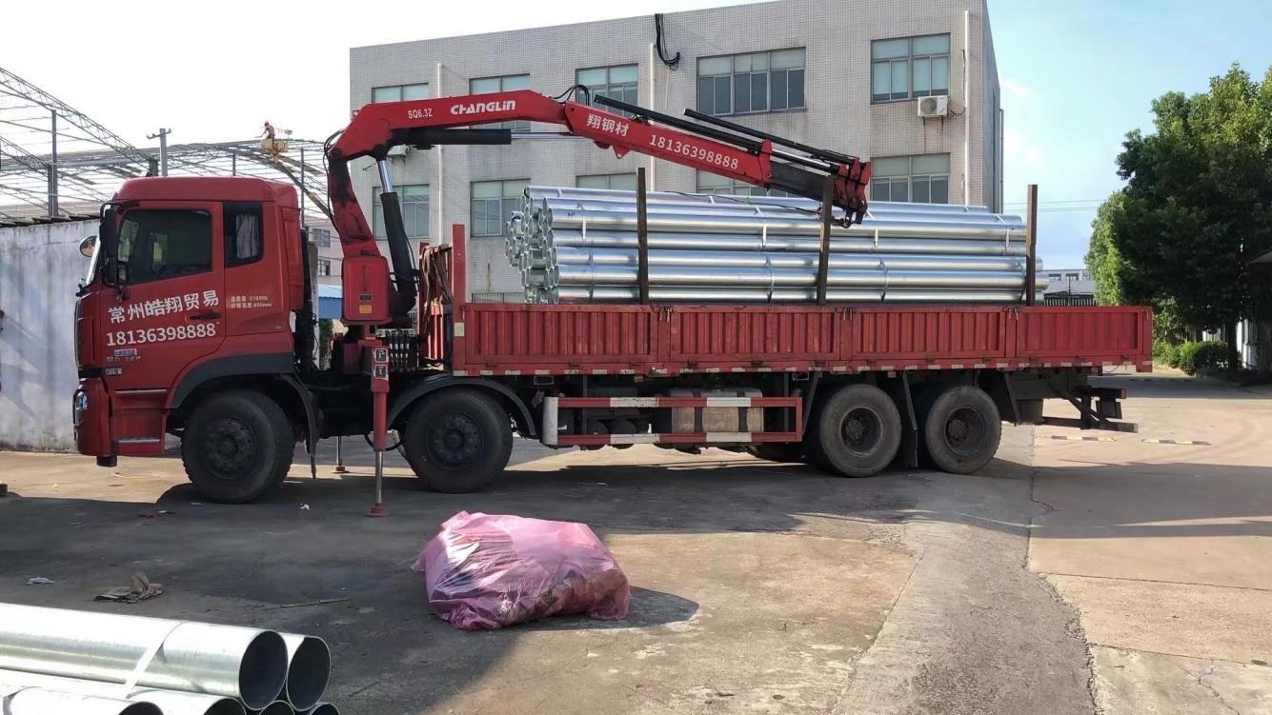

Main features of crane

(1) Rotary device
The planetary reducer is used to reduce the speed, the rotation is more stable, the rotation angle is 360 degrees, and there is no dead point.
(2) Support leg system
horizontal support leg hydraulic cylinder
The front leg of the crane adopts an extended span to enhance stability, with a full extension span of 5.7 meters.
oil cylinder of front vertical support leg
The standard hydraulic support leg can adapt to various chassis heights.
posterior leg
The standard configuration features fixed rear outriggers for normal operation. An optional hydraulic rear outrigger can be installed to enhance overall stability, making it suitable for more complex and challenging conditions.

(3) Lifting Arm System
The hexagonal cross-section is adopted, and the lateral stability and arm cylinder stiffness are greatly improved compared with the traditional quadrilateral. One basic arm, three telescopic arms, double-stage hydraulic telescopic cylinder, three and four arms extend synchronously.

(4) Control System
crane control system
The crane is controlled by the main valve, which is located at the seat.
support leg control system
The support leg is independently controlled by the leg valve to prevent misoperation and enables bilateral manipulation.

(5) Safety devices
The standard configuration includes a height limit switch and over-rolling alarm device to provide maximum protection for the working equipment.
Optional high-power LED working lights are available for low-light conditions or nighttime operations.
Optional torque limiter for enhanced safety and reliability in the working environment.

