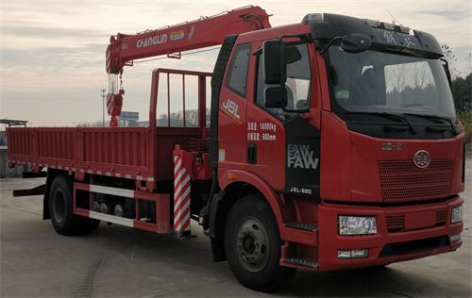

Vehicle name: | truck with loading crane | vehicle type ： | special car
Announcement batch: | 357 | date of issue ： | 20220708
Announcement model: | CHL5180JSQJ6 | Product ID: | ARGXP77402L
Chinese brand: | Sinomach Heavy Industry brand | English brand:
the name of firm ： | Sinomach Heavy Industry Group Changlin Co., Ltd. | Company address: | No.898, Huanghe West Road, Xinbei District, Changzhou City, Jiangsu Province
Exemption from Inspection
exemption ： | deny | Exemption validity period ends:
Key technical parameters
outline dimension ： | 9000×2550×3550(mm) | Trunk dimensions: | 5720×2460×600(mm)
gross mass ： | 18000(Kg) | load utilization factor:
curb weight ： | 10200(Kg) | Rated load capacity: | 7670,7605(Kg)
Rated passenger capacity: | （ human being ） | ABS ：
Approach angle/Departure angle: | 17/10(°) | Front/rear suspension: | 1400/2600(mm)
Fuel type: | diesel oil | effluent standard ： | National VI
axle weight ： | 6500/11500 | wheel base ： | 5000(mm)
number of axles ： | 2 | maximum speed ： | 89(km/h)
Number of wheels: | 6 (items) | tyre size ： | 10.00R20,11.00R20,295/80R22.5,295/60R22.5
oil wear ： | 26.25,26.25,26.92,26.92,24.77(L/100Km) | Number of spring tabs: | 10/12+8,12/12+8,13/12+8,7/7+6
front gauge ： | 1928,1827,1800(mm) | rear track ： | 1878,1860(mm)

Main features of crane

(1) Rotary device
The planetary reducer is used to reduce the speed, the rotation is more stable, the rotation angle is 360 degrees, and there is no dead point.

(2) Support leg system

horizontal support leg hydraulic cylinder
The front leg of the crane adopts an extended span to enhance stability, with a full extension span of 4.5 meters.
oil cylinder of front vertical support leg
The standard hydraulic support leg can adapt to various chassis heights.
posterior leg
The standard configuration features fixed rear outriggers for normal working conditions. An optional hydraulic rear outrigger can be installed to enhance the vehicle's performance.
Stability, suitable for more complex and harsh working conditions.

(3) Lifting Arm System
The hexagonal cross-section design significantly improves lateral stability and arm cylinder stiffness compared to the traditional quadrilateral configuration. A basic section
The arm consists of three telescopic sections, with a dual-stage hydraulic cylinder for synchronized extension of the third and fourth sections.

(4) Control System

crane control system
The crane is controlled by the main valve, which is located at the seat.
support leg control system
The support leg is independently controlled by the leg valve to prevent misoperation and enables bilateral manipulation.

(5) Safety devices
The standard configuration includes a height limit switch and over-rolling alarm device to provide maximum protection for the working equipment.
High-power LED working lights, ideal for low-light conditions or nighttime illumination.
Torque limiter, providing customers with a safer and more reliable working environment.

