vehicle parameter table
Sinomach Changlin truck-mounted crane and transport vehicle
Vehicle name: | truck with loading crane |  | 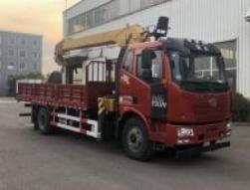
class of vehicle ： | truck with loading crane
Vehicle model: | CA5180JSQP62K1L2A1
exemption ： | deny
fuel oil ： | yes
exemption from conscription ： | deny
environmental protection ： | yes
Chinese brand: | Jiefang Plaque | manufacturer ： | China First Automobile Group Corporation
engine type ： | CA4DK1-22E6 | engine power ： | 165/224
engine displacement ： | 4764 | Engine manufacturer: | China First Automobile Group Corporation
Fuel type: | diesel oil | oil wear ： | 26.25
Dimensions (length/width/height): | 9000×2550×3650 | Trunk (length/wide/height): | 6300×2460×600
Total mass (Kg): | 18000 | load utilization factor: | 1.14,1.07
Preparation mass (Kg): | 11705,12000 | Rated load capacity (Kg): | 6100,5805,6165,5870
ABS ： | have | Front passenger(s): | 3,2
Approach Angle/Departure Angle: | 17/12 | Front/rear suspension (mm): | 1400/2600
wheel base （mm）： | 5000 | axle weight ： | 6500/11500
number of axles ： | 2 | Maximum speed (km/h): | 89
Number of wheels: | 6 | tyre size ： | 10.00R20
Conversion form: | steering wheel | Based on the criteria: | GB3847-2005, GB17691-2018 National V standards
Chassis base standard: | National VI
else ： | The vehicle is equipped with a straight-arm crane model SQS200, with a weight of 3315kg and a maximum lifting capacity of 8000kg.
Note: The vehicle specifications are subject to the actual published parameters.

crane technical parameters

order number | project |  |  |  | unit |  | numeric value
1 | maximum lifting moment |  |  |  | kN·m |  | 200
2 | maximum lifting load |  |  |  | kg |  | 8000
3 | maximum working range |  |  |  | mm |  | 13300
4 | fully retracted boom length |  |  |  | mm |  | 4360
5 | Maximum lifting height (above ground) |  |  |  | mm |  | Approximately 15,300
6 | lift ratio |  |  |  |  |  | 6/4
7 | maximum boom angle |  |  |  | (°) |  | 77
8 | minimum boom angle |  |  |  | (°) |  | 0
9 | transverse span of front leg |  |  |  | mm |  | 2114~5740
10 | transverse span of rear outrigger |  |  |  | mm |  | 2200
11 | maximum rate of ascent and descent | Main hook (single rope) | Lift | m/min |  | 87
11 | maximum rate of ascent and descent | Main hook (single rope) | descend |  |  | 87
12 | swiveling speed |  |  |  | r/min |  | ≤2.5
13 | rotation angle |  |  |  | ° |  | 360° full rotation
14 | crane self-weight |  |  |  | kg |  | 3300 (including rear legs)
15 | oil pump form |  |  |  | ------------- |  | gear pump
16 | fuel tank capacity |  |  |  | L |  | 150
17 | working pressure of hydraulic system |  |  |  | MPa |  | 23
18 | flow rate of hydraulic system |  |  |  | L/min |  | 60

外形图 of crane

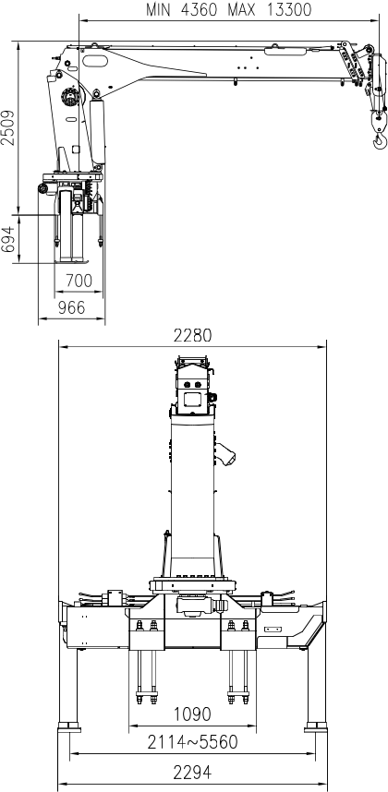

crane characteristic curve

performance curve
H Hoist arm lifting height (M)
R hoist arm working radius (m)

Main features of crane

(1) Rotary device
The worm gear reducer has a full rotation of 360 degrees and no dead point.
(2) Support leg system: Front horizontal support leg cylinder
The front outrigger of the crane is of the extended type to increase its stability, and the full extension span is 5.56 m.
Standard hydraulic support leg, adaptable to various chassis heights. Rear support leg
The standard configuration is fixed rear outriggers, which can meet the normal working conditions. The optional hydraulic rear outriggers can increase the stability of the vehicle and be suitable for more complex and harsh working conditions.
(3) Lifting Arm System
The hexagonal section is adopted, the lateral stability and arm cylinder stiffness are greatly improved compared with the traditional quadrilateral. One basic arm, three telescopic arms, a single hydraulic cylinder, the third and fourth arms are synchronized by rope arrangement.
(4) Control System of the Crane
The crane is controlled by the main valve, and the control system of the support leg can be realized on both sides.
The support leg is operated by the leg valve to avoid misoperation, and the same can be achieved on both sides.
(5) Safety devices
The standard configuration includes a height limit switch and over-rolling alarm device to maximize protection for the working apparatus. An optional high-power LED working light is available for low-light conditions or nighttime operations.
Optional torque limiter to provide customers with a safer and more reliable working environment.

