Manufacturer: Changlin Co., Ltd., Sinomach Group Manufacturer: Changlin Co., Ltd., Sinomach Group
Product model: CHL5110JSQC6 Product model: CHL5110JSQC6
Product Name: Truck-mounted Crane Transport Vehicle Product Name: Truck-mounted Crane Transport Vehicle
Chassis model: CGC1110HDF44F; Engine model: D40TCIF1 Chassis model: CGC1110HDF44F; Engine model: D40TCIF1 Chassis model: CGC1110HDF44F; Engine model: D40TCIF1 Chassis model: CGC1110HDF44F; Engine model: D40TCIF1
External dimensions (length × width × height) (mm): 6700 × 2400 × 3415 External dimensions (length × width × height) (mm): 6700 × 2400 × 3415
Inner dimensions of the cargo compartment (length × width × height) (mm) or volume (m³) or mixing capacity (m³): 3950×2300×500
Total weight (kg): 11200 | Tare weight (kg): 6900 11200 Total weight (kg): 11200 | Tare weight (kg): 6900 6900
Fuel type: Diesel Maximum speed (km/h): 90 Fuel type: Diesel Maximum speed (km/h): 90 Fuel type: Diesel Maximum speed (km/h): 90 90
Drive type 4×2 Number of steering axles (units) 1 Drive type 4×2 Number of steering axles (units) 1 Drive type 4×2 Number of steering axles (units) 1 1
Tire specifications: 8.25R16LT, 18PR. Number of tires: 2/4 Tire specifications: 8.25R16LT, 18PR. Number of tires: 2/4 Tire specifications: 8.25R16LT, 18PR. Number of tires: 2/4 2/4
Side protection device, rear lower protection device Side protection device, rear lower protection device Side protection device, rear lower protection device Side protection device, rear lower protection device
Lower protective device with warning signs on the lifting tail plate Lower protective device with warning signs on the lifting tail plate Lower protective device with warning signs on the lifting tail plate Lower protective device with warning signs on the lifting tail plate
Horizontal bearing surface (count) 8 8
Load layout marking, compressed air drying system for pneumatic braking system, oil-water separator Load layout marking, compressed air drying system for pneumatic braking system, oil-water separator Load layout marking, compressed air drying system for pneumatic braking system, oil-water separator Load layout marking, compressed air drying system for pneumatic braking system, oil-water separator
Brake type Drum type/Drum type Number of pressure test connectors (air reservoirs) (units) 2 Brake type Drum type/Drum type Number of pressure test connectors (air reservoirs) (units) 2 Brake type Drum type/Drum type Number of pressure test connectors (air reservoirs) (units) 2 2
Automatic brake clearance adjustment device, Pressure test connector quantity (brake chamber) (units), Anti-lock braking system (ABS), Signal alarm device available Automatic brake clearance adjustment device, Pressure test connector quantity (brake chamber) (units), Anti-lock braking system (ABS), Signal alarm device available Automatic brake clearance adjustment device, Pressure test connector quantity (brake chamber) (units), Anti-lock braking system (ABS), Signal alarm device available Automatic brake clearance adjustment device, Pressure test connector quantity (brake chamber) (units), Anti-lock braking system (ABS), Signal alarm device available
Combined fuel consumption (L/100km) 20.8 (D40TCIF1) Combined fuel consumption (L/100km) 20.8 (D40TCIF1)
Type of hazardous goods vehicle: Not applicable. Suspension type: Non-independent leaf spring. Type of hazardous goods vehicle: Not applicable. Suspension type: Non-independent leaf spring. Type of hazardous goods vehicle: Not applicable. Suspension type: Non-independent leaf spring. Type of hazardous goods vehicle: Not applicable. Suspension type: Non-independent leaf spring.

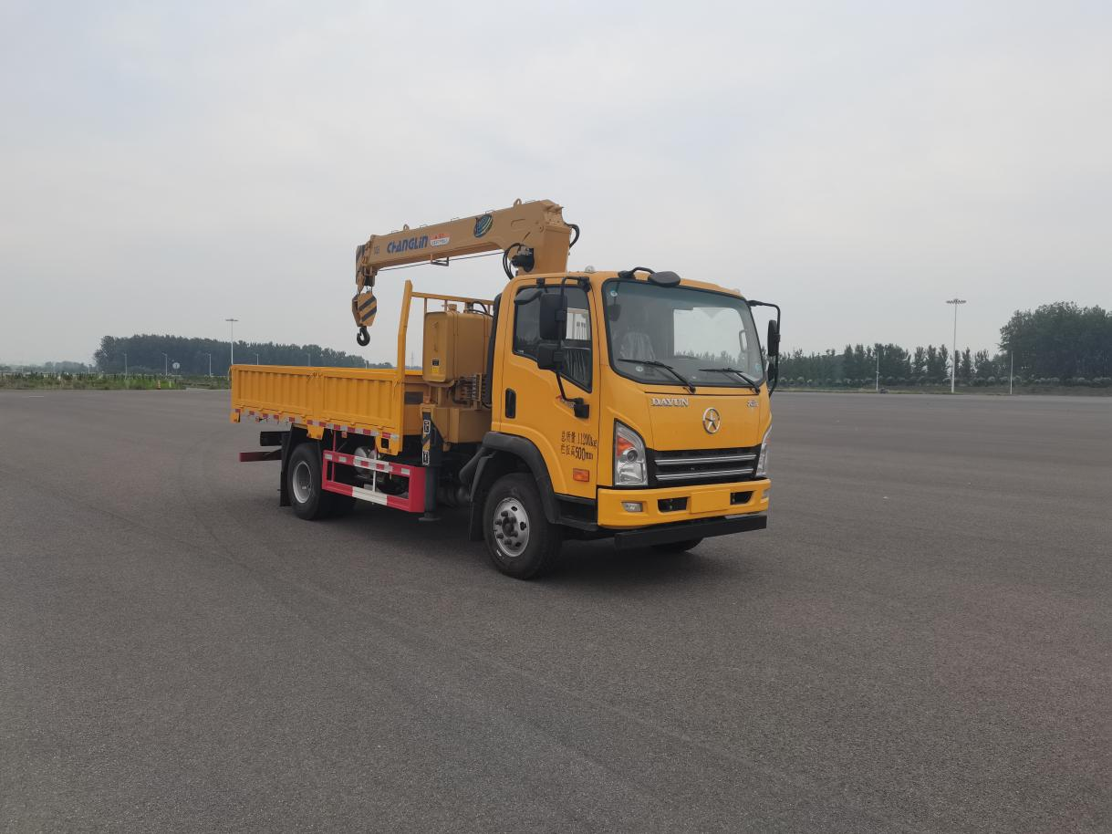

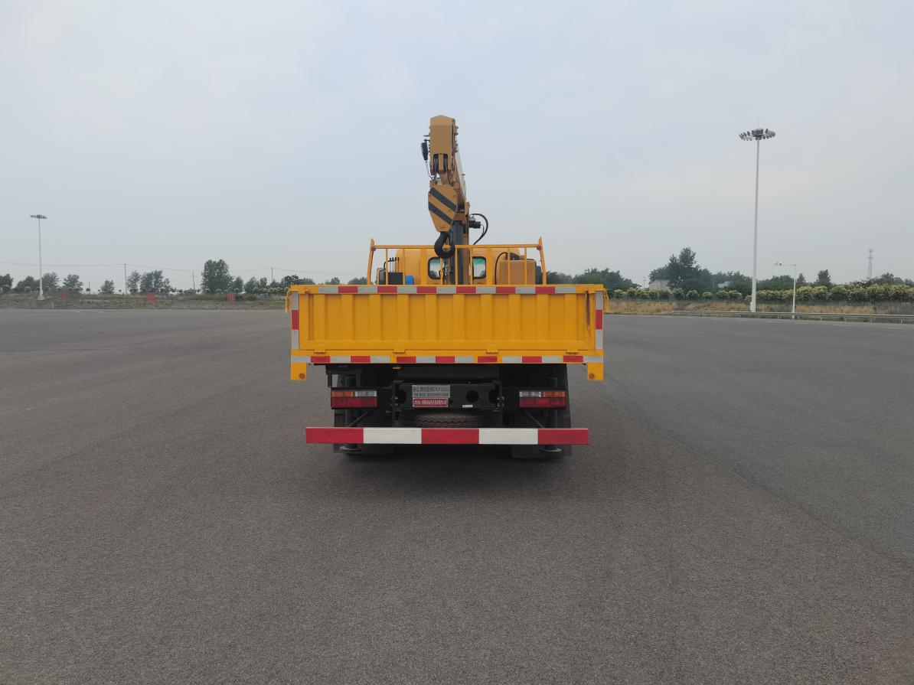

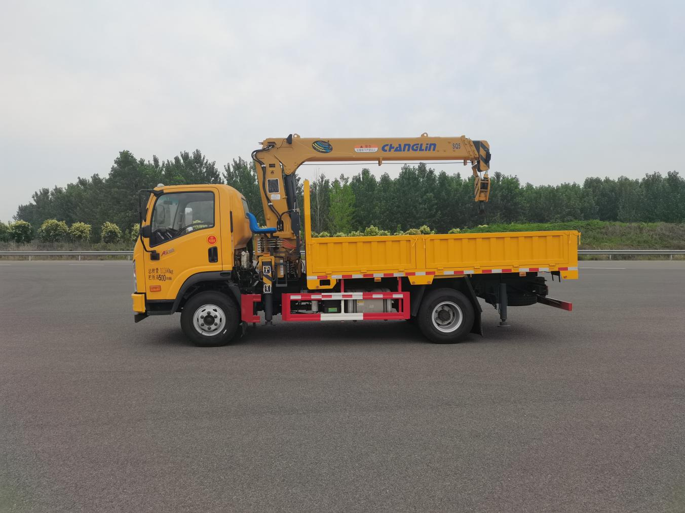

5 straight arm telescopic truck crane
2.1 Main technical parameters:
order number | project |  |  |  | unit |  | numeric value
1 | maximum lifting moment |  |  |  | kN·m |  | 125
2 | maximum lifting load |  |  |  | kg |  | 5000
3 | maximum working range |  |  |  | mm |  | 8600
4 | fully retracted boom length |  |  |  | mm |  | 3725
5 | Maximum lifting height (above ground) |  |  |  | mm |  | About 10,800
6 | lift ratio |  |  |  |  |  | 4
7 | maximum boom angle |  |  |  | (°) |  | 77
8 | minimum boom angle |  |  |  | (°) |  | 0
9 | transverse span of front leg |  |  |  | mm |  | 2235~5005
10 | transverse span of rear outrigger |  |  |  | mm |  | ————
11 | maximum rate of ascent | main hook  (Single rope) | Lift | m/min |  | 37.6
11 | maximum rate of ascent | main hook  (Single rope) | descend |  |  | 37.6
12 | swiveling speed |  |  |  | r/min |  | ≤2.5
13 | rotation angle |  |  |  | ° |  | 360° full rotation
14 | crane self-weight |  |  |  | kg |  | 2000
15 | oil pump form |  |  |  | ------------- |  | gear pump
16 | fuel tank capacity |  |  |  | L |  | 100
17 | working pressure of hydraulic system |  |  |  | MPa |  | 23
18 | flow rate of hydraulic system |  |  |  | L/min |  | 40

2.2外形图 and characteristic curve of truck crane

2.3 Product Configuration
(1) Base
Base type
Three-point bridge, standard width, suitable for crane types installed on trucks.
rotator
The worm gear reducer has a full rotation of 360 degrees without dead center.
(2) Support leg system
pre horizontal support leg
The crane operator pulls the horizontal hydraulic support leg, with a full extension span of 5 meters.
length of the anterior vertical support leg
The standard hydraulic support leg retracts to 654mm below the installation surface and extends to 1233mm below the installation surface.
(3) Lifting Arm System
The structure with hexagonal cross-section has good lateral stability. It has two telescopic arms, a single-stage hydraulic telescopic cylinder, and the second and third arms are synchronized by wire rope arrangement.
(4) Hydraulic System
master control valve
The system is equipped with a 6-function manual main control valve, which controls the extension, retraction, luffing, lifting, and vertical leg cylinder extension of the mast.
(5) Control System
crane control system
The crane is controlled by the operating lever distributed in the direction of the cab, and the crane can be operated on both sides.
support leg control system
The support leg is controlled by the operating handle mounted on the main valve, and can also be operated from both sides.
(6) Safety devices
Standard high limit switch and over winch alarm device
Optional high-power LED working light
optional torque limiter
(7) Other attachments
structural attachment
A complete bolt clamping assembly, large size, including 8 M24x2 bolts (800mm length), clamping washers, and other necessary accessories

