GE520H SPECIFICATIONS
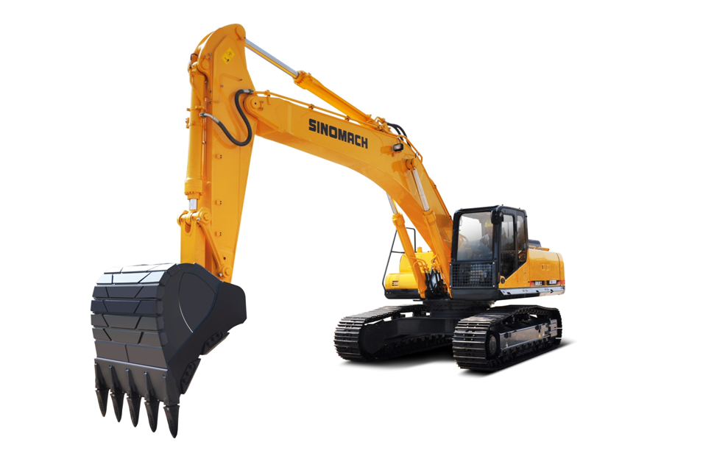
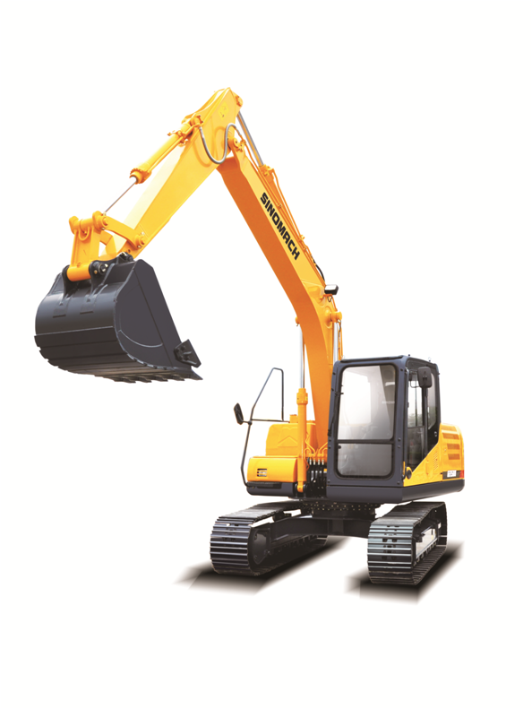
1.产品简介 Introduction：
康明斯电喷发动机(符合三阶段排放法规)，动力强劲、高效节能、可靠耐用；先进的负流量液压系统，操作舒适，作业效率高；全功率控制，四种功率模式适应不同工况；可靠、精准的燃油喷射系统，实时控制喷油量，使燃烧更加充分，同时配置半独立散热系统，燃油效率更高；全三维建模和有限元分析技术，保证了结构件的可靠性和稳定性；优异属具拓展能力，满足市场多样化需求。
CUMMINS EFI engine (compliant with Stage III emission regulations), powerful, energy efficient, reliable and durable; advanced negative flow hydraulic system, comfortable operation, high operating efficiency; full power control, four power modes to adapt to different working conditions; reliable and accurate fuel injection system, real-time control of the injection volume, so that the combustion is more adequate, and at the same time, equipped with a semi-independent heat dissipation system, fuel efficiency is higher; full 3D modeling and finite element analysis technology to ensure the reliability and stability of structural components; excellent appliance expansion capabilities to meet the diverse needs of the market. Finite element analysis technology ensures the reliability and stability of structural parts; excellent attribute expansion capability to meet the diversified needs of the market.
2.性能特点 Characteristics：
(1)采用新一代大功率康明斯发动机，具有先进的燃油控制和喷射技术，为矿山作业提供强劲动力的同时兼顾燃油经济性；
New generation of high-power CUMMINS engine with advanced fuel control and injection technology, it provides strong power for mining operations while taking fuel economy into account.
(2)采用低速大扭矩的动力匹配策略，进一步提升整机燃油经济性，降低油耗；
Adopting the power matching strategy of low speed and high torque to further improve the fuel economy of the whole machine and reduce fuel consumption.
(3)采用半独立散热技术，可靠性更佳，可使液压系统根据实际需求，始终工作在最佳状态，并实现整机燃油经济性的改善；
Adopting the semi-independent heat dissipation technology with higher reliability, the hydraulic system can always work in the best condition according to the actual demand, realizing the improvement of the fuel economy of the whole machine.
(4)采用全新的大流量主阀，内部压损更低，额定流量更大，具备较好的节能效果；
Adopting a new high-flow main valve, with lower internal pressure loss, higher rated flow rate and better energy-saving effect.
(5)选用低噪音和低功耗的风扇，降低整机的噪音，改善整机燃油经济性；
Low noise and low power consumption fans are selected to reduce the noise of the whole machine and improve the fuel economy of the whole machine.
(6)采用主流的8寸高清显示屏，简洁的显示界面，视角效果更好。智能电子监控系统，具备整车保养信息提示、故障的自诊断和报警等多种功能；
Adopt mainstream 8-inch high-definition display, simple display interface, better viewing angle effect. Intelligent electronic monitoring system, with vehicle maintenance information tips, self-diagnosis of faults and alarms and other functions.
(7)车辆管控系统，提升为北斗双模精确定位，4G高速通讯；
Vehicle control system, upgraded to BDS dual-mode precise positioning, 4G high-speed communication.
(8)全新的蜂窝状进风设计，优化了发动机室的进排风路径和密封隔音材料，降低了整机的噪音；
The new honeycomb air intake design optimizes the air intake and exhaust paths in the engine room and the sealing and soundproofing materials, which reduces the noise of the vehicle.
(9)全面提升驾驶室内部功能布局、内饰配色以及空调风道结构，可选配遮阳帘，提升驾乘舒适性，改善驾驶室内部制冷效果；
Comprehensively upgraded cab interior functional layout, interior color scheme and air conditioning duct structure, with optional sunshade to enhance driving comfort and improve the cooling effect inside the cab.
(10)设置破碎专用程序，可实现远程控制破碎流量和压力，改善操作便捷性；
Special program for crushing, which can realize remote control of crushing flow and pressure and improve the convenience of operation.
(11)独立散热自清洁功能，提升使用过程中散热性能，保证系统的稳定性和可靠性；
Independent heat dissipation self-cleaning function improves heat dissipation performance during use and ensures the stability and reliability of the system.
(12)全新开发的高耐久性结构件，可完全满足矿山作业需求，实现标配200mm破碎锤的能力，并可根据需要匹配钩掘设备；
Newly developed and highly durable structural parts can fully meet the needs of mining operations, realizing the capacity of 200mm crushing hammer as standard, and can be matched with hook digging equipment according to the needs.
(13)标配双筋履带板，可提升矿山地区的行走抓地能力；
Dual ribbed track plates are standard for improved grip in mining areas.
(14)标配油浴式预滤器，提升整机在重度灰尘地区的适应能力；
Standardly equipped with oil bath pre-filter to enhance the machine's adaptability in heavy dust areas.
(15)全面的碎石防护措施，可保证驾驶室顶部、前部、右侧免受碎石等硬质外物的撞击。
Comprehensive debris protection protects the cab top, front, and right side from hard foreign objects such as debris.

3．技术规格Technical specification
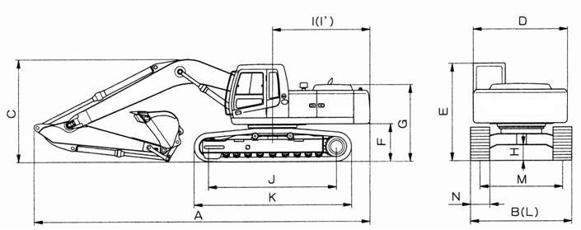
名称ITEM |  | 单位UNIT | 技术规格Specifications
 |  | 单位UNIT | GE520H
操作重量Operating weight |  | Kg | 50460
标准斗容  Rated bucket capacity |  | m³ | 3.2
总长 Length | A | mm | 11657
总宽（600mm履带）  Width（600mm track） | B | mm | 3340/3562(Pedal)
总高 Height | C | mm | 3998
转台宽度 Turntable width | D | mm | 3214
驾驶室离地高  Height of cabin | E | mm | 3438
配重离地间隙 Ground clearance of counterweight | F | mm | 1276
发动机罩高  Engine cover height | G | mm | 2918
最小离地间隙  Min. ground clearance | H | mm | 555
转台尾端长度 Tail length | I | mm | 3740
尾端回转半径  Turning radius of turntable | I’ | mm | 3780
履带轴距  Wheel base of track shoe | J | mm | 4470
底盘长度  Length of chassis | K | mm | 5595
底盘宽度  Width of chassis | L | mm | 3340/3562(Pedal)
履带轨距  Track shoe gauge | M | mm | 2740
标准履带宽度  Standard track width | N | mm | 600
最大牵引力  Max. traction |  | kN | 339
行走速度（高/低）  Traveling speed （H/L） |  | km/hr | 4.9/2.9
回转速度  Swing speed |  | rpm | 9.4
爬坡能力 Gradeability |  | Degree(%) | 35（70%）
接地比压  Ground pressure |  | kgf/cm² | 0.85

4. 工作范围 Working range
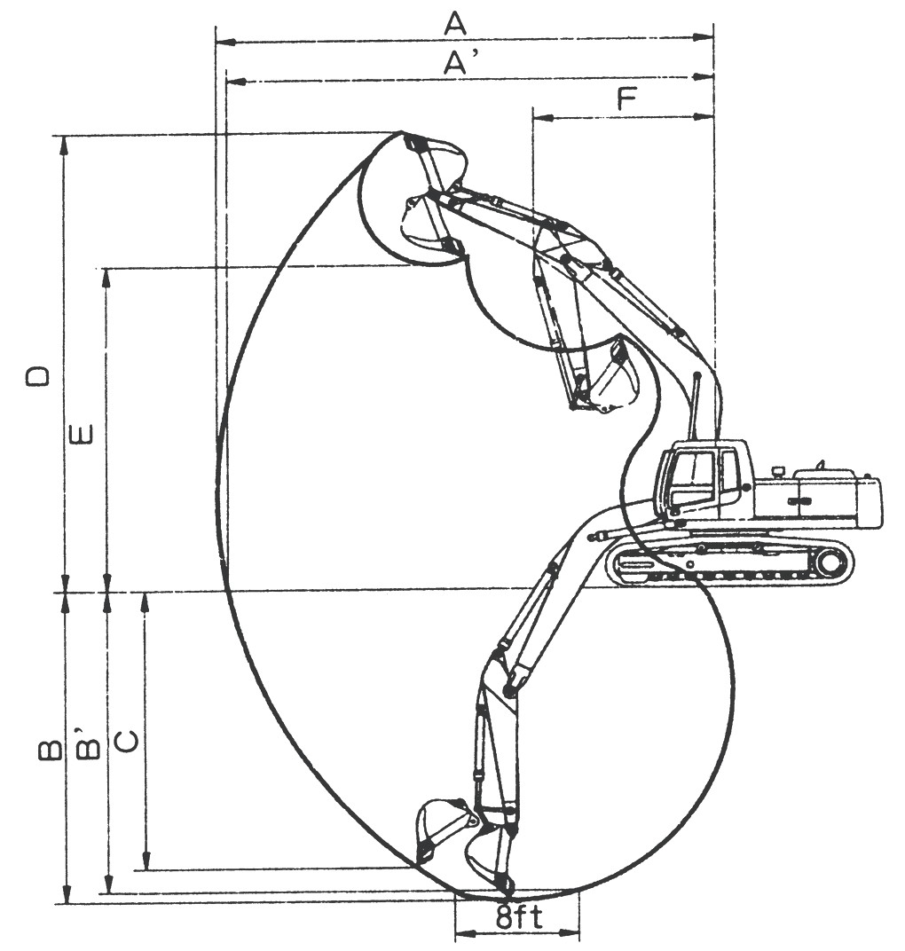

类别ITEM |  | 6.55m动臂，2.5m斗杆，3.2m³铲斗  6.55m Boom，2.5m Stick，3.2 m³ Bucket
 |  | GE520H
最大挖掘半径  Maximum digging radius | A | 10922 mm
地面最大挖掘半径  Ground maximum digging radius | A’ | 10691 mm
最大挖掘深度  Maximum digging depth | B | 6453 mm
地面最大挖掘深度（2438mm水平）  Ground maximum digging depth | B’ | 6280 mm
最大垂直挖掘深度  Maximum vertical digging depth | C | 5663 mm
最大挖掘高度  Maximum digging height | D | 11020 mm
最大卸载高度  Maximum dumping height | E | 7438 mm
最小前部回转半径  Min. front turning radius | F | 4740 mm
铲斗挖掘力  Bucket digging force | ISO | 290 kN
斗杆挖掘力  Stick digging force | ISO | 270 kN
5. 发动机性能参数 Engine specifications
规格参数  Specifications | 型号 Model |  | 康明斯 QSM11(Ⅲ)-C375  CUMMINS QSM11(Ⅲ)-C375
规格参数  Specifications | 型式 Type |  | 六缸直列、四冲程涡轮增压  6-cylinder in-line, four-stroke turbocharger
规格参数  Specifications | 排放 Emission |  | 国Ⅲ National Ⅲ
规格参数  Specifications | 冷却方式 Cooling method |  | 水冷 Water cooled
规格参数  Specifications | 缸径×行程 Bore diameter × stroke | mm | 125×147
规格参数  Specifications | 气缸排量 Displacement | L | 10.8
规格参数  Specifications | 额定功率 Rated power |  | 280kW/2000rpm
规格参数  Specifications | 最大扭矩Max. torque | N.m | 1898/1300rpm
规格参数  Specifications | 机油量 Engine oil capacity | L | 31.8-40.9
规格参数  Specifications | 额定油耗率 Rated diesel consumption | g/kW.h | 193 (1100rpm)
规格参数  Specifications | 起动马达 Starter |  | 24V 7.2kW
规格参数  Specifications | 发电机 Generator |  | 24V 70A
规格参数  Specifications | 蓄电池 Accumulators |  | 4×12V×120Ah
6. 主要部件配置 Main configuration
部件 机型 | GE520H
排放等级 Emission | 国三 National Ⅲ
发动机 Engine | 康明斯 CUMMINS  QSM11(Ⅲ)-C375
主泵 Main pump | 川崎 KAWASAKI  K5V212DPH
主控阀 Main valve | 川崎 KAWASAKI  KMX32NA
回转马达 Swing motor | 川崎 KAWASAKI  M5X130CHB
行走马达Travelling motor | 纳博 NABTESCO  GM95VA

