GHT215W Fully Hydraulic Wheel Excavator

GHT215W is a new generation of fully hydraulic wheel excavator developed independently. It adopts high-power, low fuel consumption and environment-friendly engine, which ensures strong power and power reserve: The high-precision hydraulic system is precisely matched with the bridge box, which ensures the randomness of working and sleeping states: The hydraulic system adopts advanced hydraulic components matching, which has the characteristics of "high reliability, good quality, safety and environmental protection.and comfort". Meanwhile, it can provide various special configurations, which can meet the needs of different industries and customers.
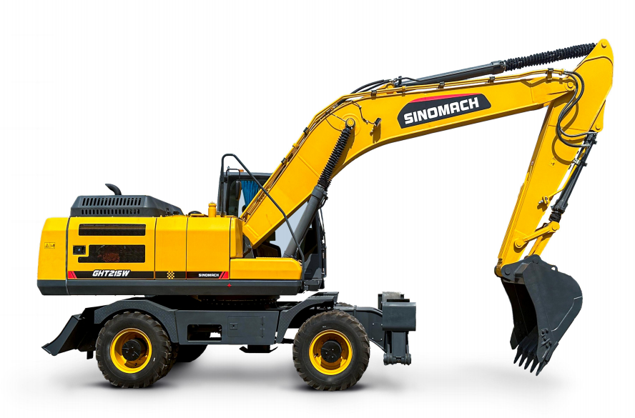

Technical Parameters:

发动机型号 | Engine model | 6BTA5.9-C180-II
功率 | Power | 132kw/2200rpm
整机重量(kg) | Operating Weight (kg) | 21500
斗容(m³) | Bucket capacity (m ³) | 1.0
尺寸规格 | Dimensions
运输时总长(mm) | Transportation length (mm) | 9700
运输时总高(mm) | Transportation height (mm) | 3300
整机宽度(mm) | Overall width (mm) | 2490
尾部回转半径(mm) | Tail turning radius (mm) | 2750
轮距(mm) | Track width (mm) | 1975
轴距(mm) | Wheelbase (mm) | 2855
作业范围 | Scope of work
最大挖掘高度(mm) | Max excavation height (mm) | 11000
最大卸载高度(mm) | Max unloading height (mm) | 8020
最大挖掘深度(mm) | Max excavation depth (mm) | 6437
最大挖掘半径(mm) | Max excavation radius (mm) | 10050
工作参数 | Working parameters
液压系统压力(Mpa) | Hydraulic system pressure (Mpa) | 32
液压系统流量(L/min) | Hydraulic system flow (L/min) | 2*239
动臂长度(mm) | Boom length (mm) | 5700
斗杆长度(mm) | Stick length (mm) | 2900
铲斗挖掘力(kN) | Bucket digging force (kN) | 152.1
斗杆挖掘力(kN) | Stick digging force (kN) | 119.5
燃油箱容量(L) | Fuel tank capacity (L) | 350
液压油箱容量(L) | Hydraulic oil tank capacity (L) | 215
爬坡度(%) | Climbing slope (%) | ≥60
回转速度(r/min) | Rotation speed (r/min) | 11
公路最高行走速度(km/h) | Max traveling speed (km/h) | 30
推土板尺寸(mm) | Bulldozer plate size (mm) | 2500*590
推土板提升高度(mm) | Plate lifting height (mm) | 430
推土板支地高度(mm) | Plate support height (mm) | 180

