GYS122J单钢轮全液压振动压路机
GYS122J FULL HYDRAULIC SINGLE DRUM VIBRATORY ROLLER
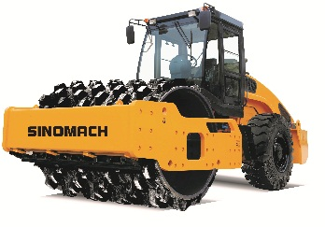
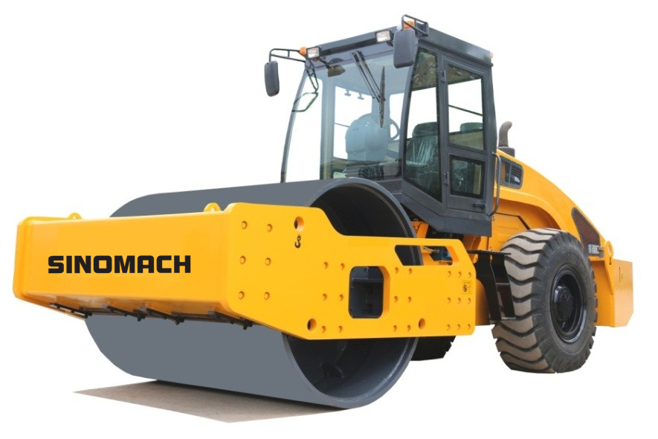

适用范围 Application
适用于高等级公路、大坝、铁路、机场等大型工程基础的压实，可碾压砂土、砾石、碎石、岩石填方等非粘性材料及半粘性材料
Suitable for compaction of large-scale engineering foundations such as high-grade roads, dams, railways, airports, etc., non-stick materials and semi-viscous materials such as sand, gravel, gravel, rock fill, etc.

性能特点:Performance characteristic
- 液压前后轮驱动，多档无级变速，爬坡能力强；
Hydraulic front drum and rear wheel drive, multi-speed stepless speed change, strong climbing ability
- 液压振动，电控延时起振，激振力大，压实性能好；
Hydraulic vibration, electronically controlled delay start, high excitation force, good compaction performance
- 液压转向，铰接式车架，转向轻便灵活，操作轻便灵活；
Hydraulic steering, articulated frame, light and flexible steering, light and flexible operation
- 配置压路机专用驱动桥，驱动性能优越；
Equipped with a dedicated drive axle for the roller, which has superior drive performance.
- 液压行走制动，电控盘刹停车制动，设有制动释放装置，可供近距离拖行，安全性能好；
Hydraulic travel brake, electric control disc brake parking brake, with brake release device for short-distance towing, good safety performance;
- 后机罩可大角度翻起，维修保养方便；
The rear hood can be turned up at a large angle for easy maintenance
- 驱动和振动系统均配置进口国际知名品牌液压元件，性能可靠；
The drive and vibration system are equipped with imported international famous brand hydraulic components, and the performance is reliable.
8.可选配不同花纹轮胎；可选配其它品牌柴油机;标配驾驶室，可选装冷暖空调。可选配凸块式钢轮。
Optional different pattern tires; optional other brands of diesel engines; standard cab, optional air conditioning. Optional bump type steel wheel

技术参数 Technical parameters
产品型号 Model | GYS122J
工作质量Operating weight (kg) | 12000
振动轮直径Vibratory drum diameter (mm) | 1500
压实宽度Compaction width (mm) | 2130
静线载荷Static line pressure | 312 N/cm
最小离地间隙Min. ground clearance (mm) | 420
轴距 Wheel base (mm) | 3100
最小转弯半径 Min. turning radius (mm) | 6400
理论爬坡能力 Gradeability | 50%
振动频率Vibratory frequency(Hz) | 30/35
名义振幅Vibratory amplitude (mm) | 1.9/0.9
激振力Centrifugal force (kN) | 280/180
行驶速度 Travelling speed (km/h) | (L)0～5.5 ，(F)0～10
发动机型号 Engine model | WP4G110E22
发动机功率/转速 Engine power/speed (kW /rpm) | 82/2200
外形尺寸（长×宽×高）(mm)  Dimension (Length ×Width × Height) | 6140×2280×3080

主要配置说明 Main configuration
序号  S/N | 名称  ITEM | 型号  MODEL | 数量  NO. | 生产厂家  MANUFACTURER
1 | 柴油机  Engine | WP4G110E301 |  | WEICHAI
2 | 振动泵  Vibratory pump | HPV055 | 1 | LINDE
3 | 振动马达  Vibratory motor | HMF055 | 1 | LINDE
4 | 驱动泵  Hydraulic pump | HPV075 | 1 | LINDE
5 | 前驱动马达  Front drive motor | HMF055 | 1 | LINDE
6 | 桥驱动马达  Axle drive motor | HMV055 | 1 | LINDE

