GYS22J单钢轮振动压路机
GYS22J SINGLE DRUM VIBRATORY ROLLER
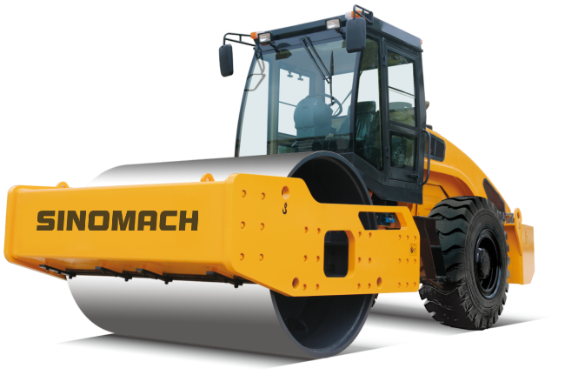
主要性能:Main features
- 配置6缸增压具有世界先进水平的发动机，功率储备大，效率高，超低油耗，清洁环保。
Equipped with 6-cylinder supercharger with world-class engine, large power reserve, high efficiency, ultra-low fuel consumption, clean and environmentally friendly
- 振动系统配置美国PERMCO齿轮泵和齿轮马达，效率高，质量可靠。
The vibration system is equipped with American PERMCO gear pump and gear motor, with high efficiency and reliable quality.
- 采用带同步器的压路机专用变速箱，变速换档轻便舒适，性能可靠。
Adopting a special gearbox for the roller with a synchronizer, the shifting shift is light and comfortable, and the performance is reliable.
- 选配带差速器和钳盘式制动器的驱动桥，牵引力强大，通过性能良好。
Driving axle with differential and caliper disc brakes for powerful traction and good performance
- 电控起振，操作方便，具有高低振幅两种振动型选择，压实性能优良。
Electric control start-up, easy to operate, with high and low amplitude vibration type selection, excellent compaction performance
- 具有两套制动系统，行车制动为气顶油钳盘式，停车制动为内涨型鼓式，安全性能好。
With two sets of brake system, the service brake is a gas-top oil tongs disc type, the parking brake is an internal rising drum type, and the safety performance is good.
- 后罩壳为流线型设计，可大角度起翻，维修保养方便。
The rear cover is streamlined and can be turned up at a large angle for easy maintenance.
- 整机采用三级减震，减震性能好。
The whole machine adopts three-stage damping and has good shock absorption performance.

规格型号：GYS22J型单钢轮振动压路机
MODEL: GYS22J Single drum vibratory roller
主要技术参数 Main parameter
1、工作质量 Operating weight | 22000 kg
2、振动频率 Vibratory frequency | 30 Hz
3、激振力（大振/小振）Centrifugal force （L/S） | 420/230 kN
4、振幅（大振/小振）Vibratory amplitude (L/S) | 2.0/1.0 mm
5、静线压力 Static line pressure | 516 N/cm
6、工作速度 Travelling speed Ⅰ/Ⅱ/Ⅲ | 2.5/5.0/10.5 km/h WEICHAI  2.7/5.5/11.5 km/h CUMMINS
7、爬坡能力 Gradeability | 30%
8、转弯半径（外侧） Min. turning radius | 6500 mm
9、最小离地间隙 Min. ground clearance | 450 mm
10、轴距 Wheelbase | 3200 mm
11、外形尺寸（长×宽×高）Overall dimension | 6240×2320×3080 mm
12、压轮参数（直径×宽度） Drum dimension | φ1600×2130 mm
13、驱动形式 Drive type | Mechanical drive
14、柴油机型号 Engine model | WP6G175E301
额定转速 Rated speed | 2000r/min
额定功率 Rated power | 129kW
柴油机型号 Engine model | 6BTA5.9-C180
额定转速 Rated speed | 132 kW
额定功率 Rated power | 2200 r/min
14、轮胎规格 Tyre model | 20.5-25-16PR

主要配置说明 Main configuration
序号  S/N | 名称  ITEM | 型号  MODEL | 数量  NO. | 生产厂家  MANUFACTURER
1 | Engine | WP6G175E301  6BTA5.9-C180 | 1 | WEICHAI  CUMMINS
2 | Gear box | CAPGF5-90JM | 1 | HNC
3 | Drive axle | GY2203A | 1 | JINGDA
4 | Vibratory pump | P7600-F100 | 1 | PERMCO
5 | Vibratory motor | M7600-F112J | 1 | PERMCO

