GYD102J全液压振动
GYD102J FULL HYDRAULIC DOUBLE DRUM
VIBRATORY ROLLER
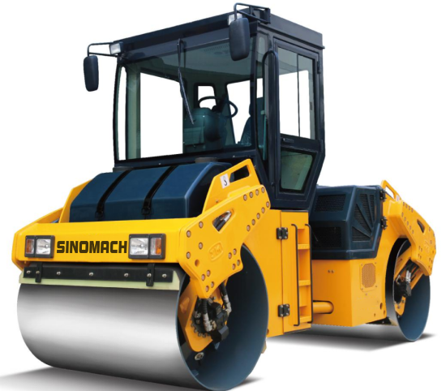

规格型号：GYD102J型振动压路机
MODEL: GYD102J FULL HYDRAULIC DOUBLE DRUM VIBRATORY ROLLER
主要性能特点：Main characteristic
适用于高等级公路和城市道路、城际及县乡公路、水利工程、体育和其它工业场地等一般路面沥青面层的压实和修补。
It is suitable for the compaction and repair of general pavement asphalt surface layer of high-grade highways and urban roads, inter-city and county highways, water conservancy projects, sports and other industrial sites, etc.
性能特点：
1、液压双轮驱动，两档无级变速，爬坡性能好；
Hydraulic two-wheel drive, two-speed continuously variable speed, good climbing performance.
2、液压双轮振动，双频双幅，电控起振；
Hydraulic two-drum vibration, dual-frequency double amplitude, electronically controlled vibration.
3、液压转向，铰接式车架，操作轻便灵活；
Hydraulic steering, articulated frame, light and flexible operation.
4、两大防腐洒水箱连通设计，容量大，电控压力间歇喷洒水；
Two large anticorrosive sprinkler tank connecting design, large capacity, electronically controlled pressure intermittent water spraying.
5、液压行走制动，电控盘刹停车制动；
Hydraulic traveling brake, electronically controlled disc brake parking brake.
6、整机蟹形叉脚流线设计，造型美观，视野盲区小，可完全靠路肩贴边压实。
Crab-shaped fork foot streamline design, beautiful modeling, vision blind spot is small, can be completely by the shoulder side compaction.
7、两侧后机罩可大角度开起，维护保养触手可得；操作台和座椅可左右90度旋转，便于操作者观察边缘压实
Rear hood can be opened up at a large angle, maintenance is within reach; the operator's desk and seat can be rotated left and right by 90 degrees, which is convenient for the operator to observe the edge compaction.
8、驱动和振动系统均配置进口国际知名品牌液压元件，性能可靠
Equipped with imported international famous brand hydraulic components, reliable performance.
9、标配驾驶室或空调驾驶室，选配驾驶棚；
Standard cab or air-conditioned cab, optional cab shelter.
主要技术参数：Main parameters
1、整机重量 Operating weight | 10000 kg
2、压轮直径 Drum Diameter | 1100mm
3、压实宽度 Compaction width | 1700 mm
4、静线载荷 Static line pressure | 290 N/cm
5、振动频率 Vibratory frequency | 42/52 Hz
7、理论振幅 Vibratory amplitude | 0.75/0.35 mm
8、激振力 Centrifugal force | 110/65 kN
9、行驶速度 Travelling speed | 0-6，0-12km/h
10、爬坡能力 Gradeability | 30%
11、转弯半径(外侧) Min. turning radius | 6000 mm
12、轴距 Wheel base | 3300 mm
13、最小离地间隙 Min. ground clearance | 345 mm
14、外形尺寸（长×宽×高）  Dimension (L×W×H) | 4500×1900×2900mm（cab）  4500×1900×3100 mm（cab+A/C）
15、发动机 Engine
型 号 Model | 4BTA3.9-C110
功 率 Rated power | 82 kW
转 速 Rated speed | 2200 r/min
16、燃油箱 Fuel tank | 150 L
17、洒水箱 Sprinkler tank | 600 L
18、液压油箱 Hydraulic oil tank | 110 L
主要配置说明 Main configuration
序号  S/N | 名 称  ITEM | 规格型号  MODEL | 数量  NO. | 制造商  MANUFACTURER
1 | 柴油机  Engine | 4BTA3.9-C110 | 1 | 东风康明斯  CUMMINS
2 | 驱动泵  Travelling pump | HPV075 | 1 | 林德  LINDE
3 | 振动泵  Vibratory pump | HPV055 | 1 | 林德  LINDE
4 | 驱动马达  Travelling motor | MSE18 | 2 | 波克兰  POCLAIN
5 | 振动马达  Vibratory motor | MMF035 | 2 | 丹佛斯  DANFOSS

