GYR162 Hydraulic Pneumatic Tire Roller
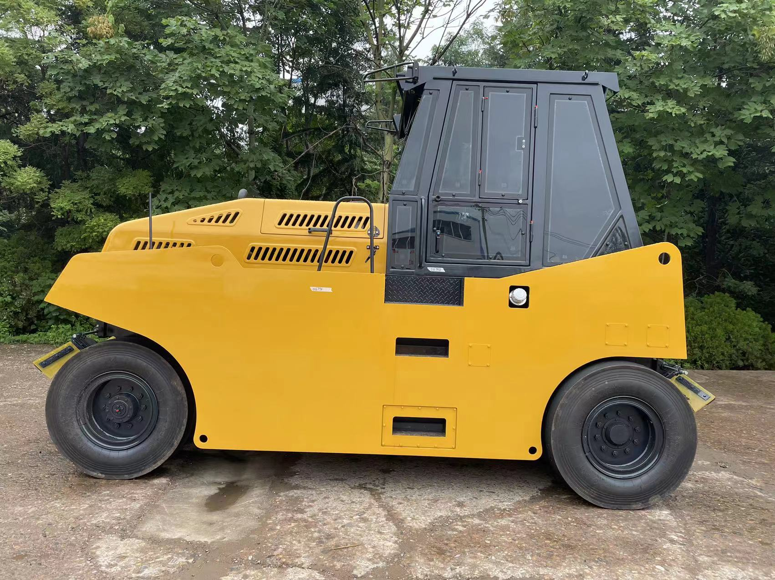
GYR162 Pneumatic tire roller series are designed for the compact cohesive and non-cohesive materials, such as asphalt concrete, cement or lime
stabilized soils, gravels, sands and clay mixtures, Rolling Cement Concrete(PCC)in the construction projects, especially suitable for the preparation of the
upper courses of high grade highway.
Main Features:
1,GYR162 low gravitational center designed for safe and comfortable operation.
2,With step-less speed changes GYR162 is easy and reliable to operate.. Glass fiber reinforced plastic spraying box and mufti-layer water
3,filter ensure the stability of the system.
4,Power strength,GYR162which adopted 4BT Cummins engine, is suitable to all environments.
5,Front wheel with automatic adjusting Heating structure to perform better compactness.
Model |  | GYR162
Operating mass | kg | 10000-16000
Max Travel apeed | Km/h | 0-14
Tire quantity (Front+Rear) |  | 4+5
Tire seize |  | 11.0-20-16
Wheel rim seize |  | 8.00V-20
Minimum Turning radius | mm | 7500
Rolling compaction width | mm | 2280
Ground clerance | mm | 340
Electrial voltage | V | 24
Grade ability | % | 30
Overall dimension (LxWxH) | mm | 4780x2280x3200
Wheel base | mm | 3700
Diesel egnine power | Kw | 75Kw/2200rpm
Diesel egnine model |  | CUMMINS4BT3.9
Fuel tank capacity | L | 223
Hydraulic tank capacity | L | 91

