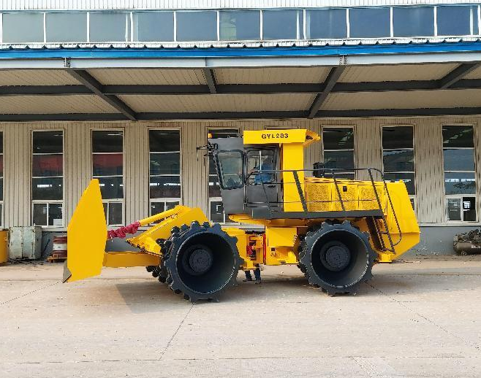
GYL283/263/233/203
适用范围
本垃圾压实机是垃圾填埋场必备的设备，具有对垃圾推平、挤碎、压实的功能，有利于节约土地、保护环境，延长填埋场的使用寿命。
Scope of application
The refuse compactors are essential equipments for refuse landfill site. It has the functions of pushing, spreading, pulverizing demolishing and compacting the refuse. Using this refuse compactor will help to save the land, protect the environmental and extend the operating life of the refuse landfill site.
主要特点
1.采用上柴水冷增压柴油发动机，带低温起动装置；
2.液力变矩器和动力换挡变速箱，四轮行走传动；
3.独特排列的长寿命耐磨齿，设置刮泥齿及剪钳，保证轮齿清洁，防止异物缠绕；
5.液压转向作业系统采用负载传感装置的柱塞液压泵，操作轻巧，高效节能；
6.集中润滑定期对关键点润滑维护，设置喷洒药物机构防蚊虫叮扰；
7.车架一体化的防翻保护结构（ROPS），前后桥行车制动及中央停车制动提供最大的安全保证；
8.驾驶室可翻转，两侧三开门机罩、双侧走廊和防护梯为工作，主要传动元件伸手可及。
9.设置具有红外线夜视功能的车载影音倒车监视系统，以及倒车蜂鸣器大大方便驾驶员行驶和作业操作。
Features
1.SHANGCHAI water-cooled turbocharged diesel engine with the cold starting system.
2.Torque converter and power gearshift transmission are applied on four wheels.
3.The high wear life teeth are arranged specially, two scraper bars and two wire cutters on four
compaction wheels will avoid the wire wrap-around and keep the wheel clean.
4.Hydraulic system is driven by a piston pump with load sensing system, provides smooth and light control，high efficiency and energy economy.
5.The crucial spots are maintained regularly by the central lubrication system. The disinfector spray device is equipped to guard against mosquito.
6.The Roll-Over Protective Structure (ROPS) as an integral part of the frame, service brakes on the front and rear axles and central parking brake will guarantee most reliable safety.
7.Turnover driver's cabin, engine hood with three windows at dual sides, access step and protective ladder in both sides make main components accessible.
8.Infrared vehicle video monitor system and backup buzzer are greatly convenient for driver's travel and working with more safe in increased rear view.

主要技术参数 MAIN TECHNICAL DATAS
 |  | GYL203 | GYL233 | GYL263 | GYL283
整机质量 | kg | 20000 | 23000 | 26000 | 28000
前轮轴荷 | kg | 9500 | 11000 | 12500 | 13500
后轮轴荷 | kg | 10500 | 12000 | 13500 | 14500
长 | mm | 7355 | 7355 | 8150 | 8150
宽 | mm | 3000 | 3000 | 3800 | 3800
高 | mm | 3600 | 3600 | 3650 | 3650
轴距 | mm | 3350 | 3350 | 3500 | 3500
离地间隙 | mm | 435 | 435 | 490 | 490
压轮宽度（前/后） | mm | 1040/835 | 1040/835 | 1195/970 | 1195/970
压轮直径（前/后） | mm | 1500/1500 | 1500/1500 | 1620/1620 | 1620/1620
压轮齿数（前/后） |  | 50/40 | 50/40 | 50/40 | 50/40
发动机厂家 |  | SHANGCHAI | SHANGCHAI | SHANGCHAI | SHANGCHAI
发动机型号 |  | SC8DK200G3 | SC8DK200G3 | SC9DK260G3 | SC9DK260G3
发动机功率 | kW | 147 | 147 | 192 | 192
发动机转速 | r/min | 2200 | 2200 | 2200 | 2200
前进速度Ⅰ档 | km/h | 0-4.2 | 0-4.2 | 0-4.41 | 0-4.41
前进速度Ⅱ档 | km/h | 0-10 | 0-10 | 0-7.1 | 0-7.1
前进速度Ⅲ档 |  |  |  | 0-10.87 | 0-10.87
后退速度Ⅰ档 | km/h | 0-5.8 | 0-5.8 | 0-4.41 | 0-4.41
后退速度Ⅱ档 |  |  |  | 0-7.1 | 0-7.1
最大爬坡能力 | % | 100 | 100 | 100 | 100
推铲高度 | mm | 1650 | 1650 | 1880 | 1880
推铲宽度 | mm | 3000 | 3000 | 3800 | 3800
推铲提升高度 | mm | 1000 | 1000 | 1200 | 1200
推铲入地深度 | mm | 150 | 150 | 200 | 200
转向角 | ±° | 40 | 40 | 40 | 40
横向摆动角 | ±° | 15 | 15 | 15 | 15
转弯半径（前轮外侧） | mm | 6250 | 6250 | 7200 | 7200
燃油箱 | L | 450 | 450 | 500 | 500
液压油箱 | L | 236 | 236 | 236 | 236
驱动方式 |  | 液力传动，动力换挡，全轮驱动
行车制动 |  | 气推油，四轮钳盘制动
驻车/紧急制动 |  | 机械，涨蹄式制动器
转向方式 |  | 液压，中央铰接，可摆动

